**Exchange Server**

**Contents**

**1.** **Purpose** 1

**2.** **Procedure** 2

**3.** **Conclusion** 135

**4.** **Evaluation** 135

# **Purpose**

The purpose of this project is to establish and administer an Exchange Server 2016. This is a hefty task since the minimum RAM required for an Exchange Server is 8 GB and it requires around 40 GB of hard disk to even set up the server. These constraints are quite hard for our physical machines and hence it takes a long while to set up, run and use the Exchange Server 2016. We also deployed Exchange 2010 and Exchange 2013 to demonstrate migration.

# **Procedure**

The very first thing we need to do before we set up Exchange Server 2016 is to download the updates necessary for it. We had been given certain files by our instructor that has some of these files and we also use a command on PowerShell to acquire the newest NET Framework updates that we need. Note that this should happen before setting active directory so that we are connected to the internet without issue.

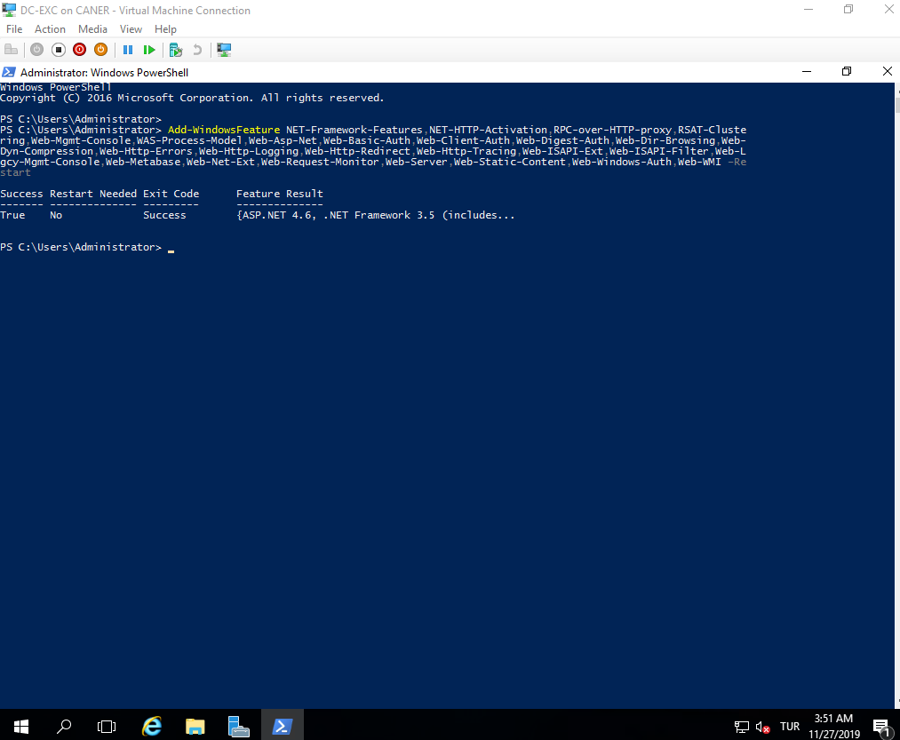

Then we need to establish an Active Directory on the PC for our Exchange Server 2016. While it is recommended that the Domain Controller (DC) and the Exchange Server are on separate machines, unfortunately with the Exchange Server’s constraints we had to have the DC of our domain and the Exchange Server on the same virtual machine. Regardless, we always need an Active Directory for the mail server to work properly and match to the users. Hence, we create a new Active Directory domain on our PC.

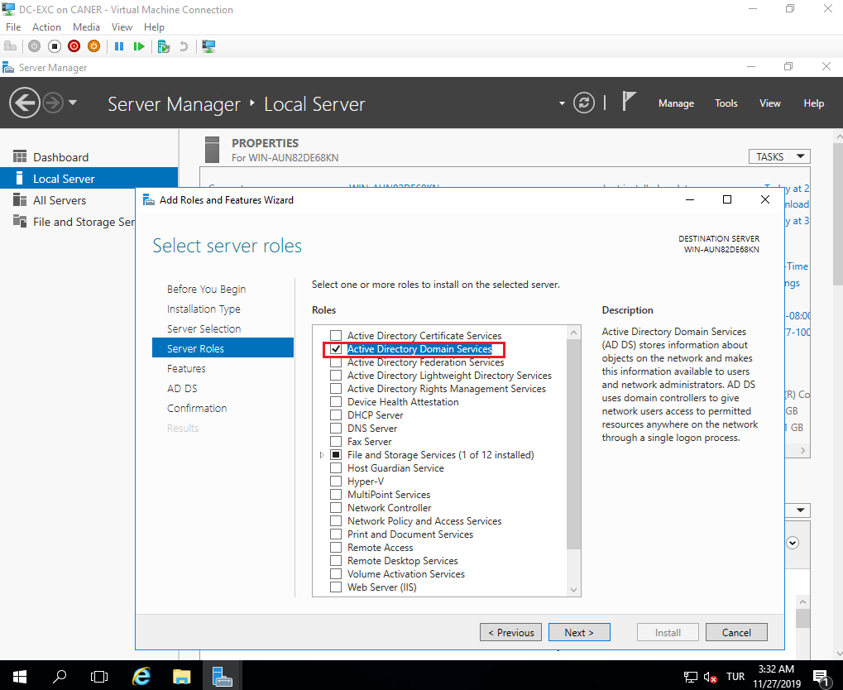

We promote the PC to the domain controller …

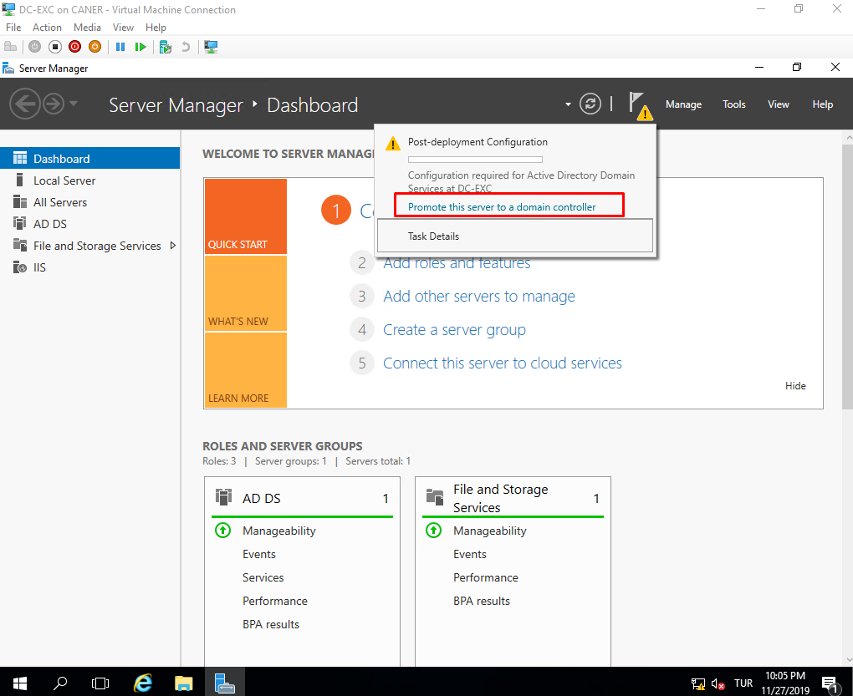

… by creating our new domain: cantan.local

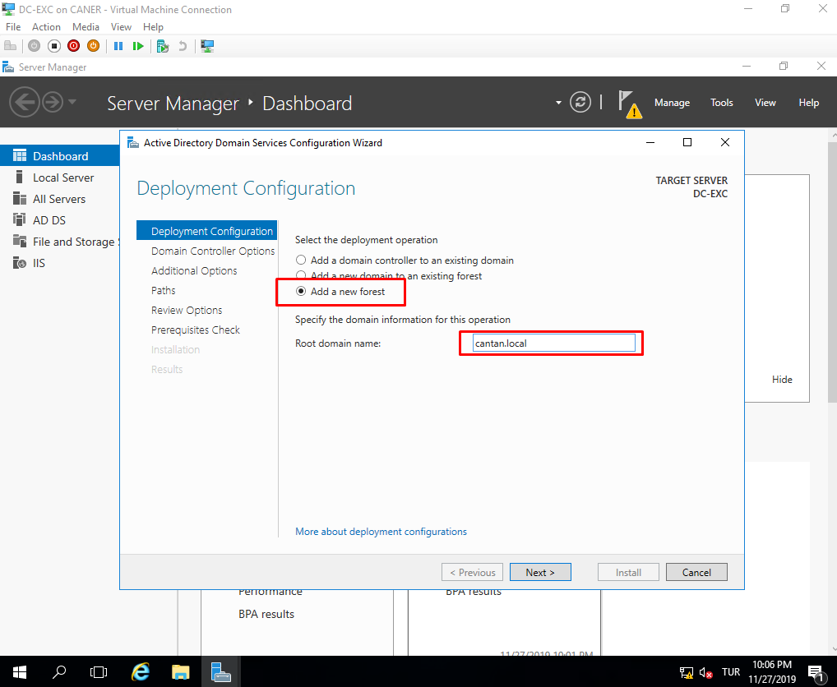

Then, we follow the usual settings for creating a new domain.

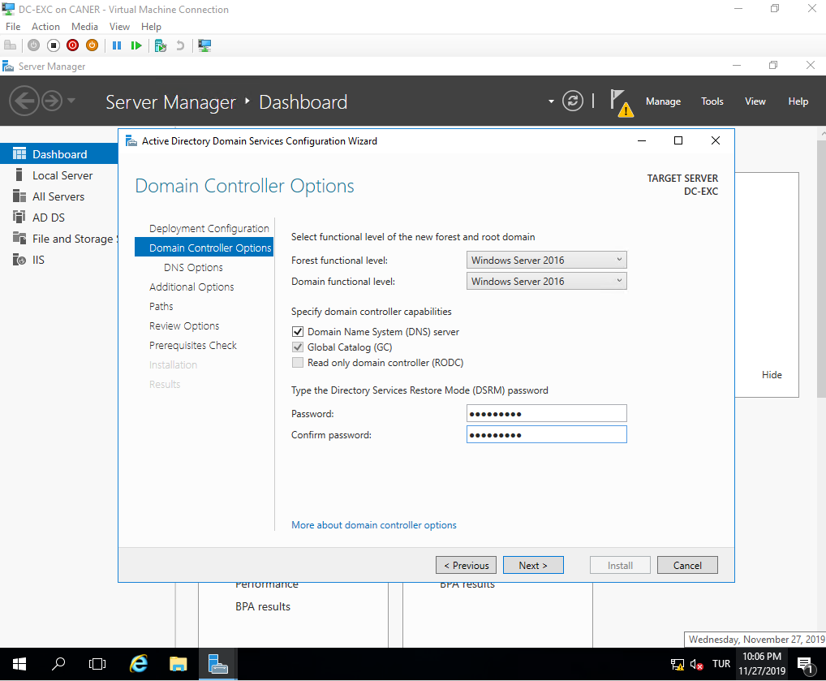

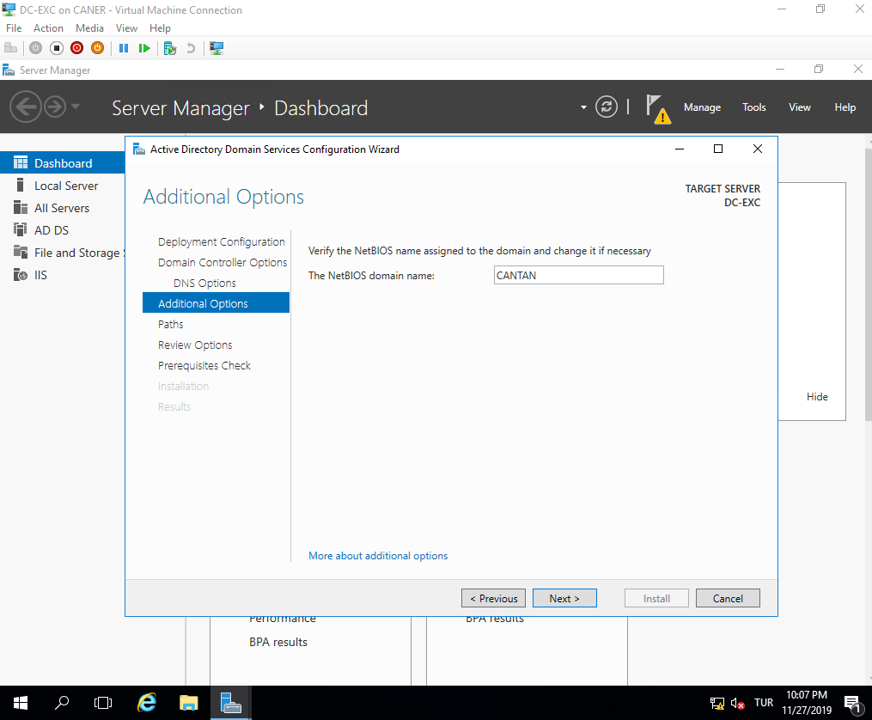

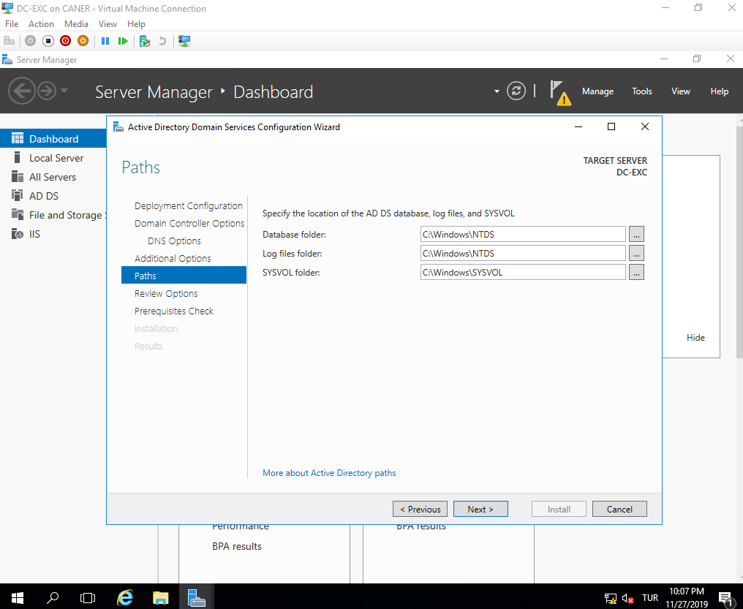

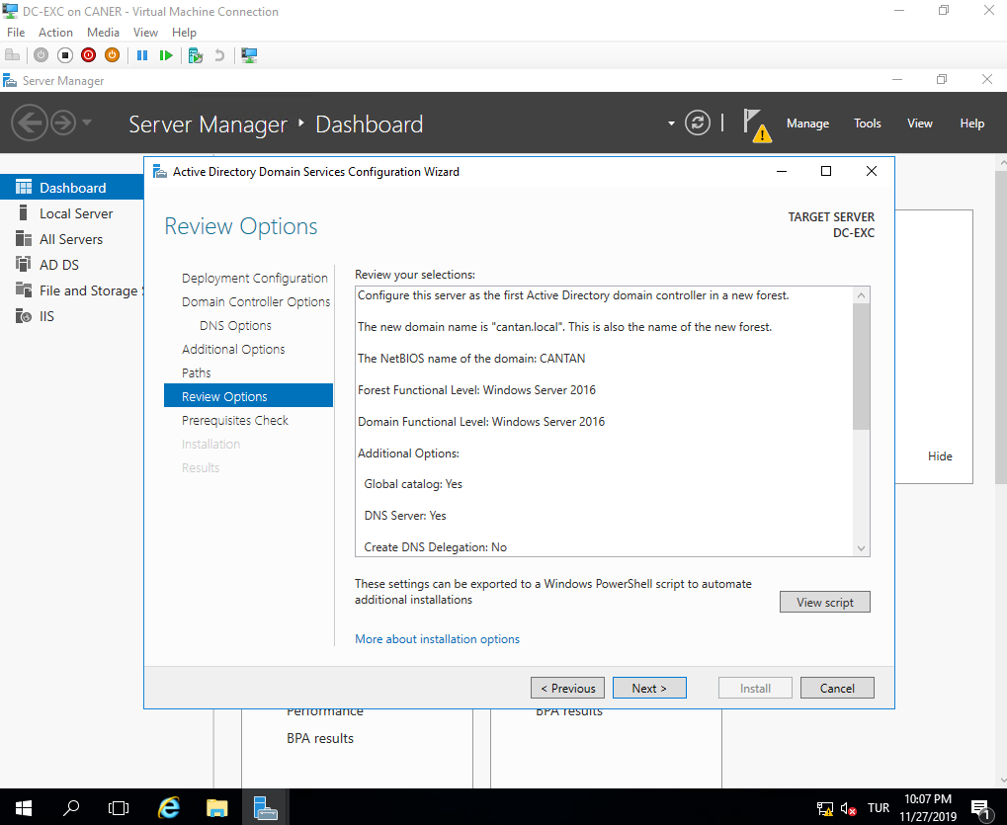

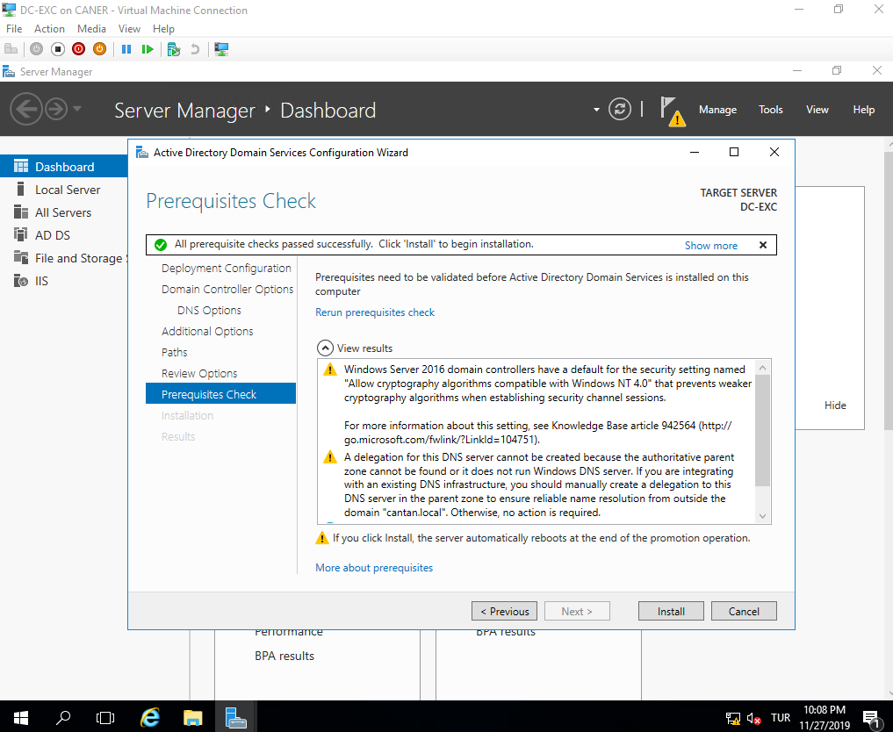

After the installation, the PC restarts automatically.

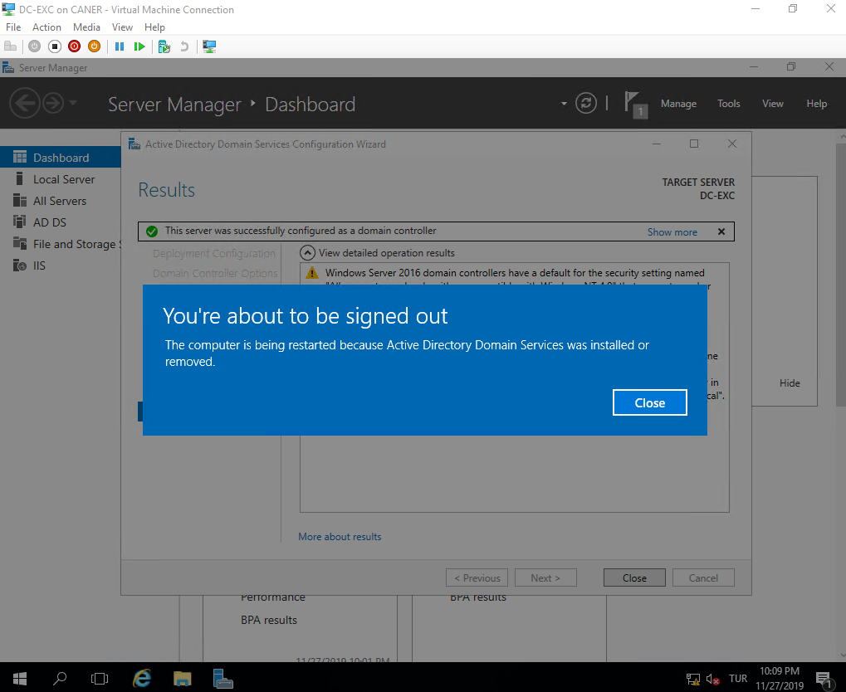

And the new Active Directory is all set.

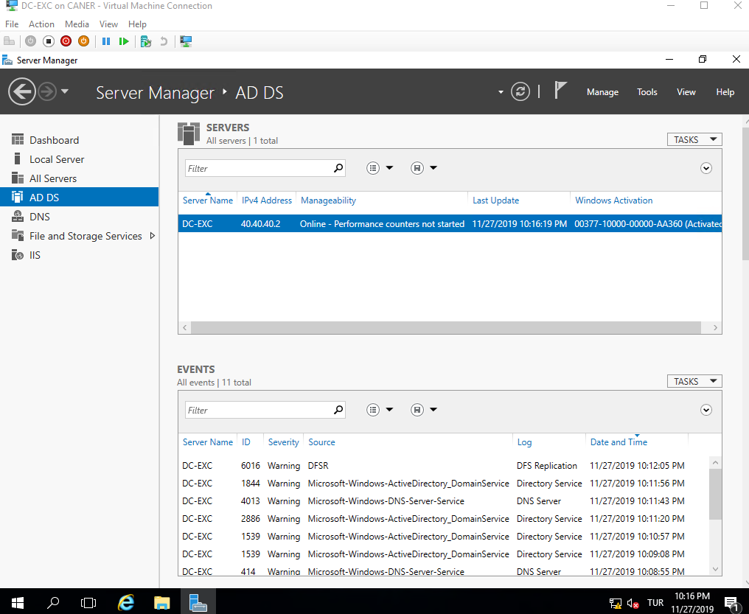

We mount the Exchange Server 2016 iso file as if it’s a mounted disk and run it.

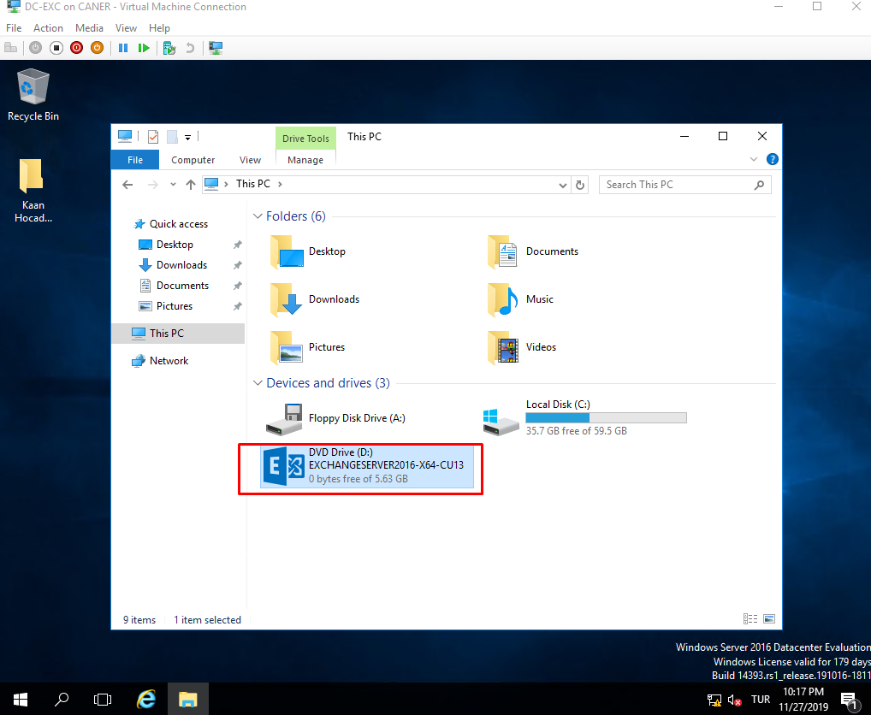

We choose “Don’t check for updates” since currently our server is not connected to the internet.

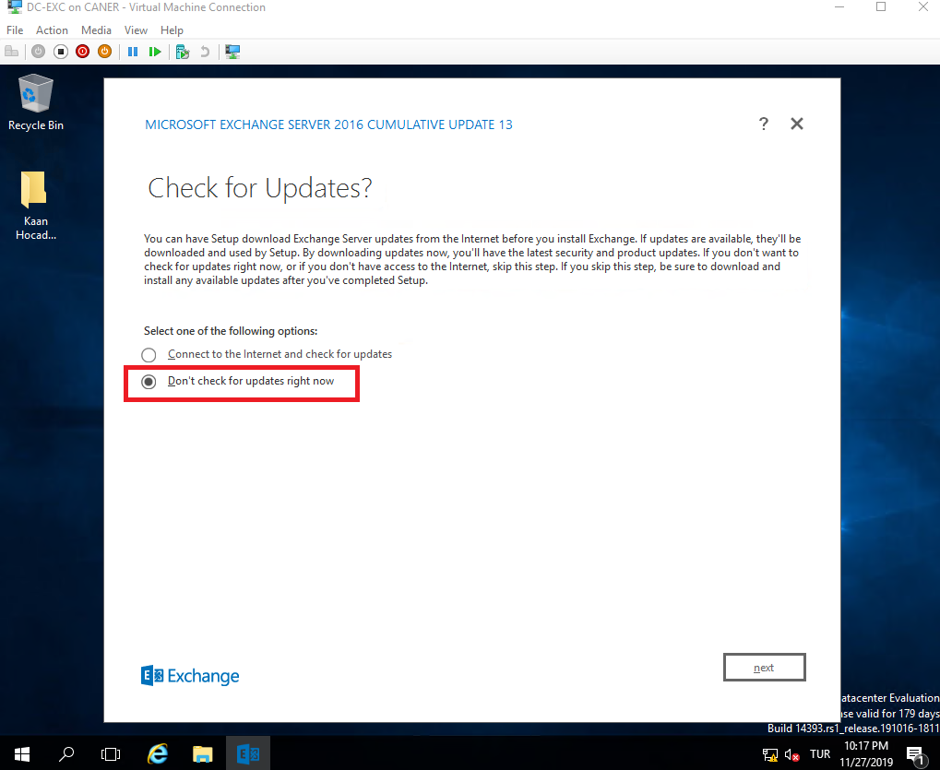

It starts to run…

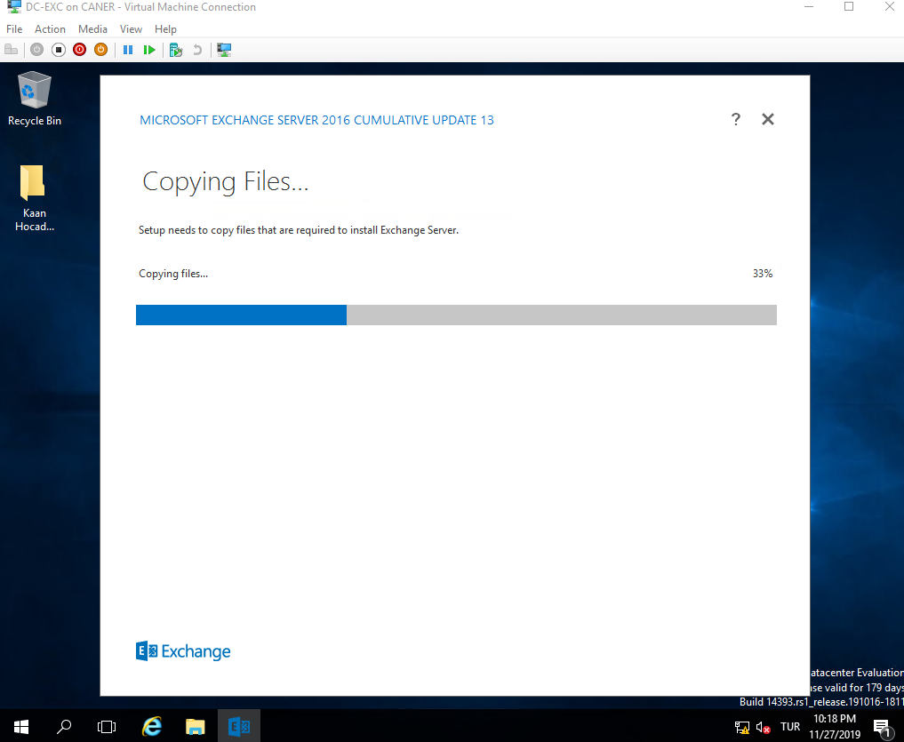

… and the Exchange Server is getting ready to set up.

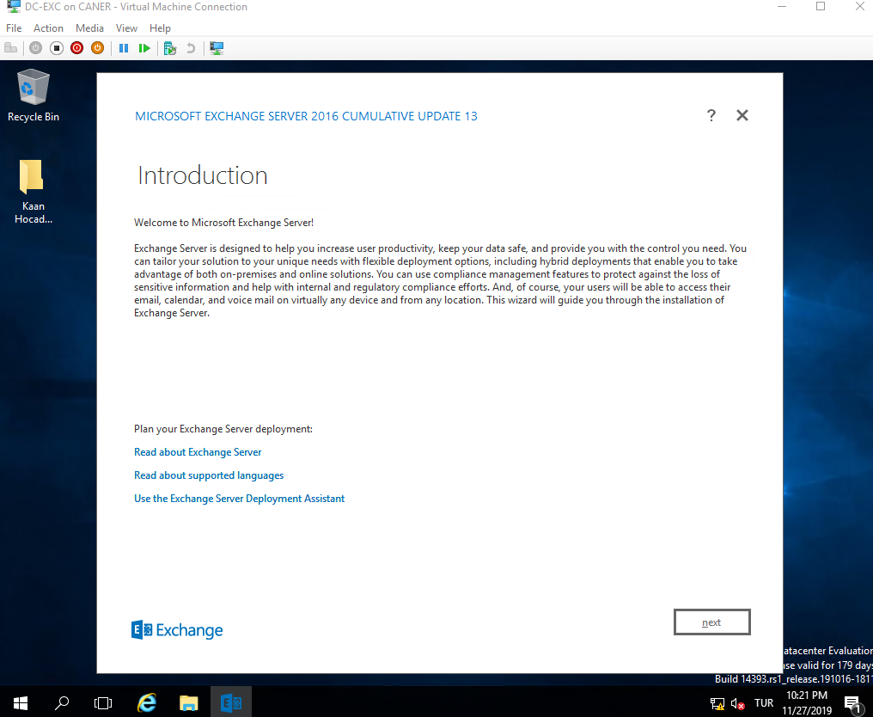

We agree the license agreement of course.

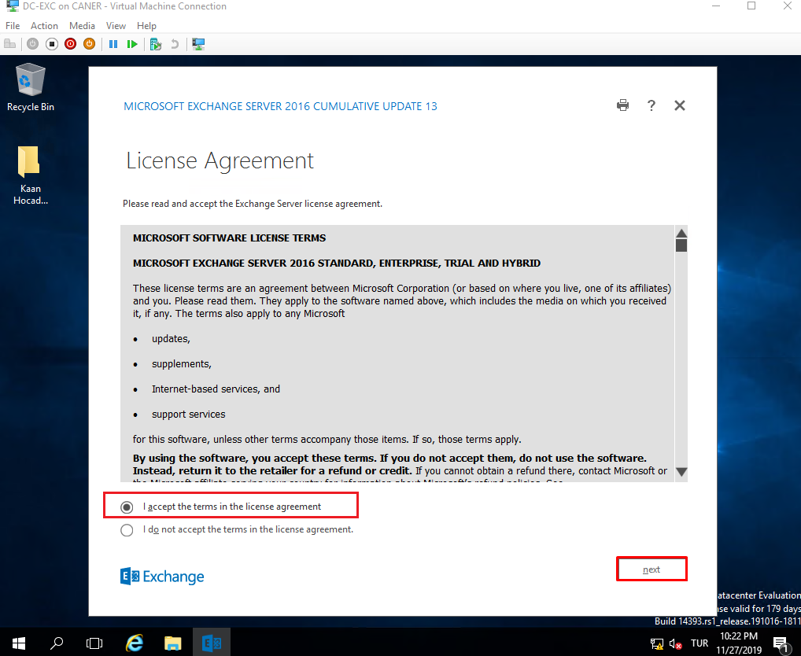

We use the recommended settings for the ease it provides.

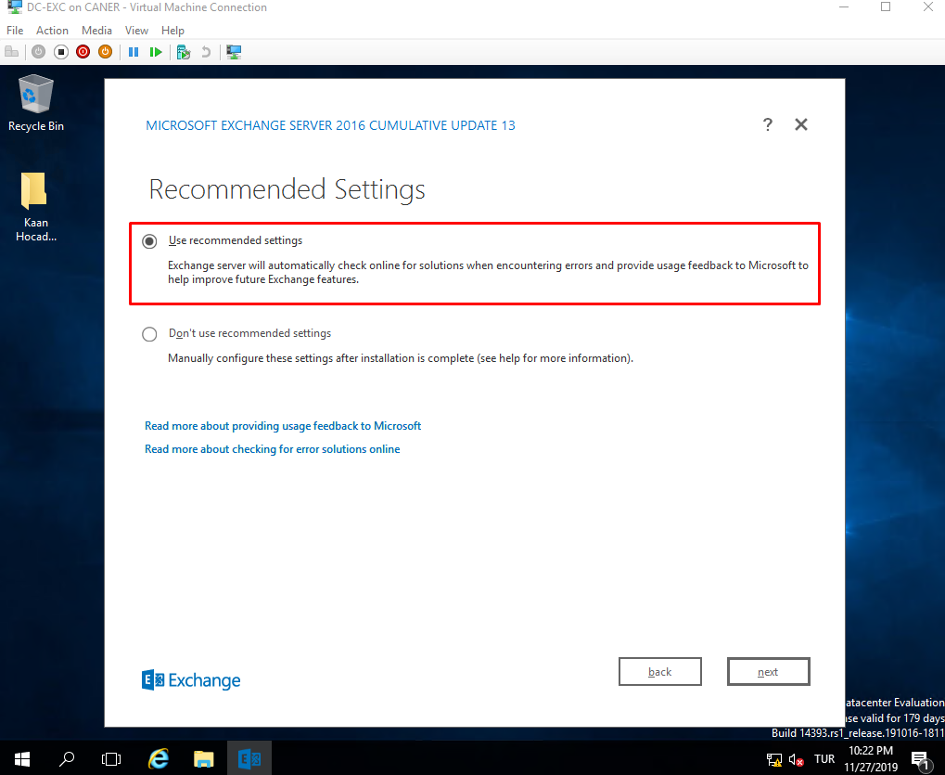

We choose the Mailbox Role and request it to automatically download roles and features it might need from Server 2016.

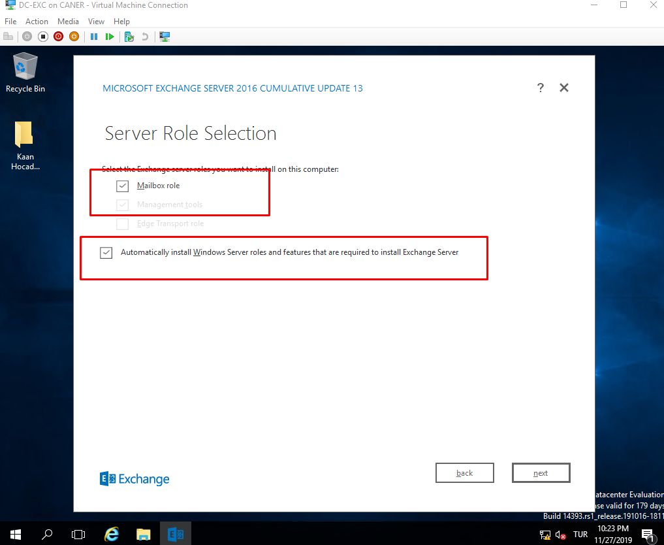

The default location has enough space, so we simply proceed.

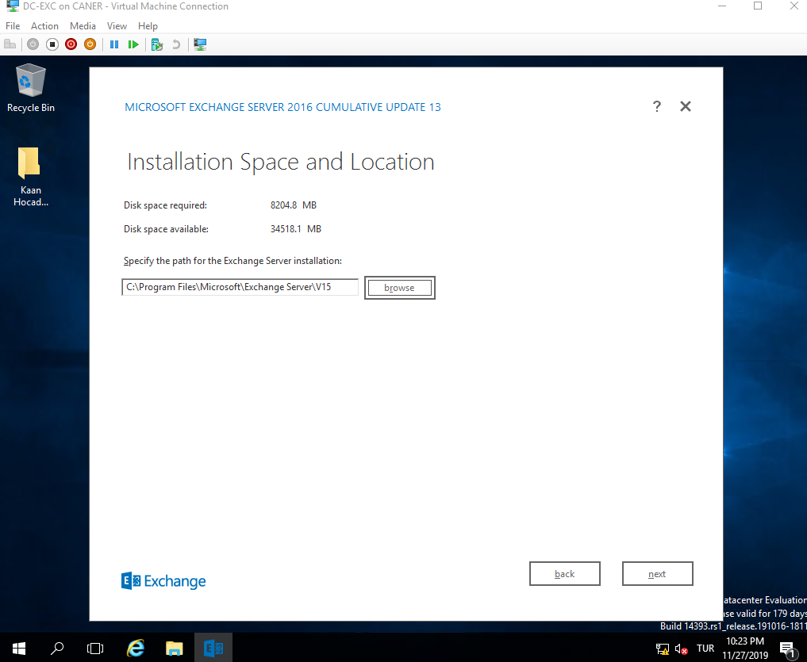

We didn’t change any setting on this page.

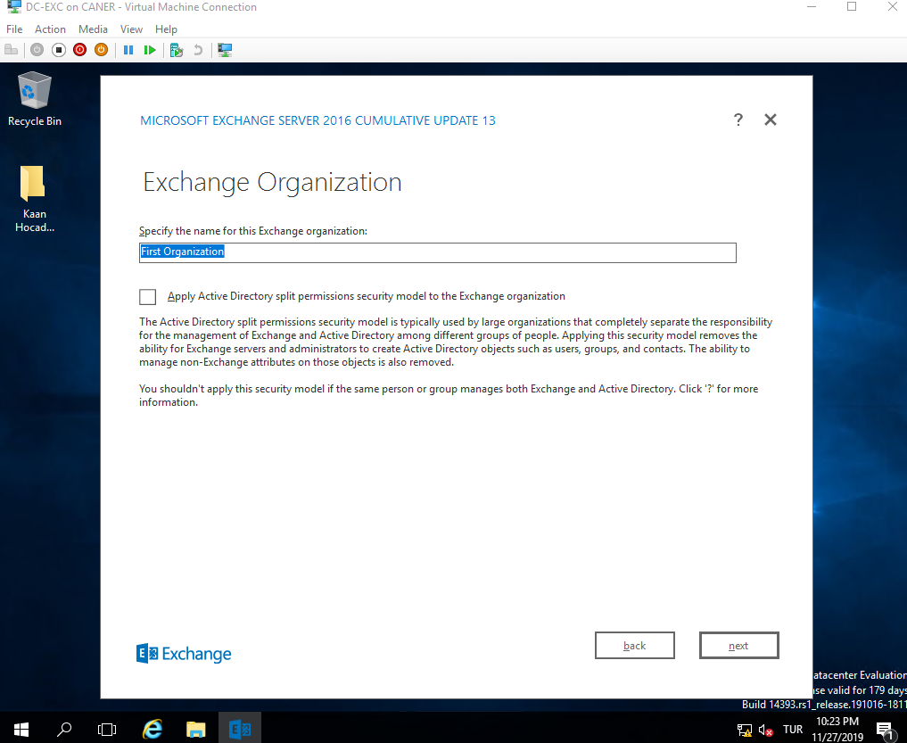

We want to disable malware scanning because it would prohibit our own internal e-mails as well.

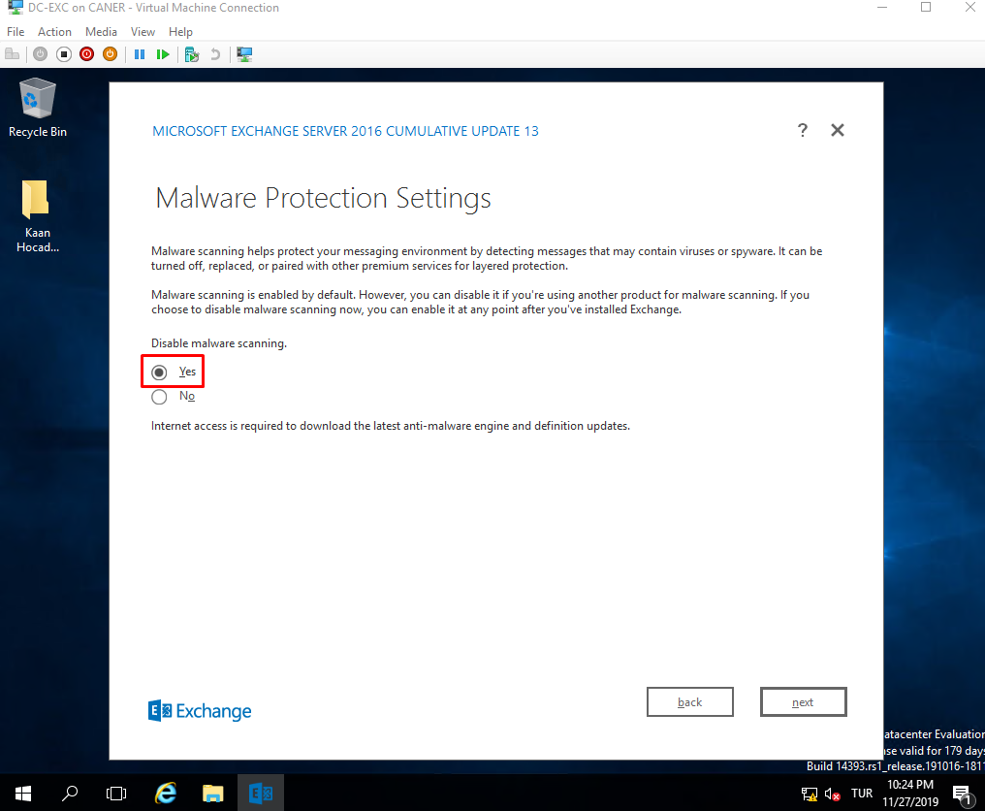

Then, the server does a Readiness Check.

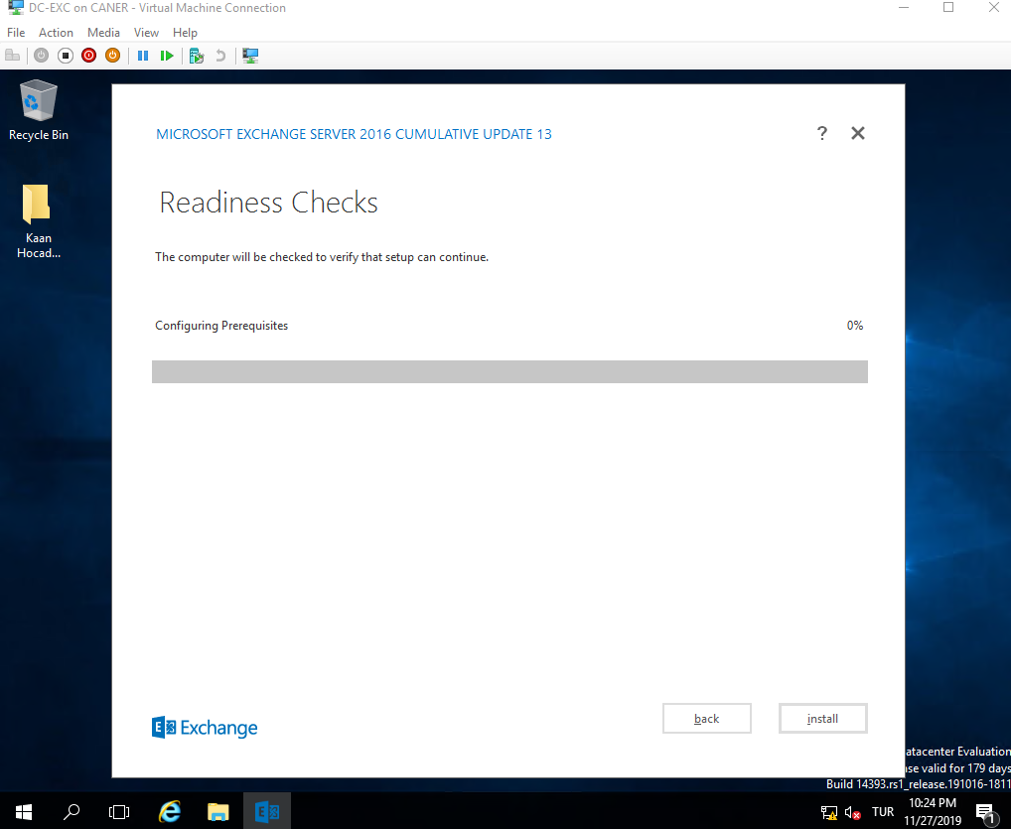

After the check is over, then we start the installation. The installation takes a very long while.

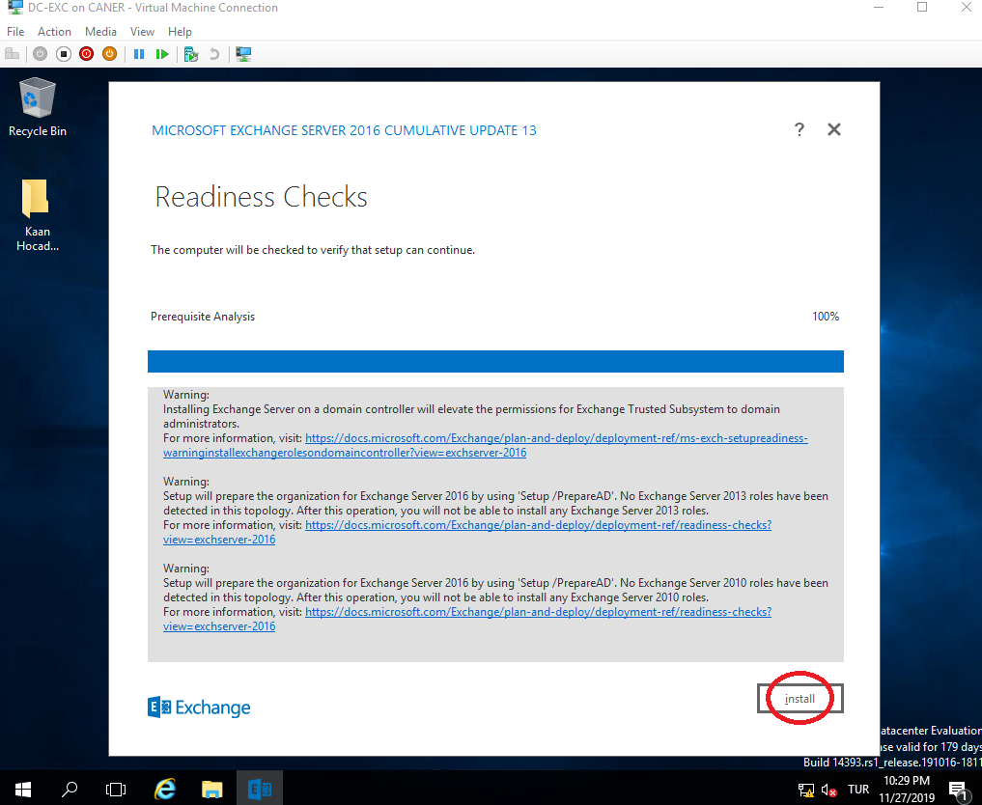

Once it ends, we need to reboot the server.

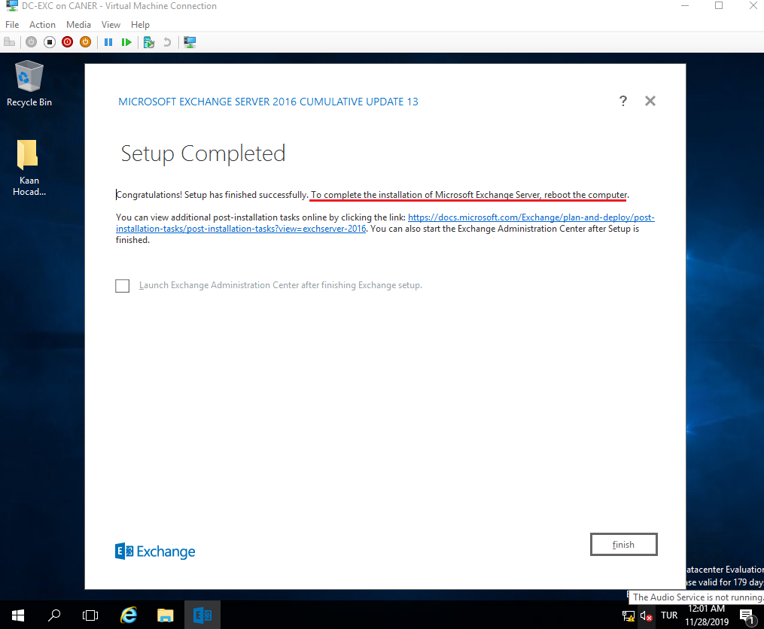

Then, we can start the Exchange Server 2016.

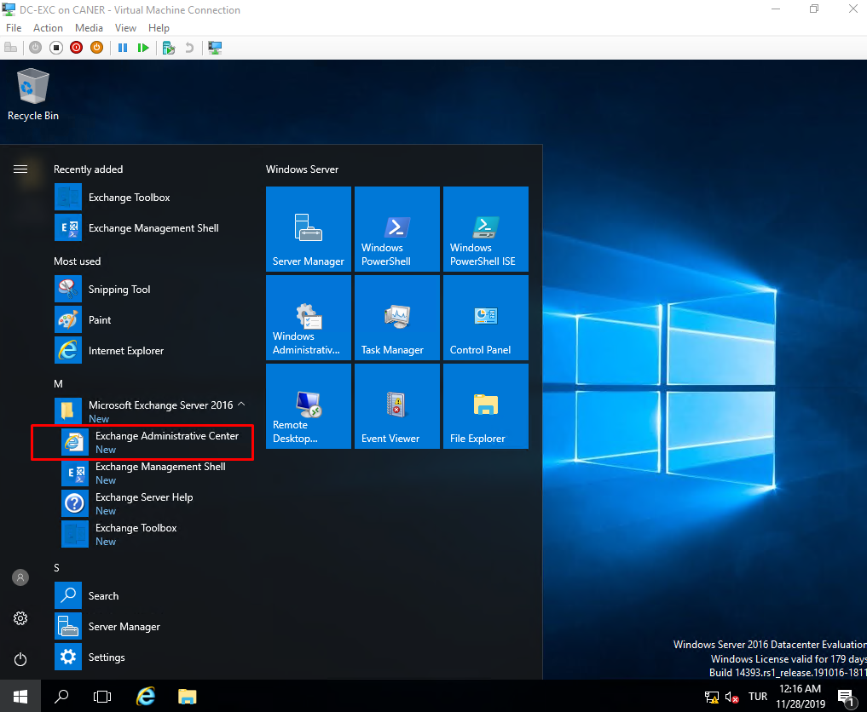

Then, we log in to the Administrator using the password from Active Directory.

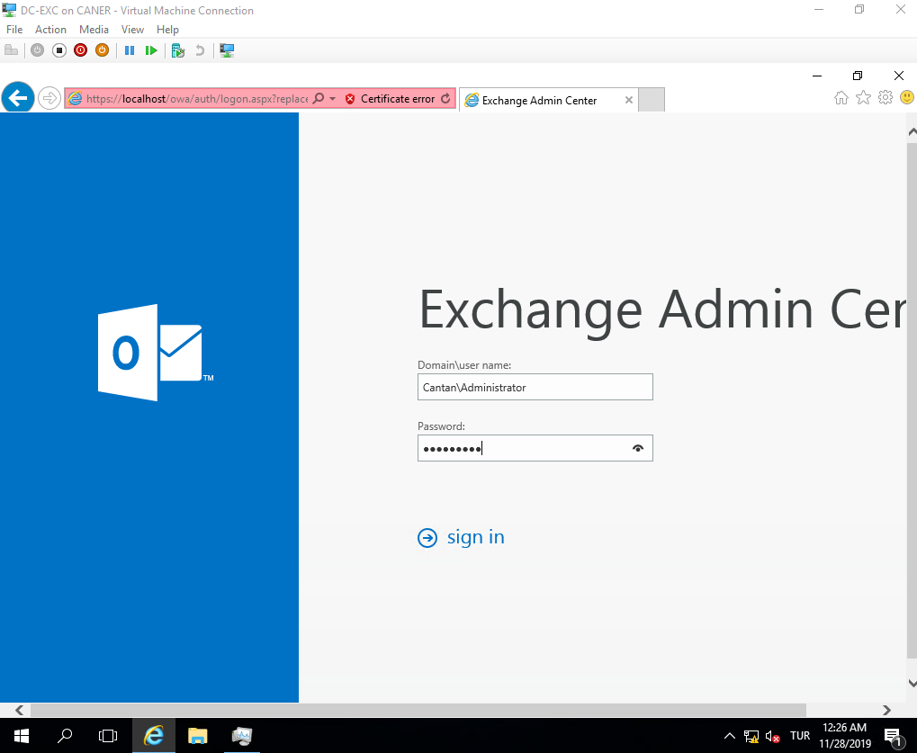

This is the opening page of Exchange 2016 Admin Center.

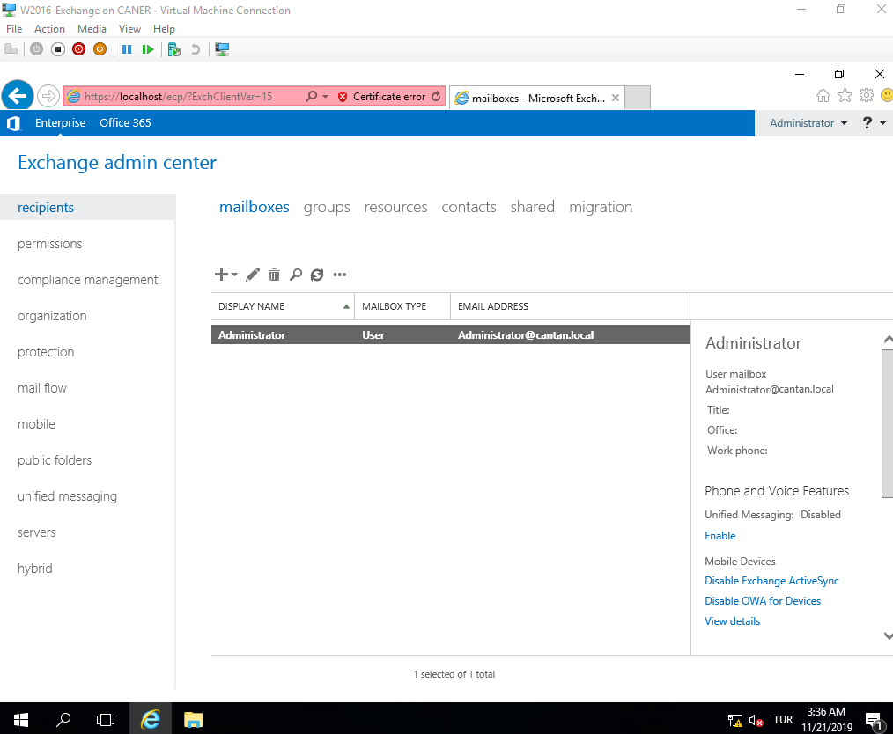

We want to change where our mailboxes are to specific physical drives. So, we add new hard drives to the virtual machine. The disks are named Backup, ExcLog and ExcDB.

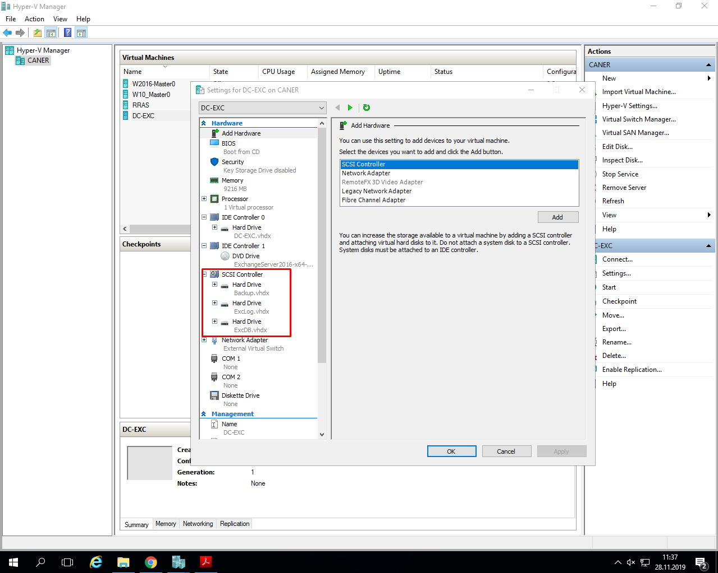

We want to change some settings, so we get to the Exchange Management Shell for ease.

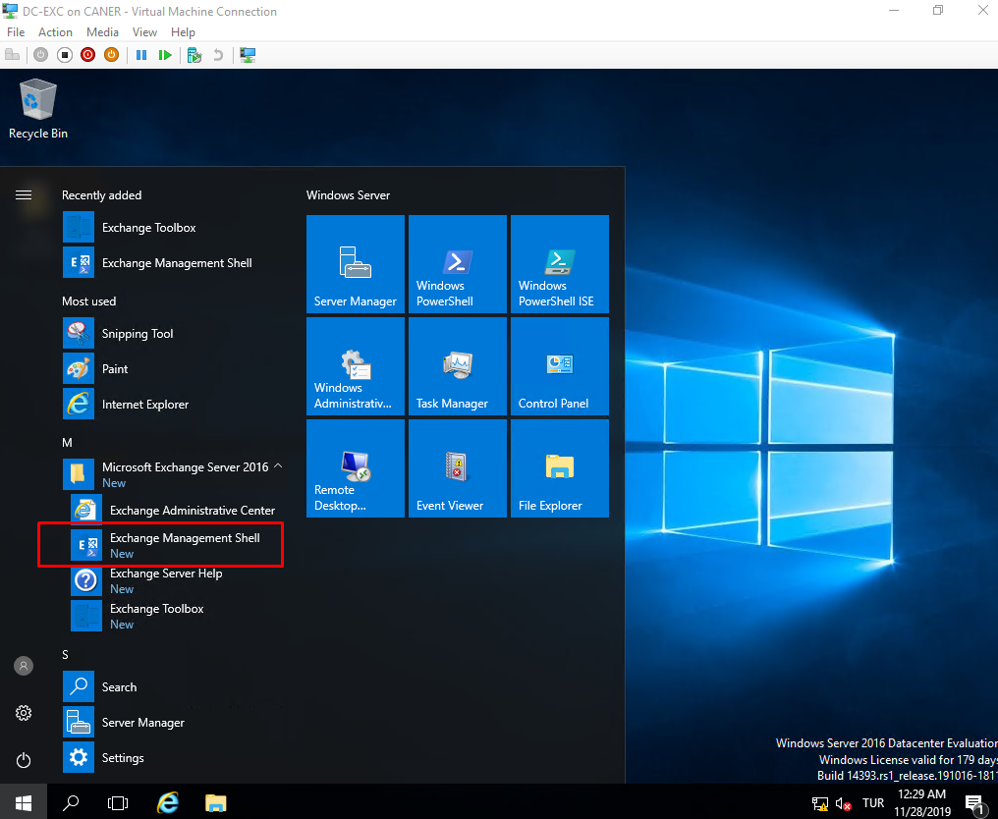

We type the following command to create a new mailbox database on the new drive we added: ExcDB. The database is called TestDB.

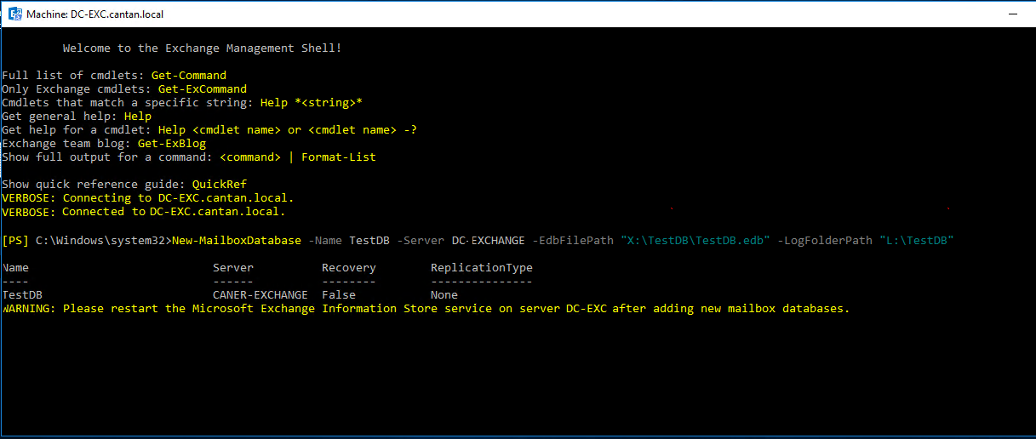

As you can see after creating the new mailbox database it is mandatory that we restart Microsoft Exchange Information Store service. However, it’s probably a better idea to restart the entire server.

We need to mount the new mail database to be able to use it for our new users.

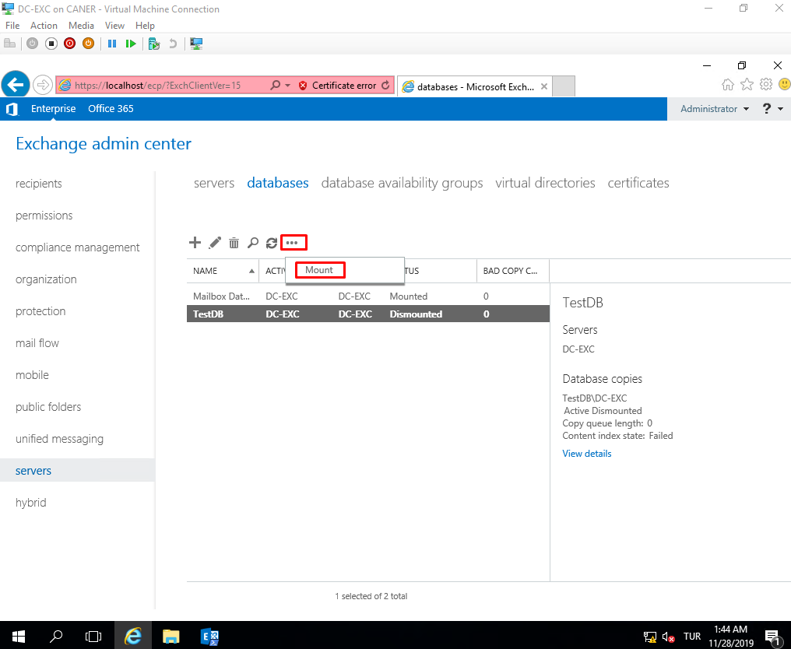

Then, we dismount the previously mounted default database since we no longer need it.

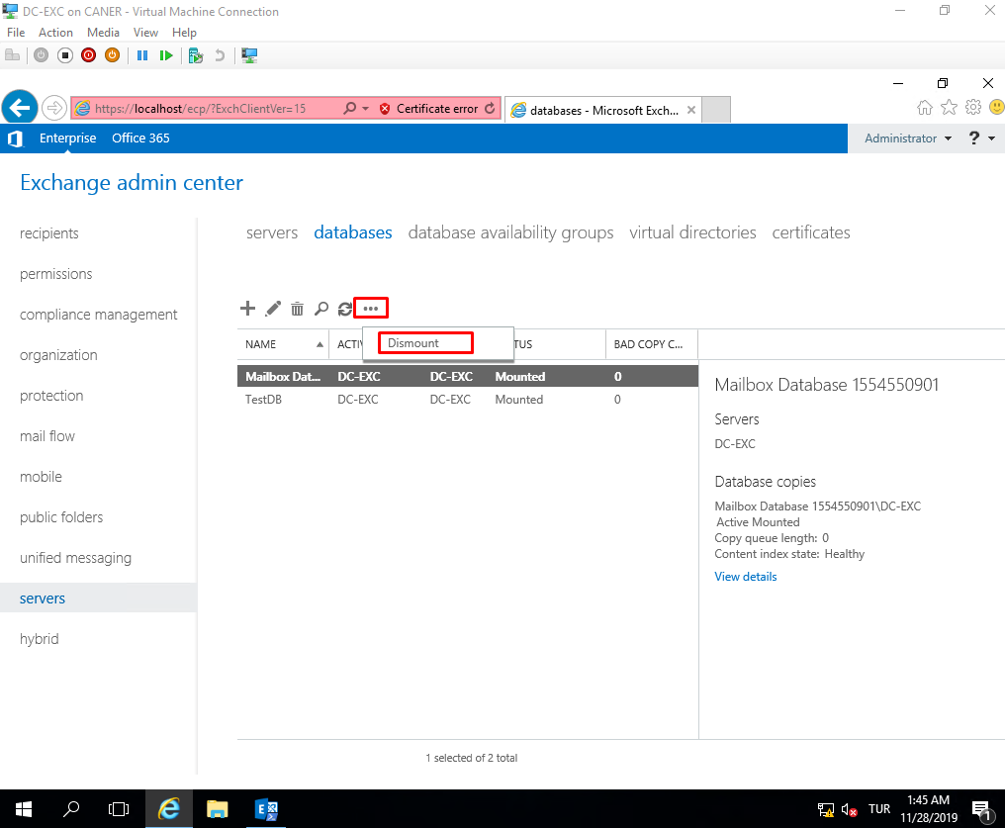

The unnecessary database is dismounted.

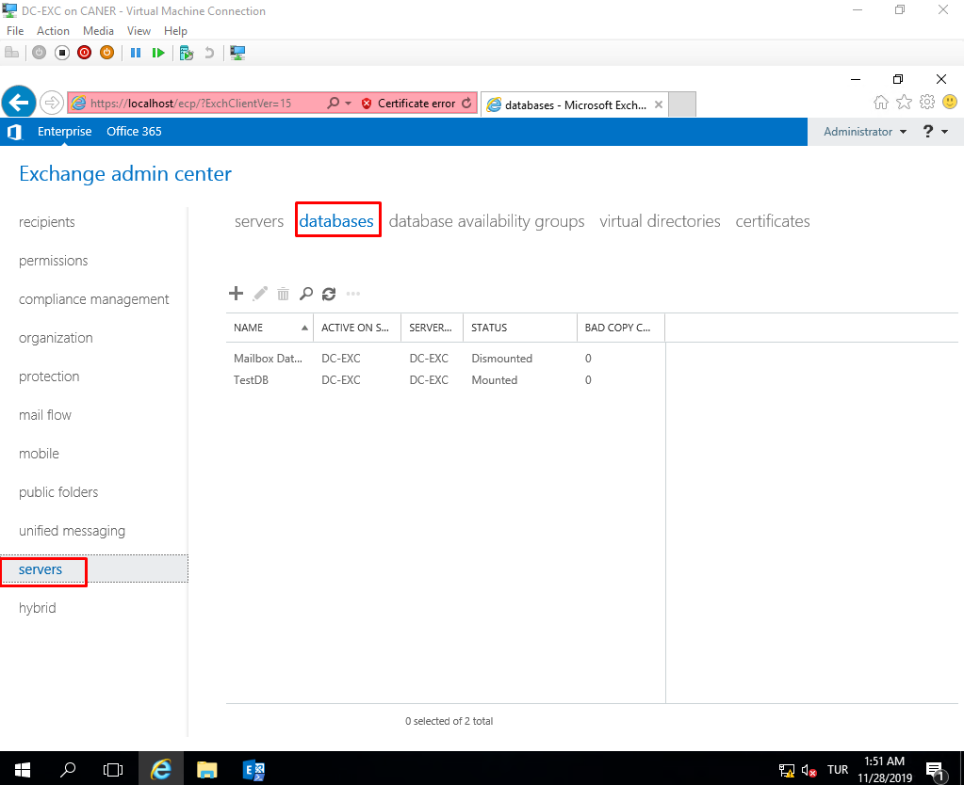

Then, we want to create new mailboxes for our users. Under recipients, mailboxes we click on the plus sign and select user mailbox.

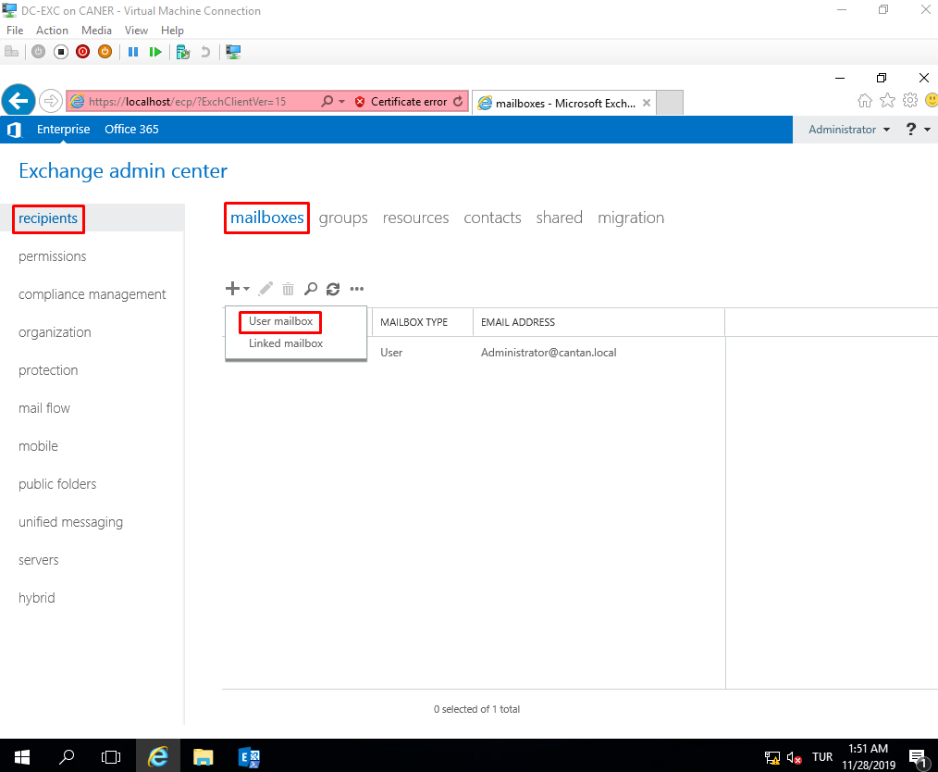

We enter the information of the new user. The logon name and password are crucial.

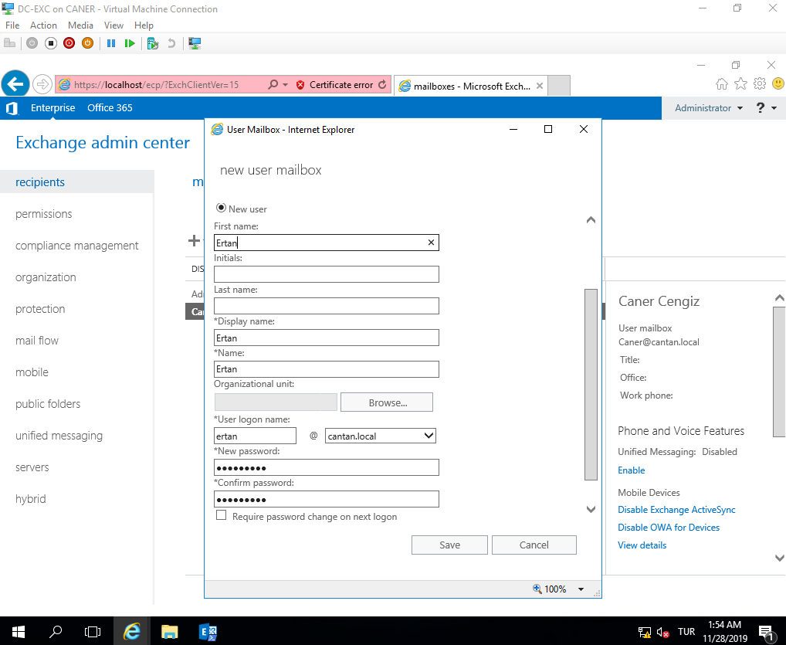

We can see that once we create a new mailbox on Exchange, the user account is automatically created on Active Directory. The vice versa is not true. For previously created users we’d have to link the mailbox to the AD account.

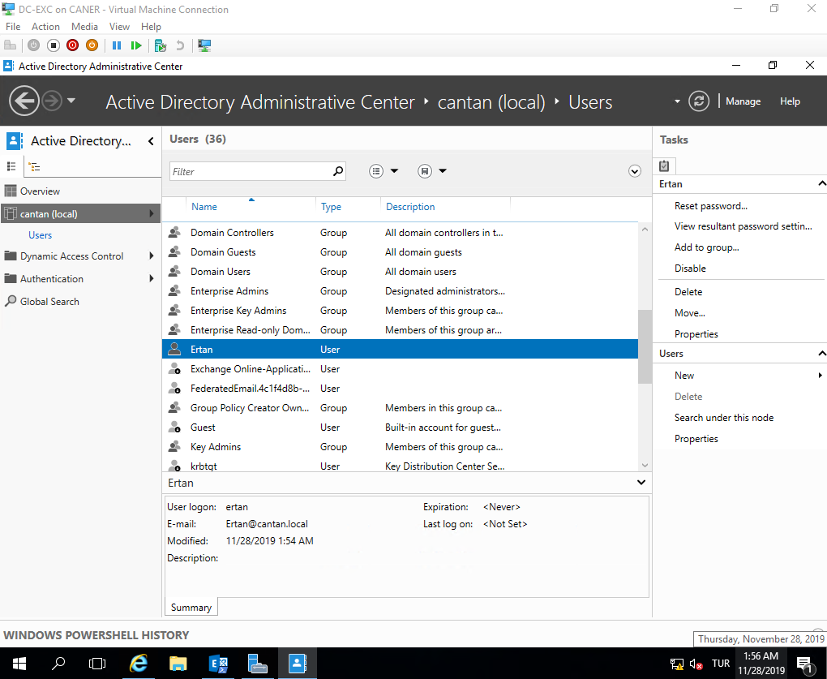

Now, let’s log in with the new user’s credentials and see its perspective.

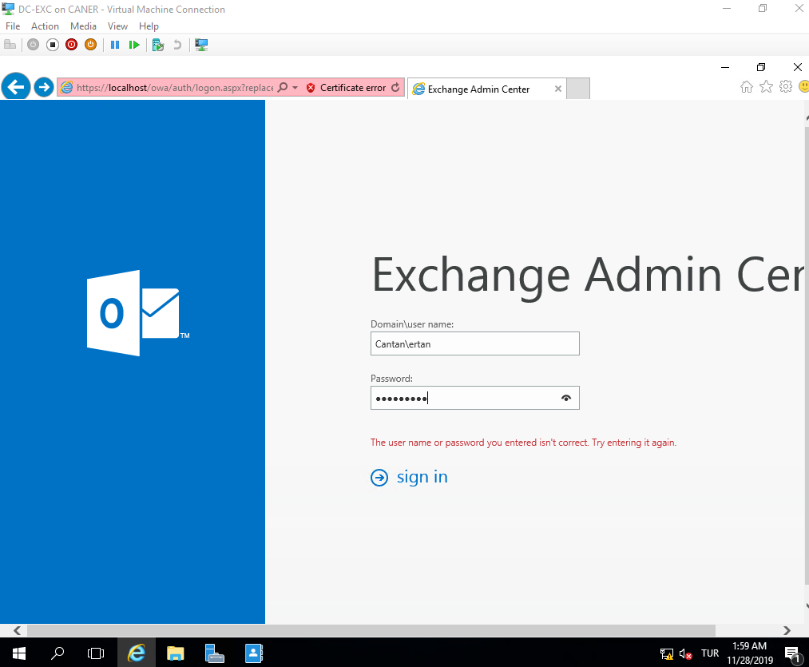

We set the time zone and language. I preferred the US because Exchange mails were less delayed due to how the host PC’s were set up.

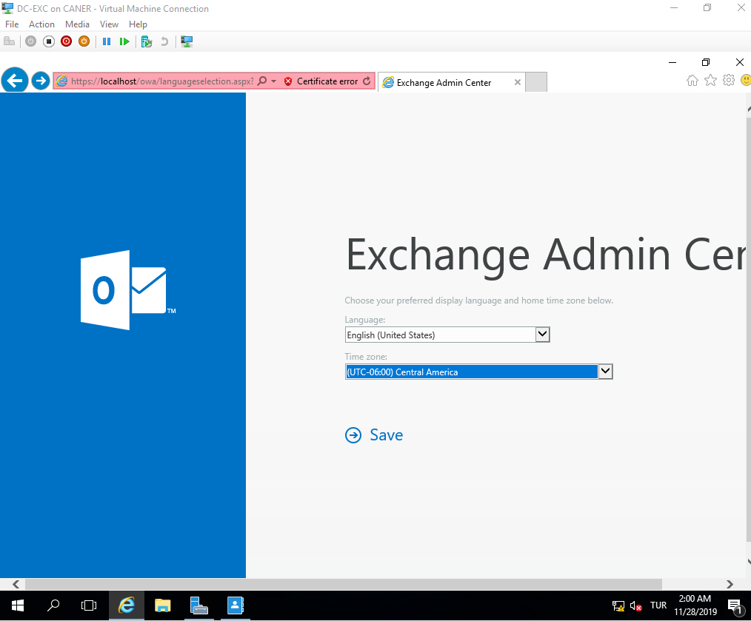

We can see the limited, because this user is not an admin, Exchange Control Panel but let’s proceed to sending and receiving e-mails. We choose my mail from top right click down menu.

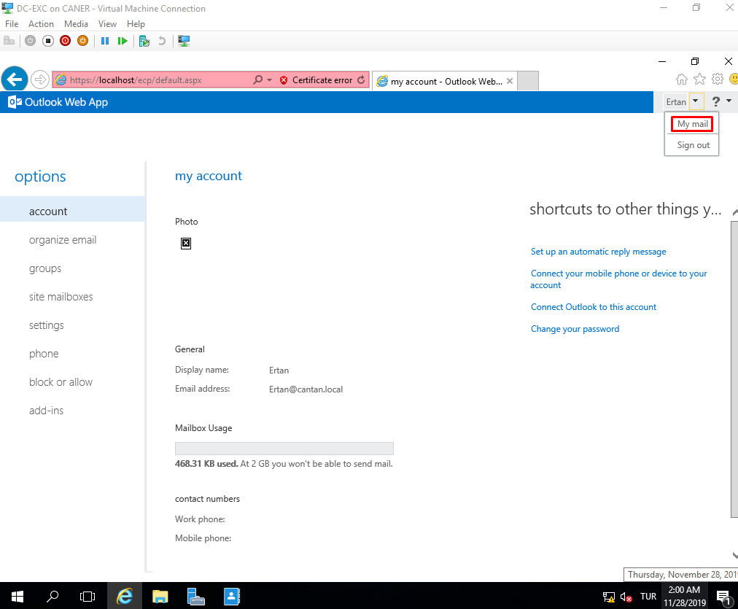

This brings us to a mail manager screen that is easy to navigate. Let’s test sending an e-mail to a previously created mailbox.

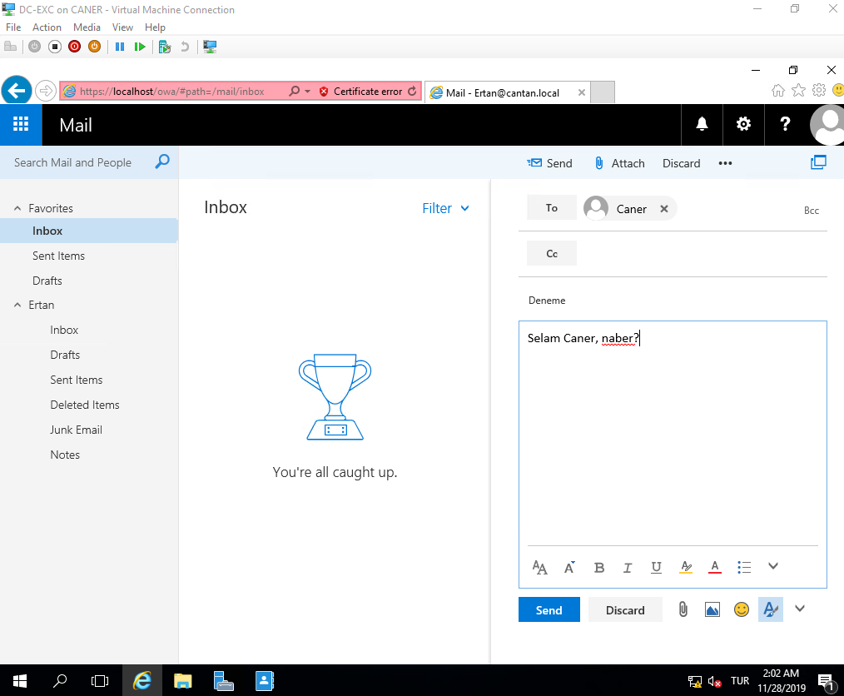

When we get to the recipient’s mailbox, we can see user Ertan’s e-mail. The Exchange Server is working properly!

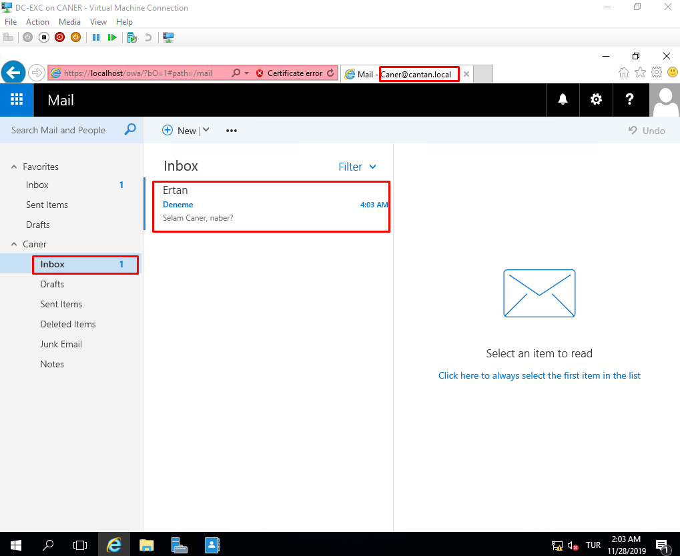

Now we have a server that’s not connected to the internet by itself because and it can send and receive e-mails, at least on its own domain, so far. What do we do if we want to send e-mails to other domains or our gmail e-mail addresses? Getting a specific static Public IP is an option but getting the server directly to the internet is a huge security breach. We could use a firewall or a RRAS server. Since firewalls are the subject of another report, for variety I shall demonstrate the establishment of a Routing and Remote Access Service on another server.

On another Server 2016 PC we add the role of Remote Access. Note that this PC is also in the domain cantan.local and has at least 2 NICs; one for communicating with our local domain and one for connecting to the internet.

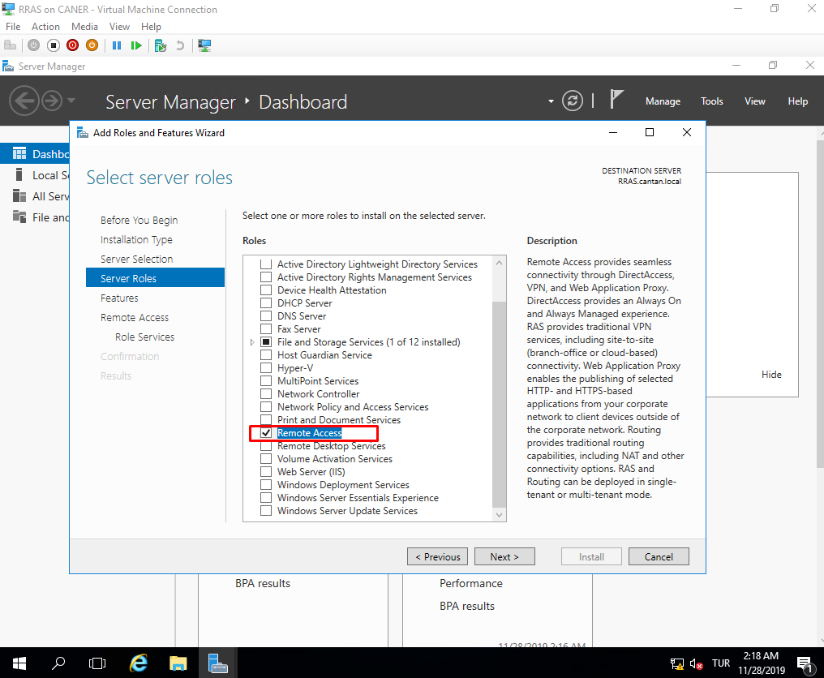

We will be mainly using routing property; however, it’s possible to use a RRAS Server for VPN or Web Application Proxies.

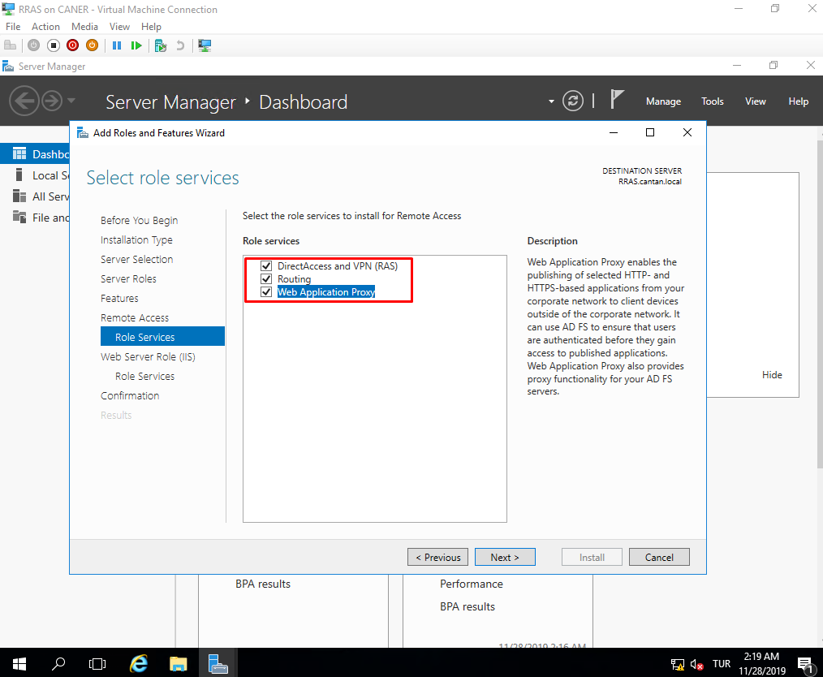

We use the Wizard to do the configuration easily.

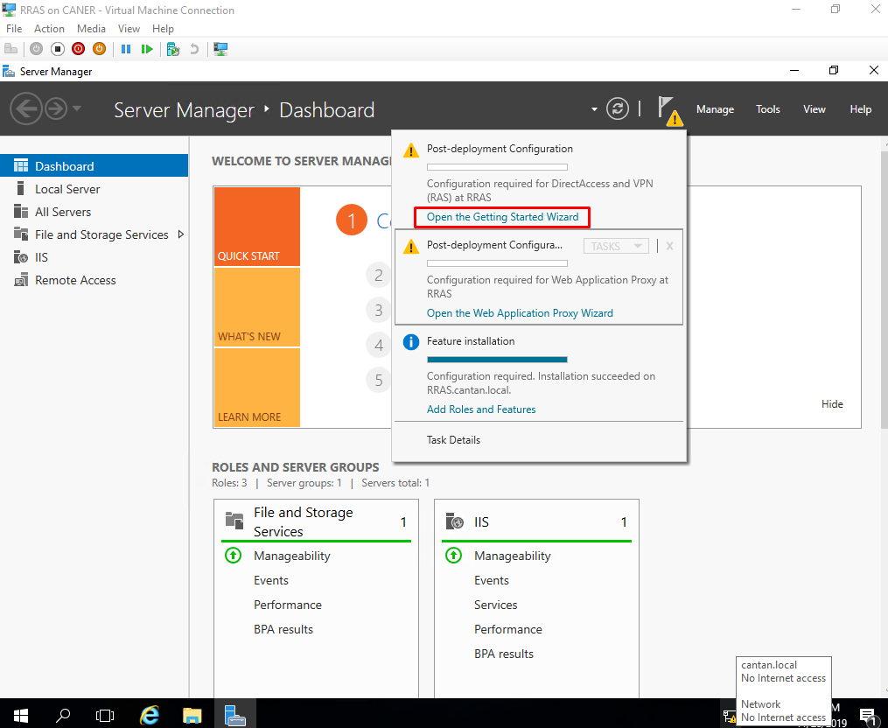

We continue with the recommended setting even though we will only be using Direct Access.

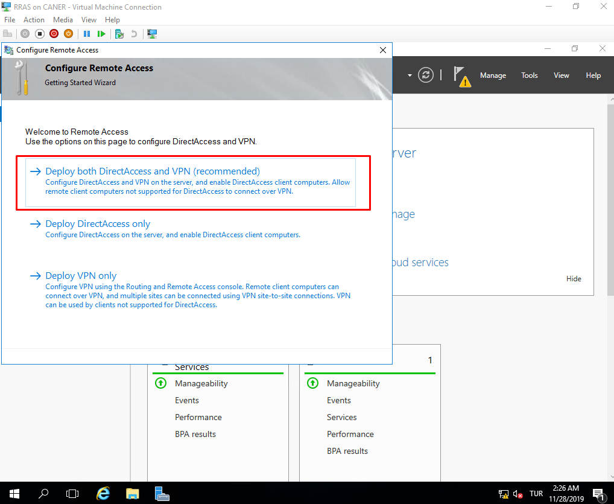

Since this Server will be directly connected to the internet, we must select edge.

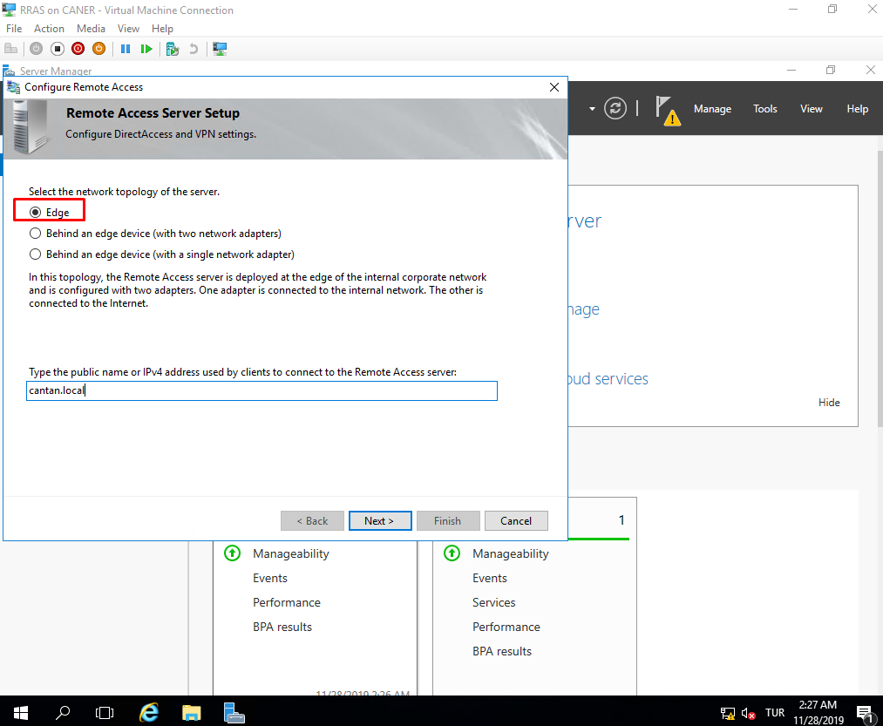

Then we open the Routing and Remote Access tool.

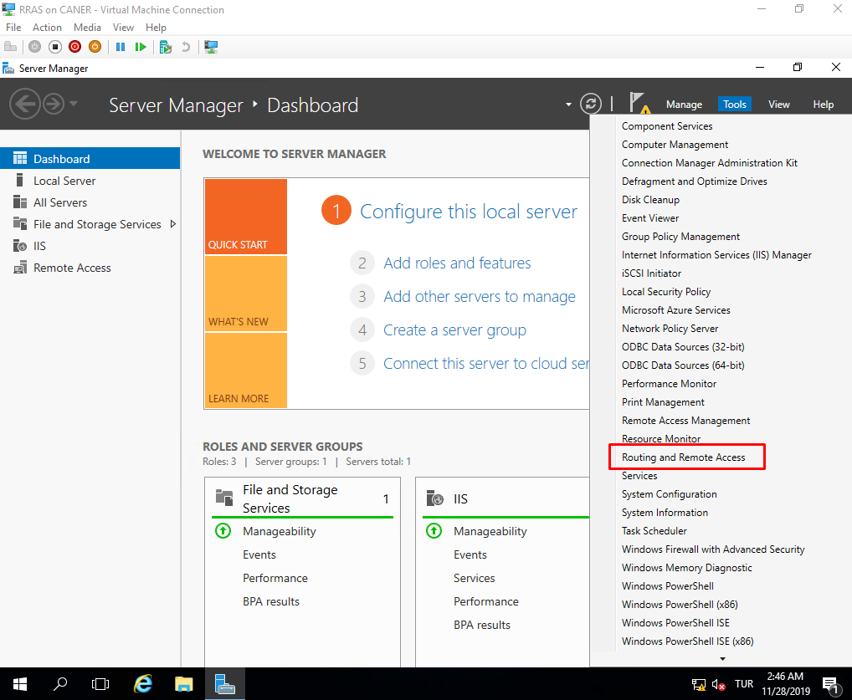

We select Configure and Enable Routing and Remote Access.

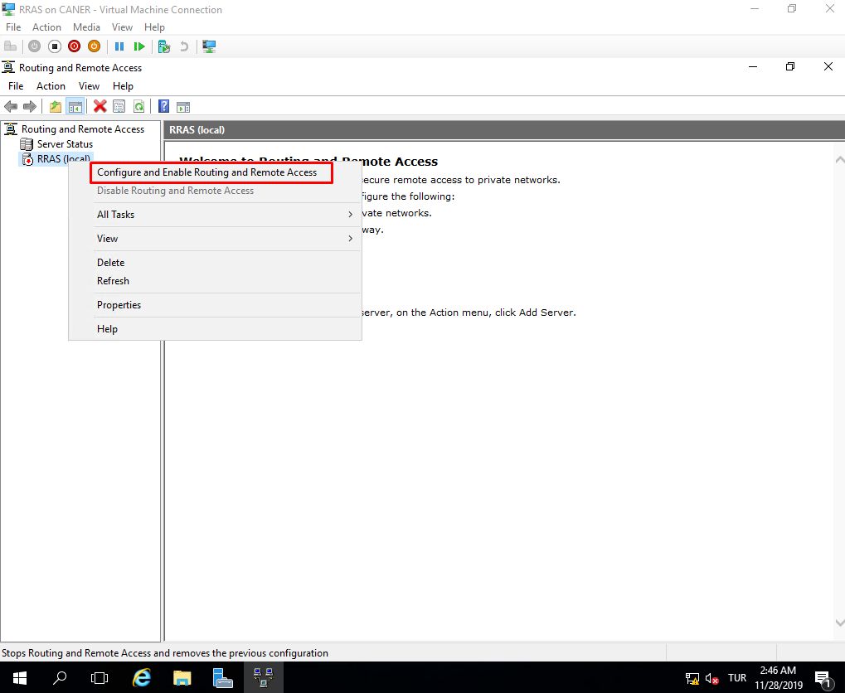

Another setup Wizard pops up.

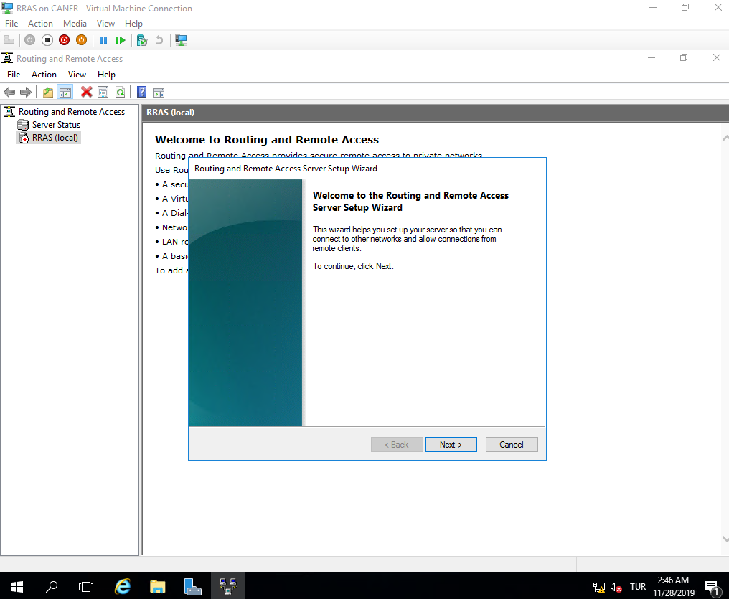

We want the RRAS Server to do NAT.

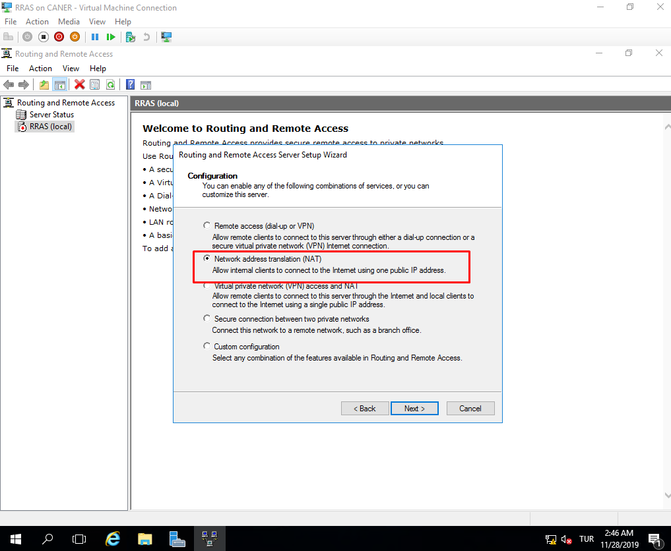

As this is the first time we’re establishing it, we must create a new interface.

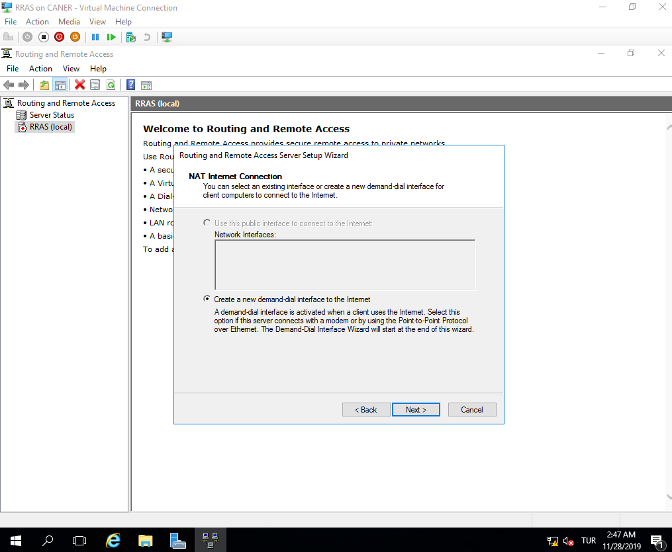

We choose the correct interface necessary for connecting to the internet. In this case, this is the interface where BAU distributes IPs via DHCP as we use its internet.

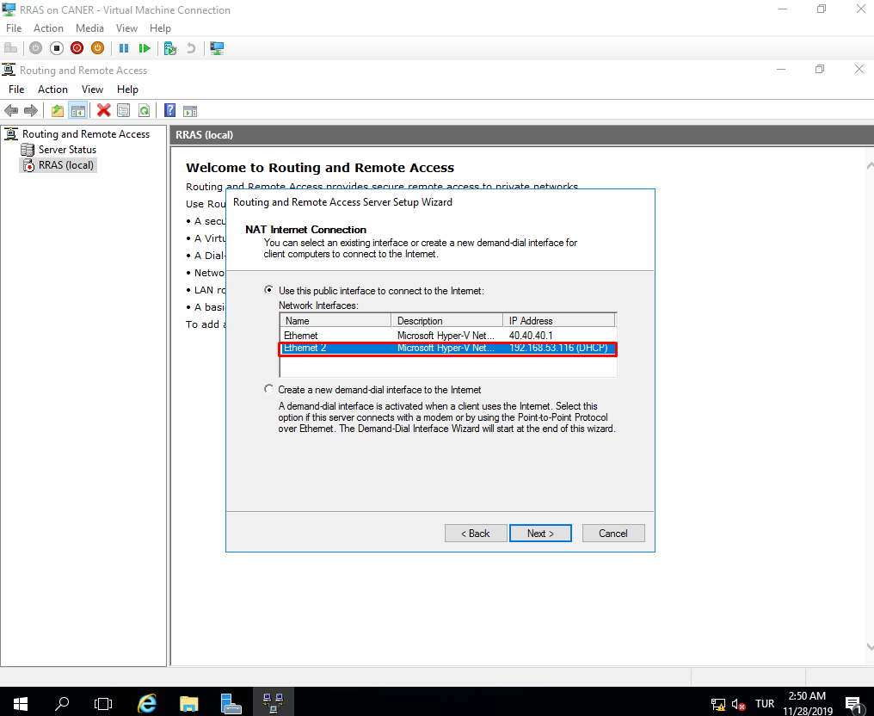

Then, it starts to establish the connection. Once the red down arrow next to RRAS(local) turns to a green up arrow we’re set.

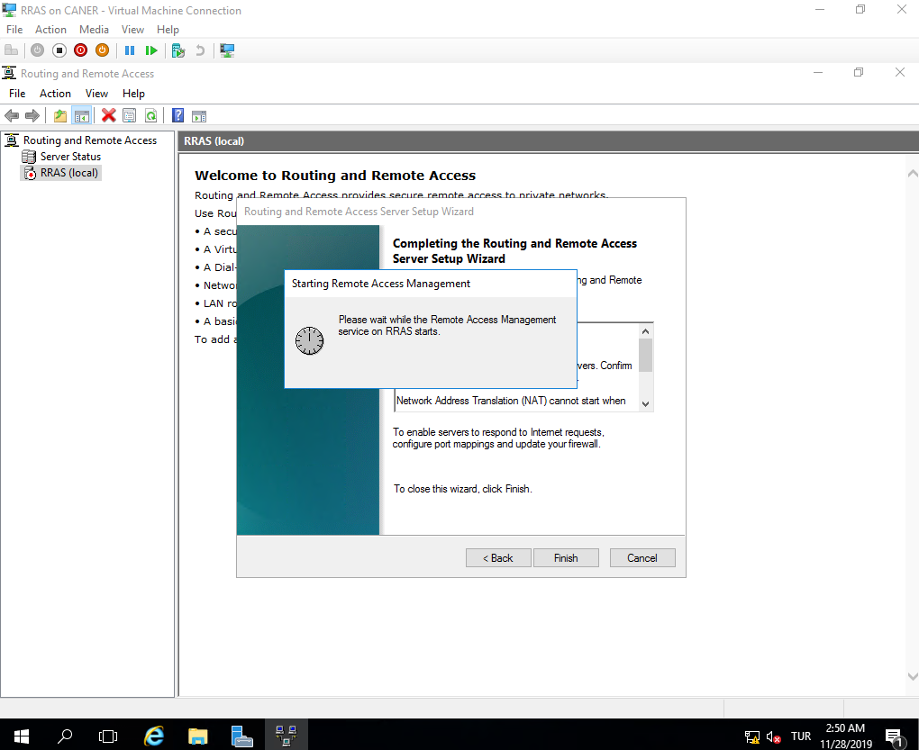

Now, we test if it worked by going back to our Exchange Server and pinging Google’s DNS.

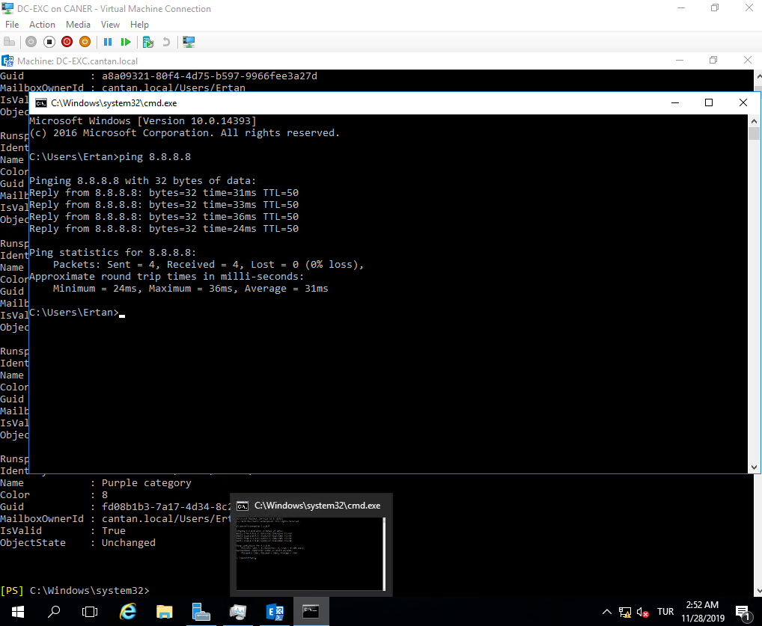

We can see that it worked. The Exchange Server can access the internet while it still has a private static IP.

Now we want to send and receive e-mails over internet. Firstly, we must configure RRAS Server’s properties to allow SMTP and POP3 protocols. We do so by right clicking the interface that’s connected to the internet.

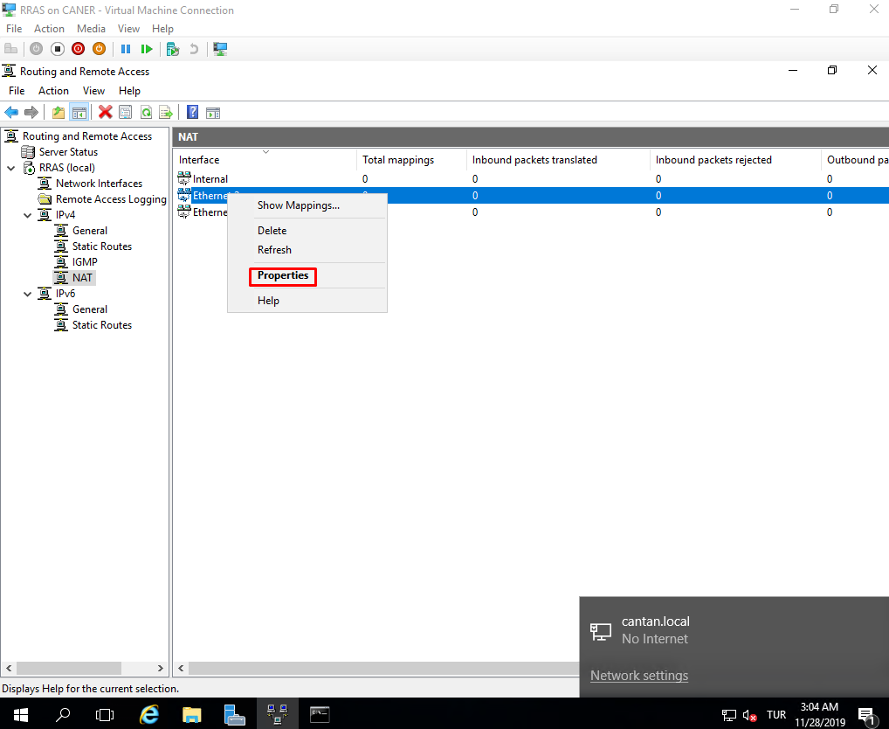

(Also, note that the arrow is green and up.)

Under Services and Ports we enable SMTP and POP3 protocols.

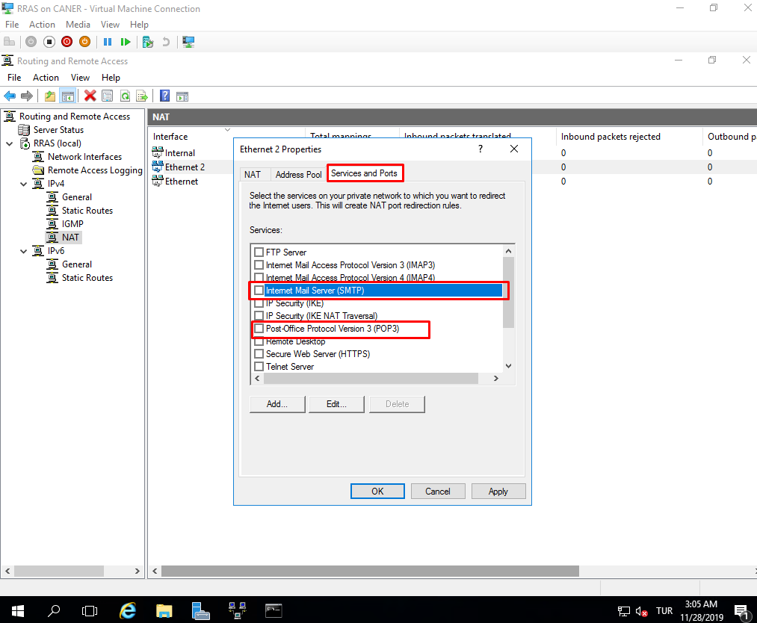

For both we enter the Exchange Server’s IP to forward the SMTP and POP3 protocols.

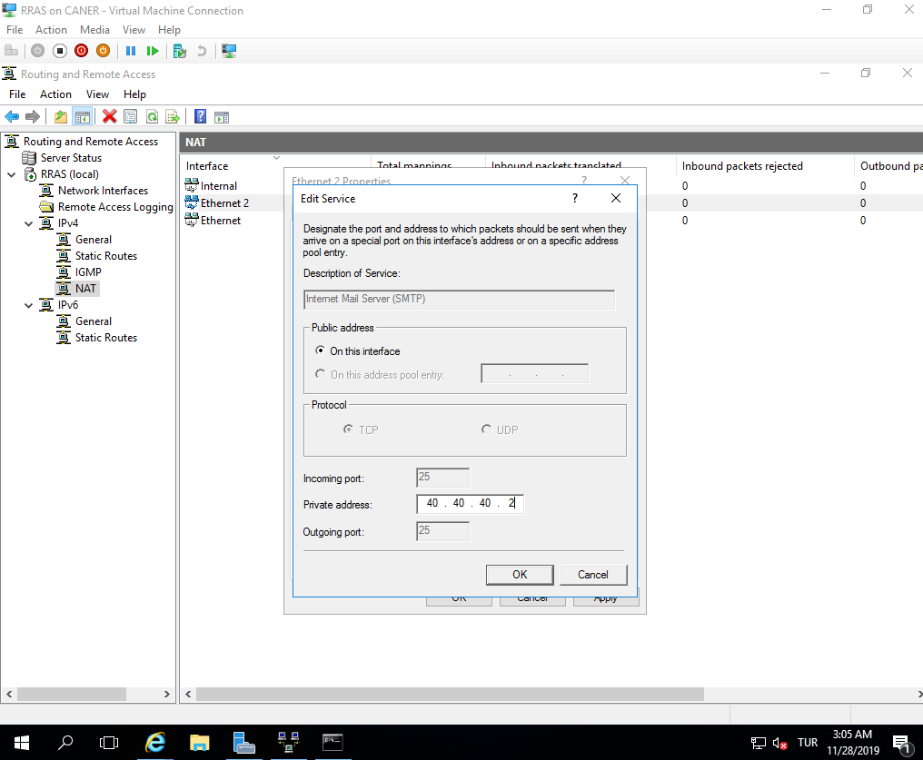

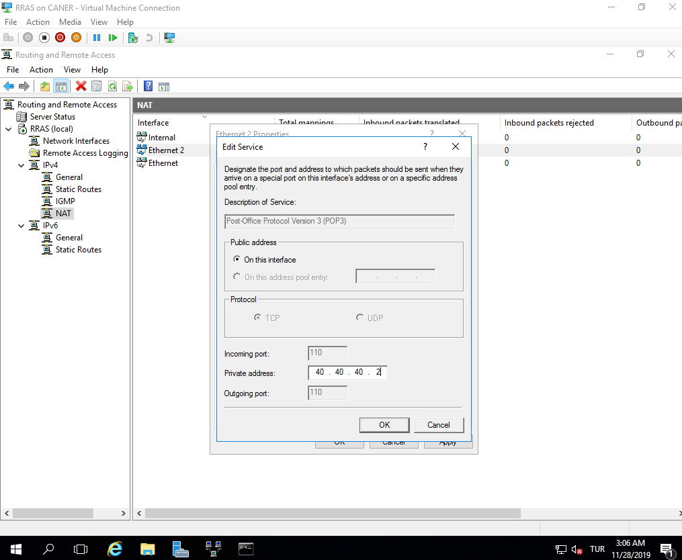

We also need to allow these on the Exchange Server. Using the administrator account’s ECP we get to Send Connectors under Mail Flow and add a new one. We obviously select Internet.

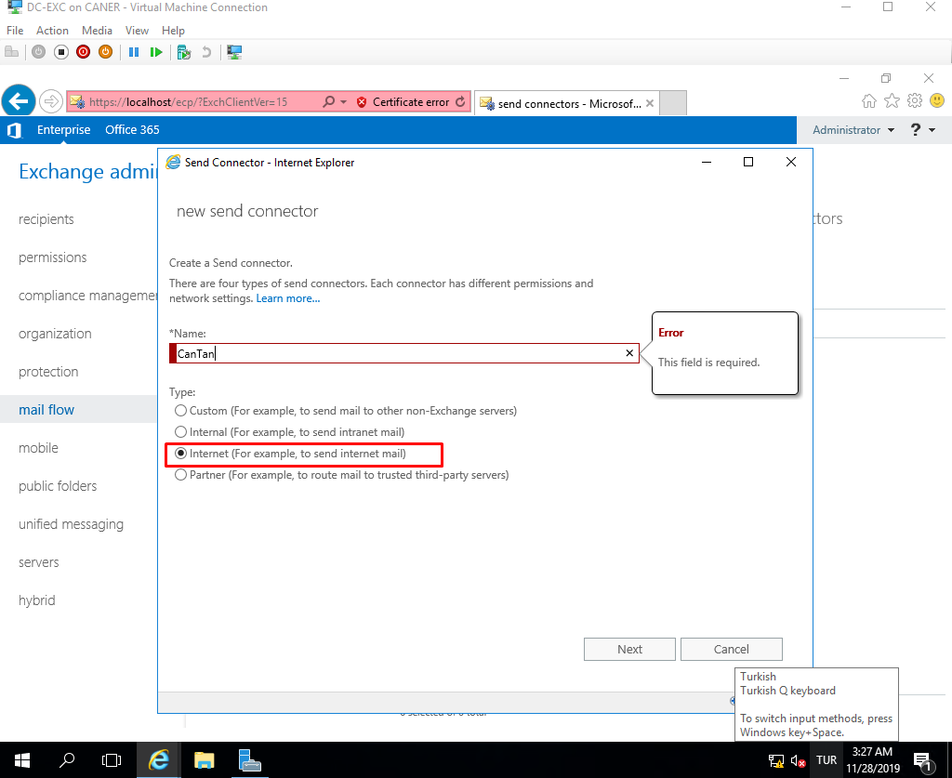

We use the MX record associated with the recipient domain instead of a smart host.

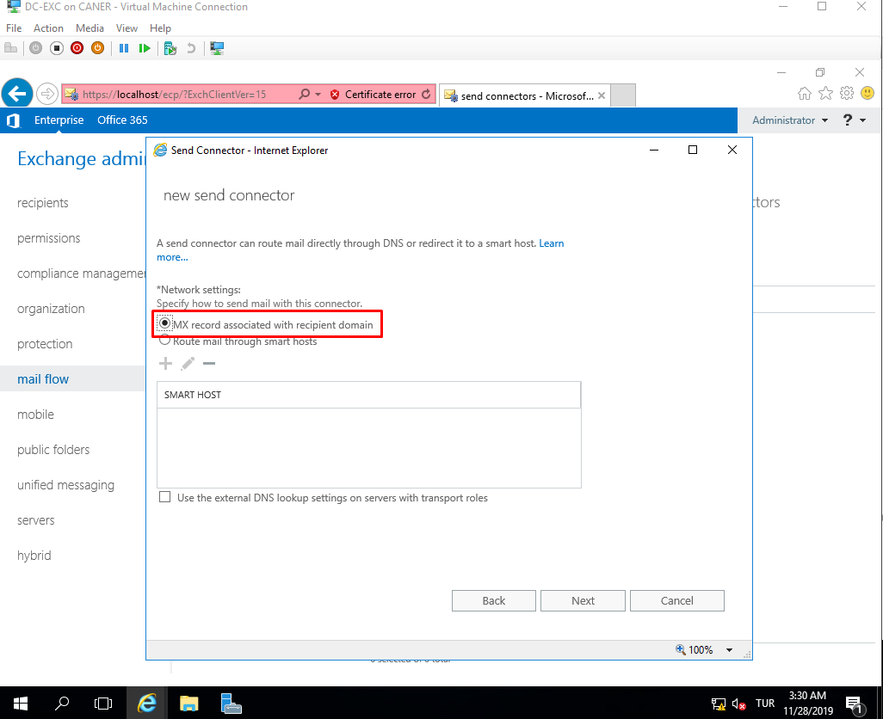

The “*” under domain for the SMTP rule means it can send to any domain.

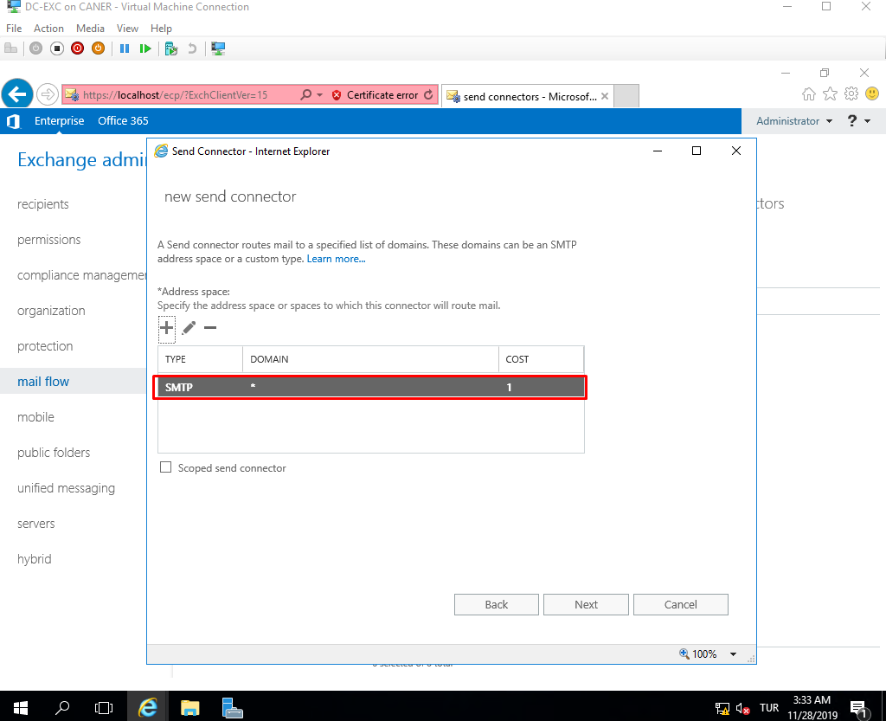

The source server is itself.

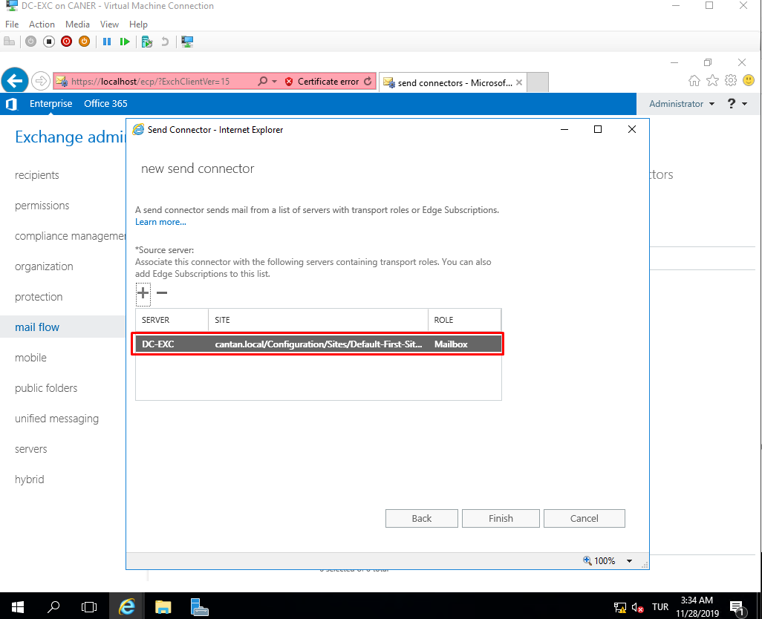

After this is done it can send e-mails to any e-mail address that can be resolved by a DNS such as a gmail address. However, before we send an e-mail let’s also add a disclaimer to all of our e-mails from this domain as extra flair. To do this, we click on the plus sign and select apply disclaimers under Rules which is under Mail Flow.

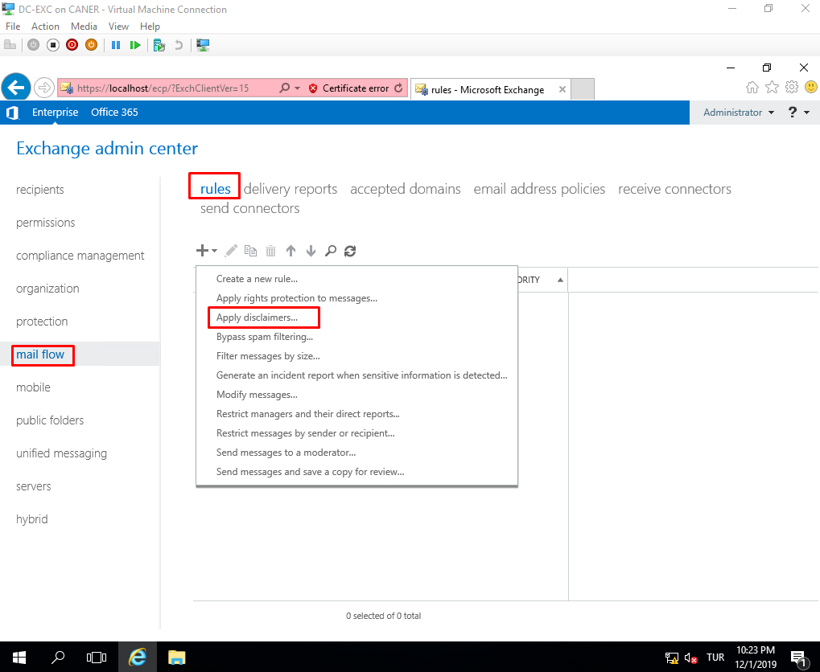

We set the rule so that anytime we send an e-mail outside of this domain, the mail says a little greeting from this domain. Many corporations use disclaimers to mention their addresses and other contact information along with a greeting to officiate the e-mails.

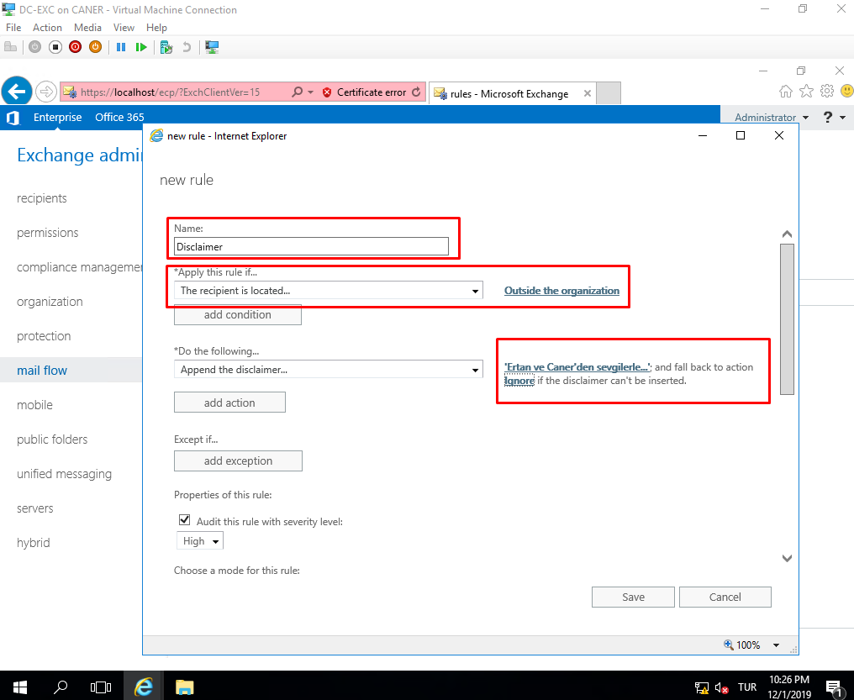

Then, we send an e-mail to a gmail account.

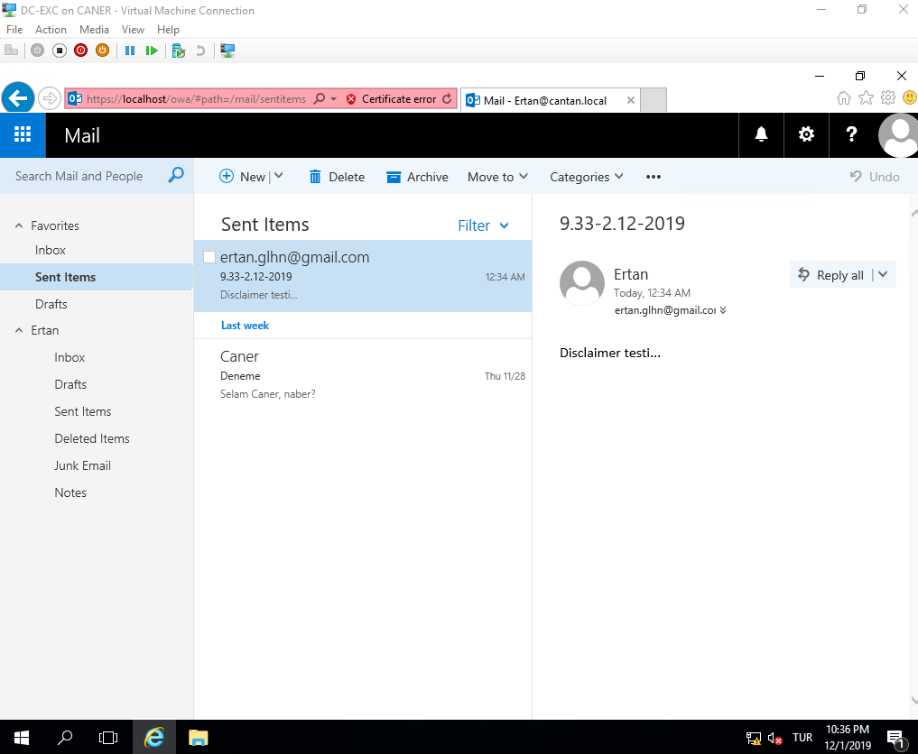

As you can see not only did we receive this e-mail, but also we’ve got to see the disclaimer.

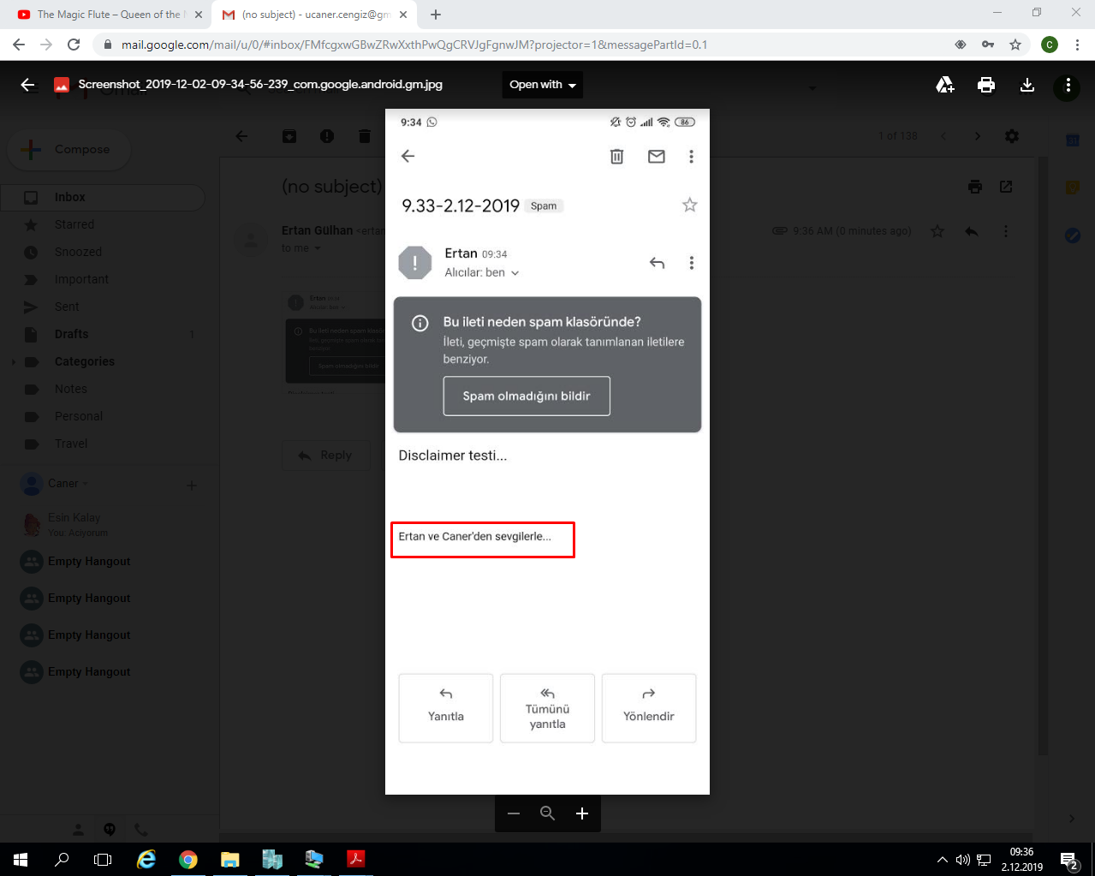

Now we can send an e-mail to any known mail address on the internet. Sadly, to be able to receive an e-mail from anyone we’d have to buy or rent an internet domain address so that our server can be found by a DNS. Currently, we can only send e-mails outside of our domain.

Now that we have sent and received some e-mails. Let’s back them up for safe keeping. We’ll use the Windows Server Backup feature for this.

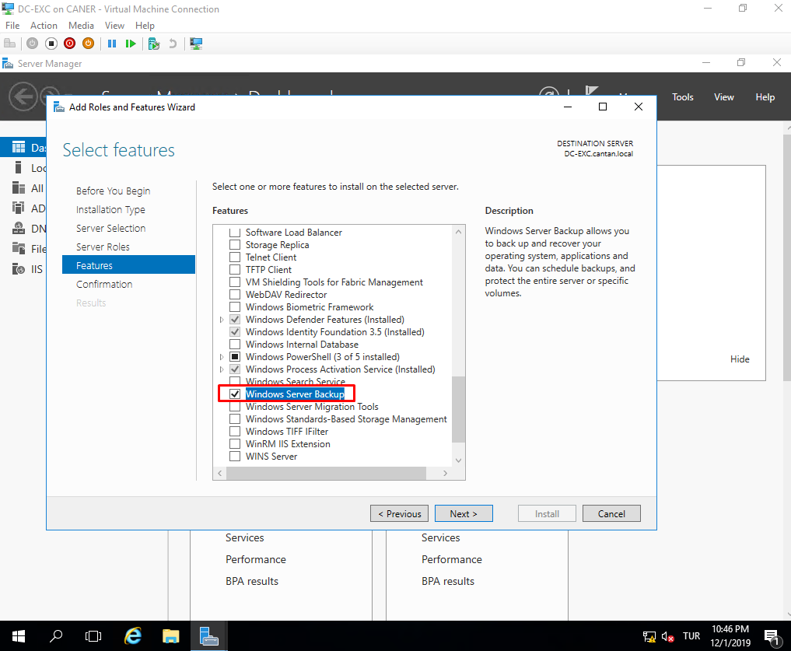

We start the backup tool.

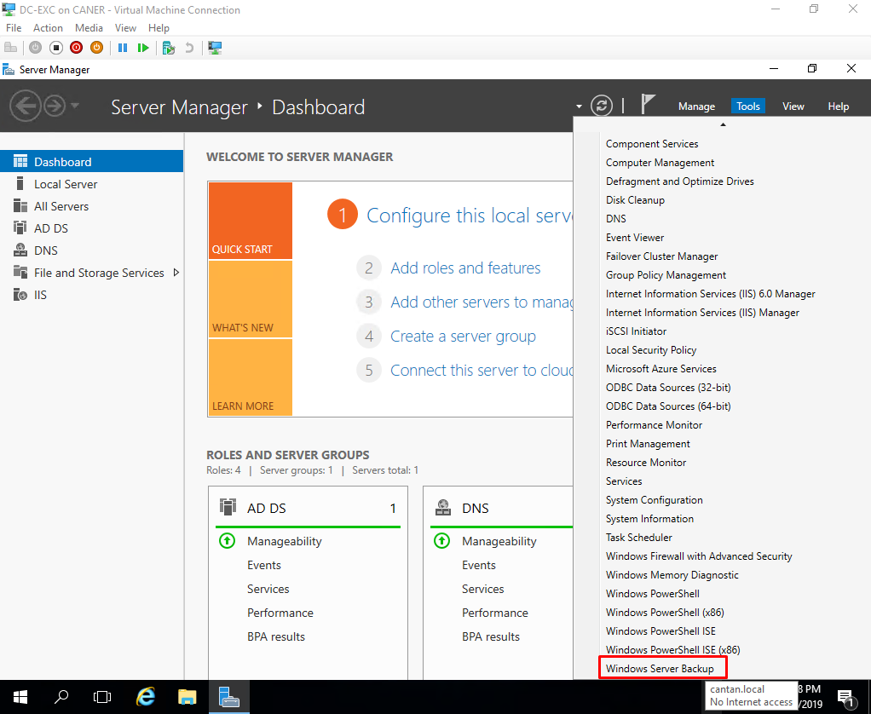

We’ll select Backup Once here to demonstrate but we could have periodically backed up our data via scheduling.

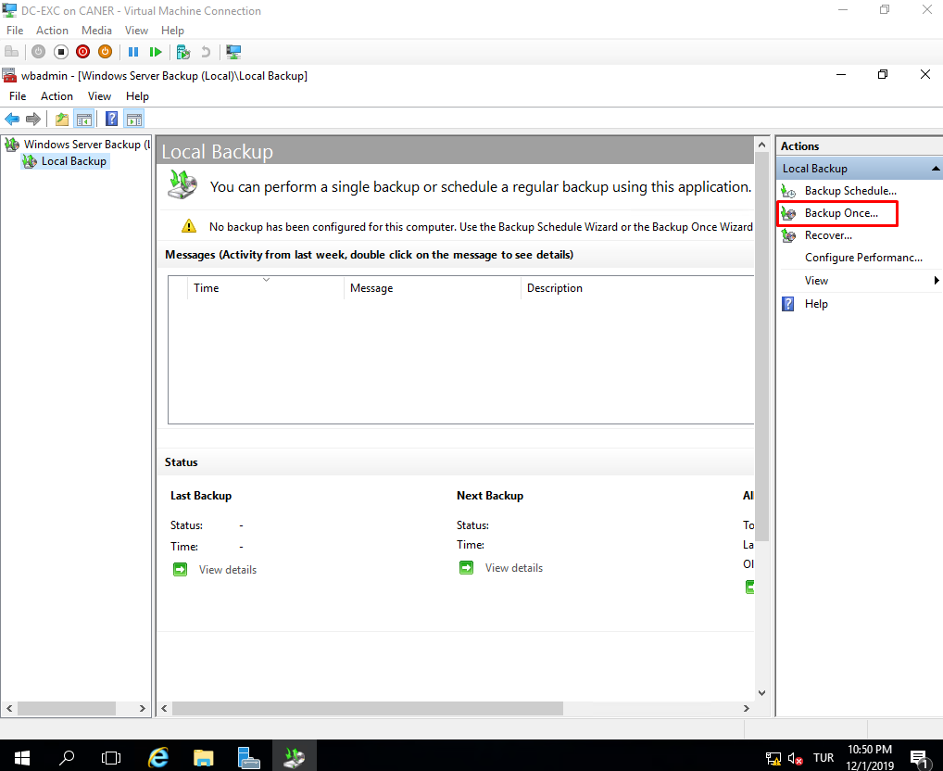

Since we don’t have a schedule, we cannot select it here.

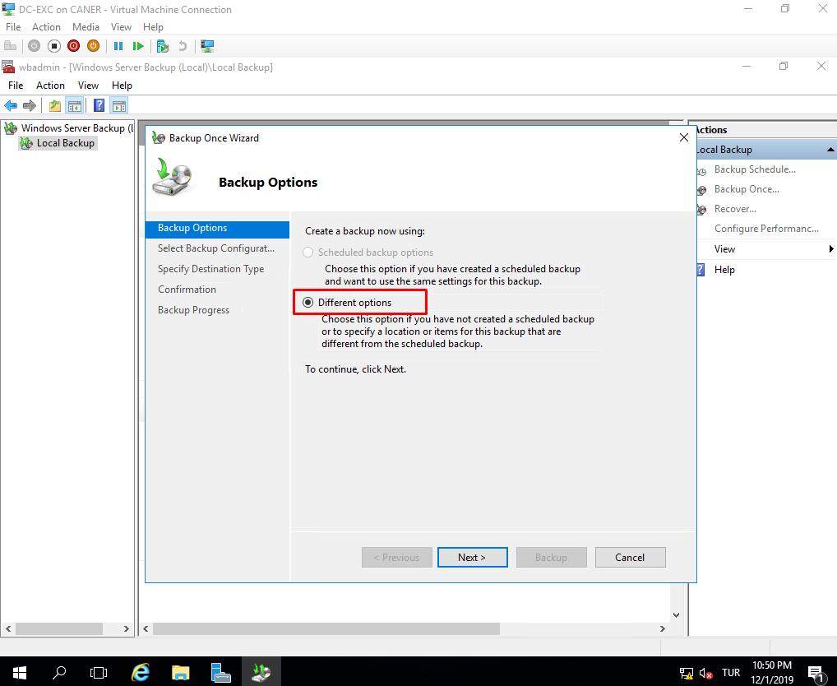

To save time we select a custom backup instead of a full backup.

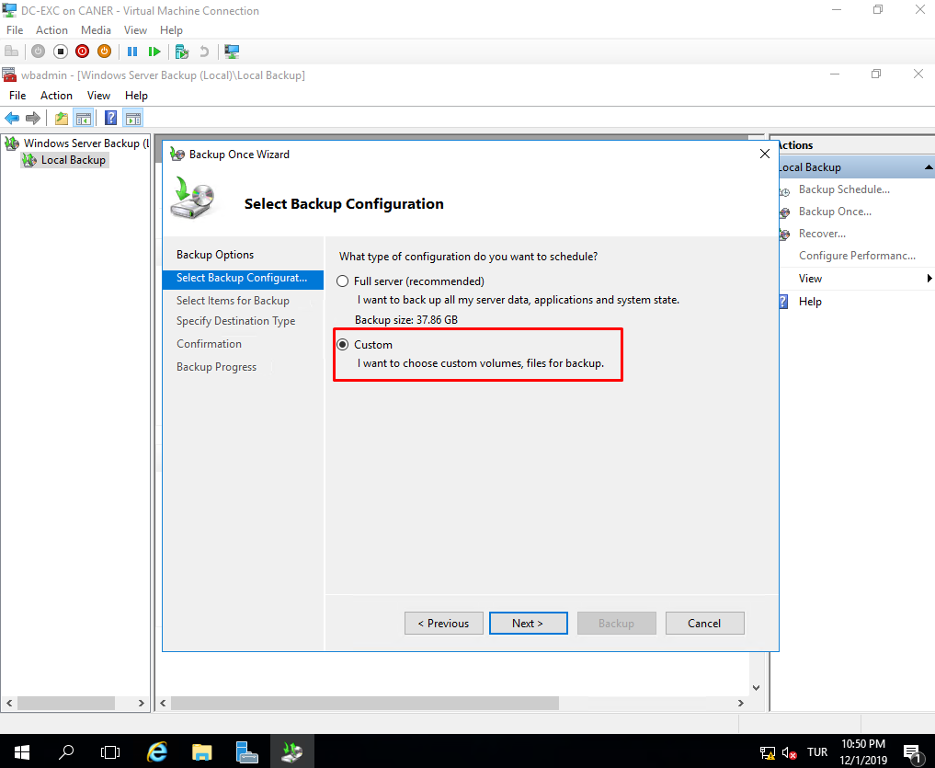

Because this is a custom backup, we select what to back up.

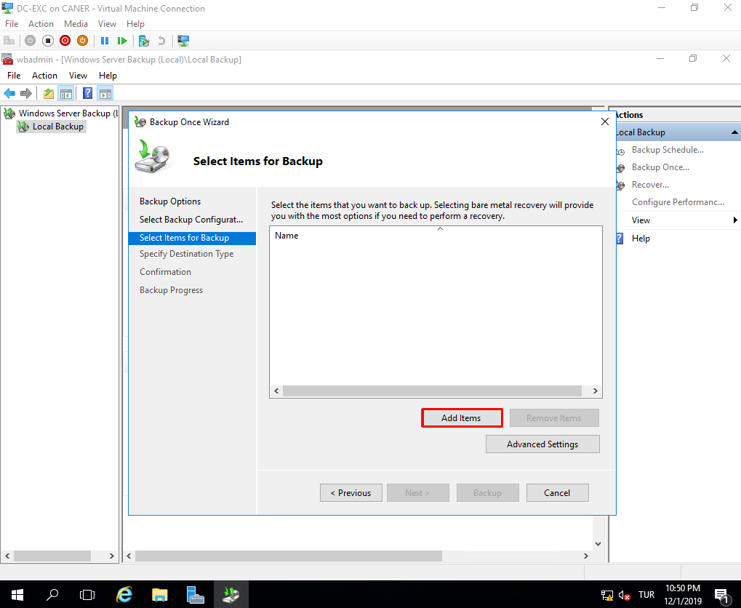

And we select only the drives we used for Exchange Server.

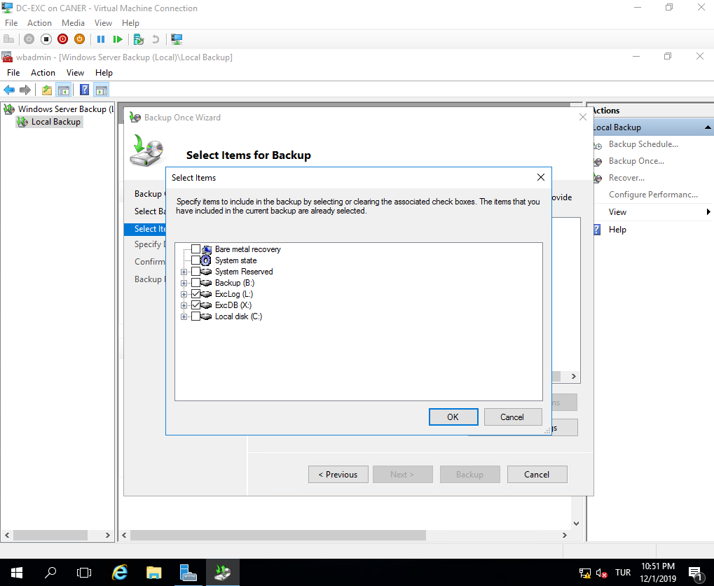

Once we add these items, we use the Advanced Settings.

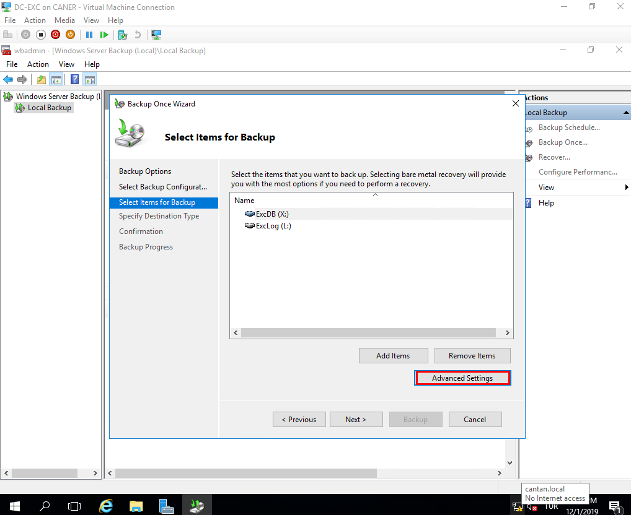

We choose VSS full backup since we don’t use any other product to back up applications.

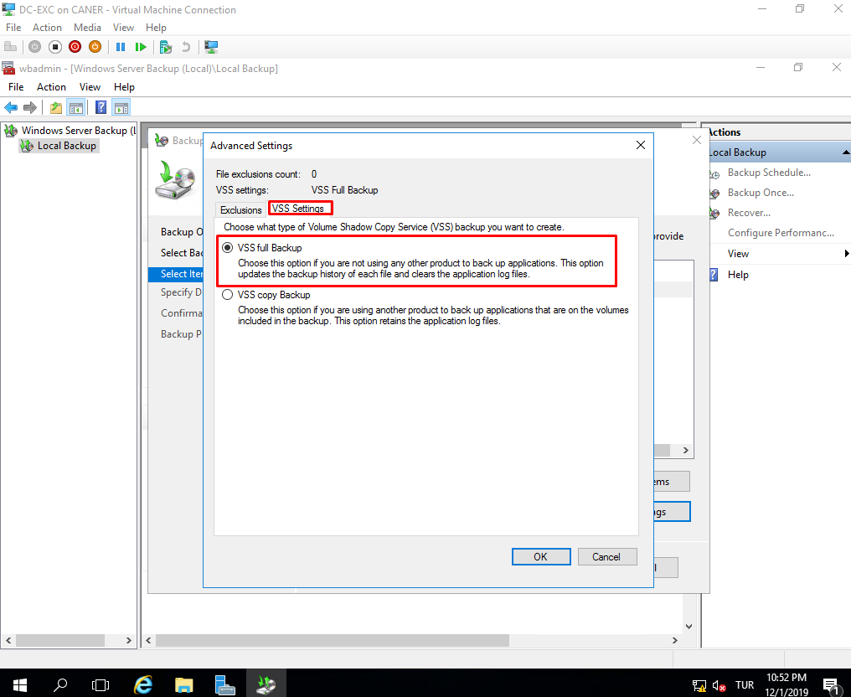

We choose the location of the backup…

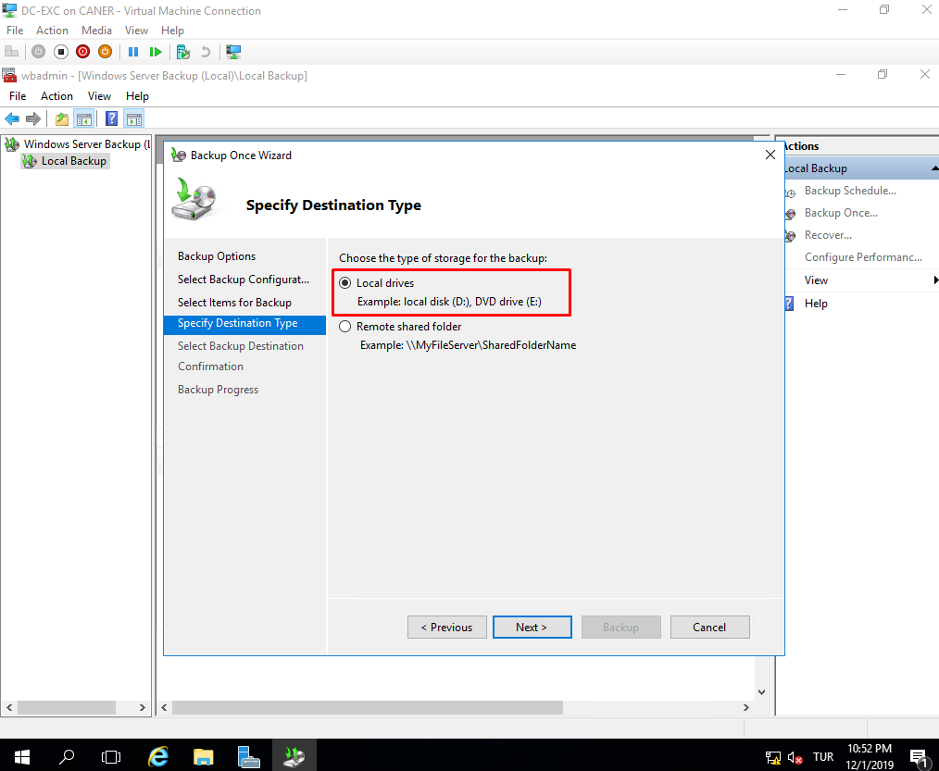

and since we added a drive named Backup(B:), let’s back up our server there.

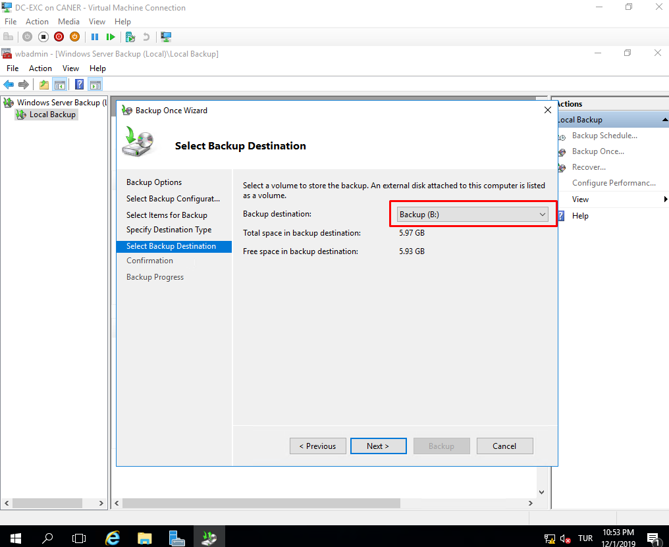

Then, we simply start the process.

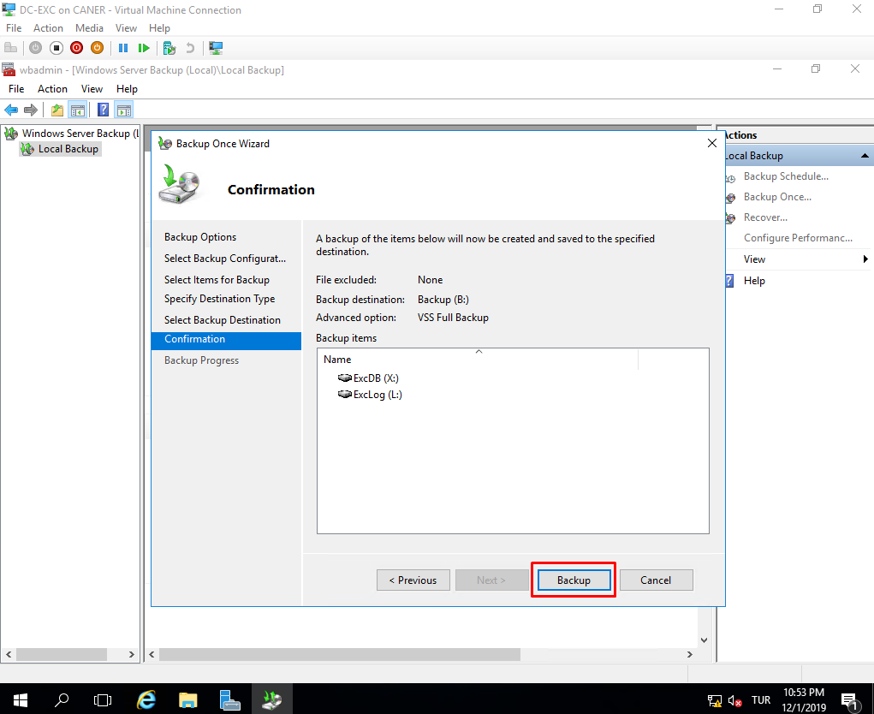

In a few minutes it’s done.

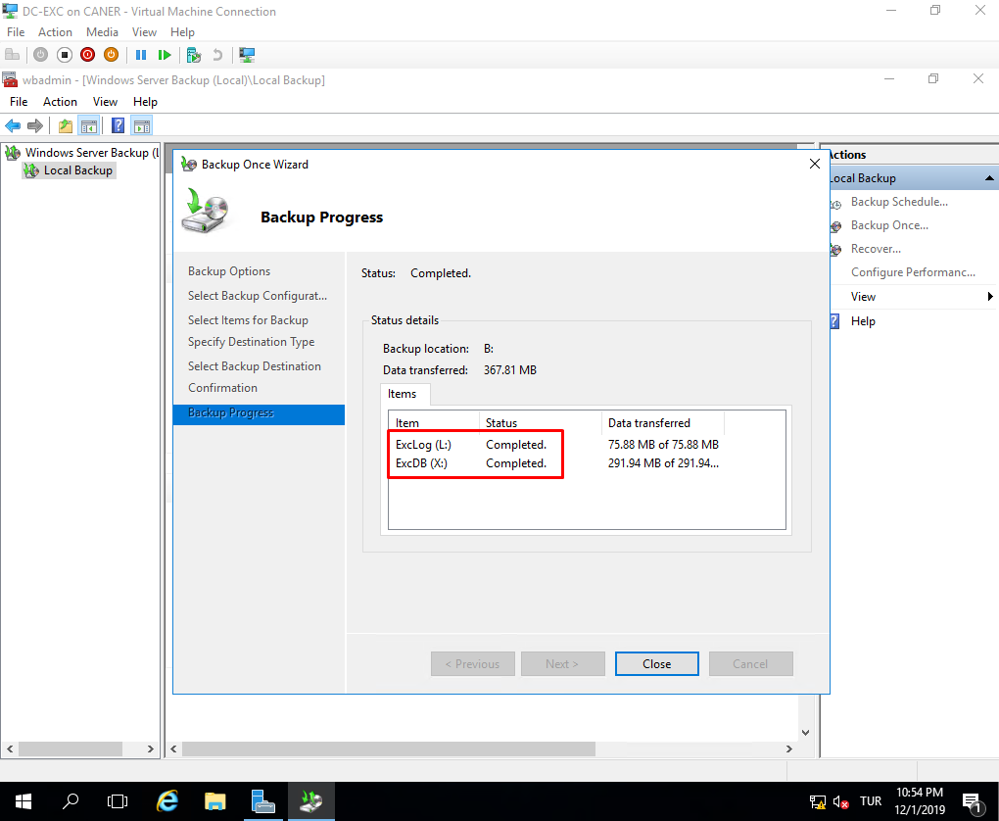

We can see the successful backup here and we could use it to recover our lost data in the case of a disaster.

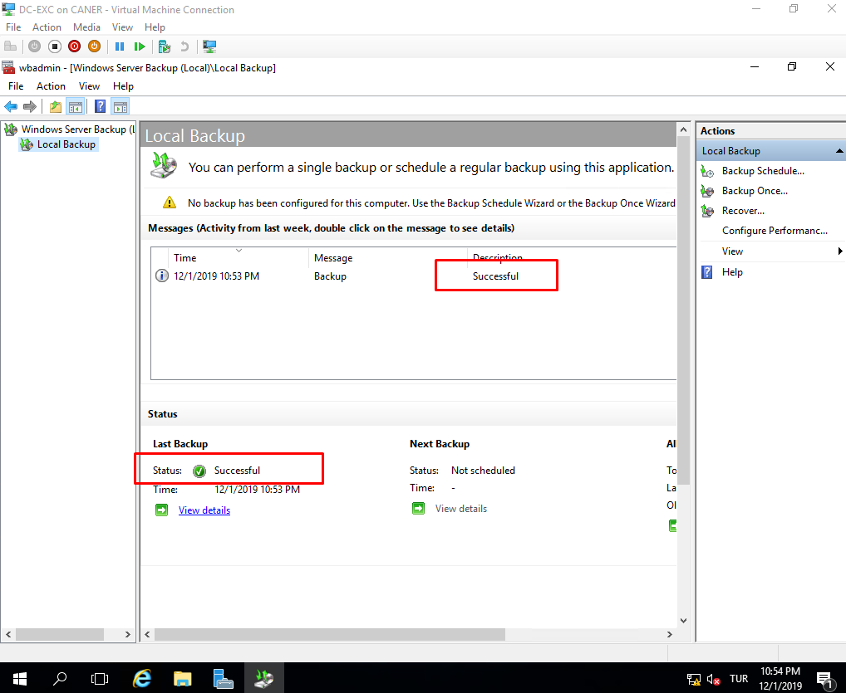

If we check the Backup(B:) drive we can see the backup image.

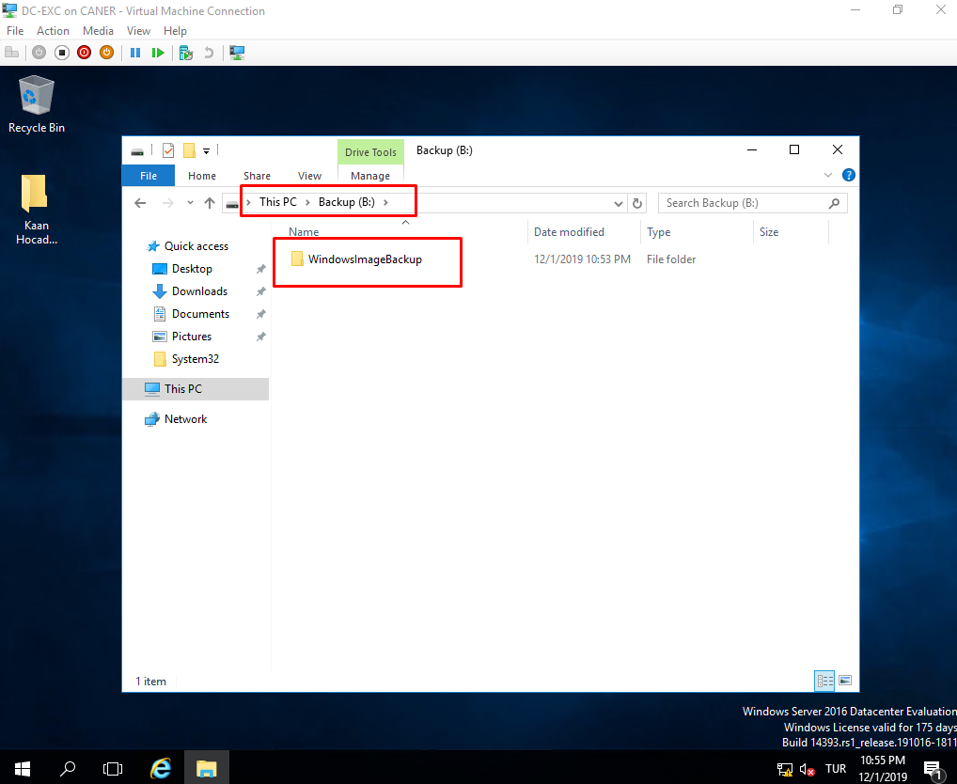

Now that we set up sending and receiving e-mails part of the Exchange Server, we can take a look at the organizational features. The first one is Distribution Groups. Distribution Groups (DGs) are useful to send mass e-mails without sifting through our entire list of users. This is especially useful for big companies. To create a new DG, we go to recipients and choose groups.

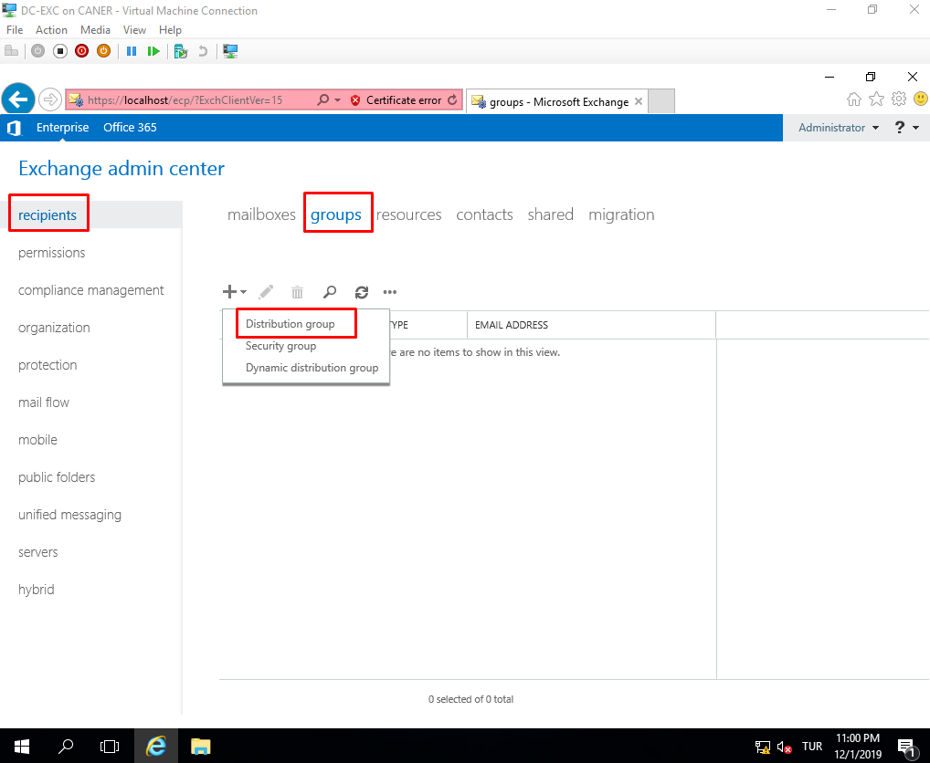

We name the group and designate owners of it along with writing a descriptive note.

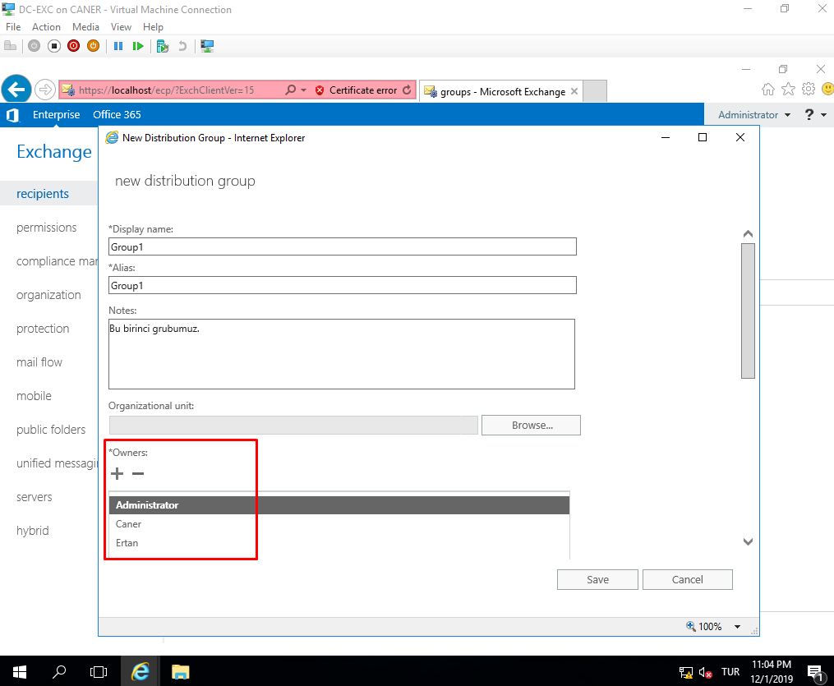

Since we selected add group owners as members, if we send an e-mail to the group’s address it goes to every owner. We can also add non-owner members if we are the owner of the group. Note that with the specified security rules below, anyone can leave the group without asking for permission; however, when someone new wants to join the group, the owners are sent an e-mail to confirm the new user as eligible for joining.

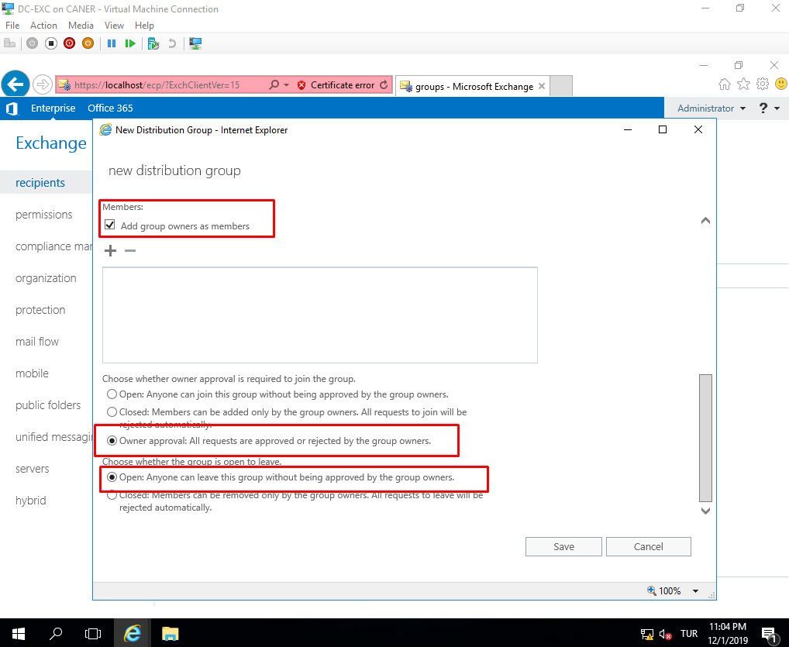

A user can join or request to join a DG via the groups tab and selecting the sign with a plus.

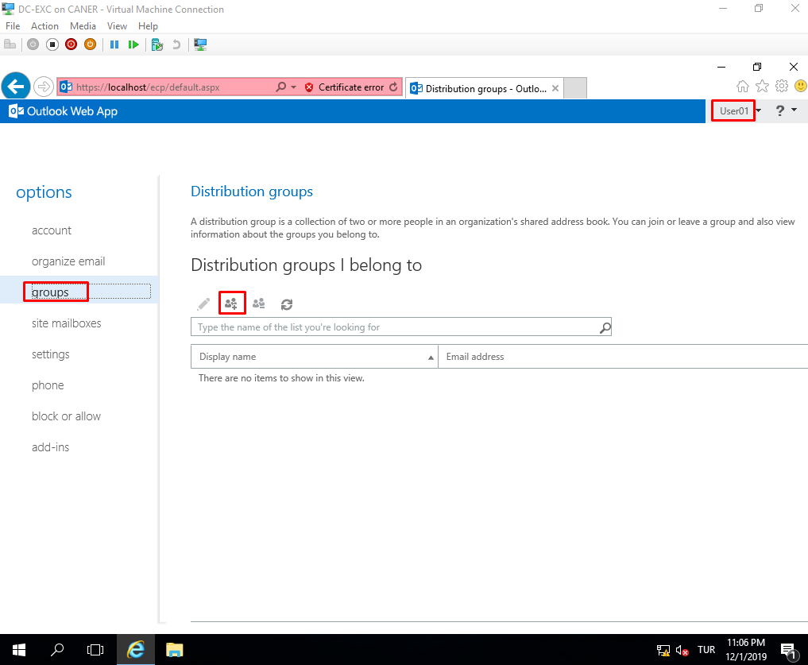

As an admin we can also enable archiving the e-mails which is user specific.

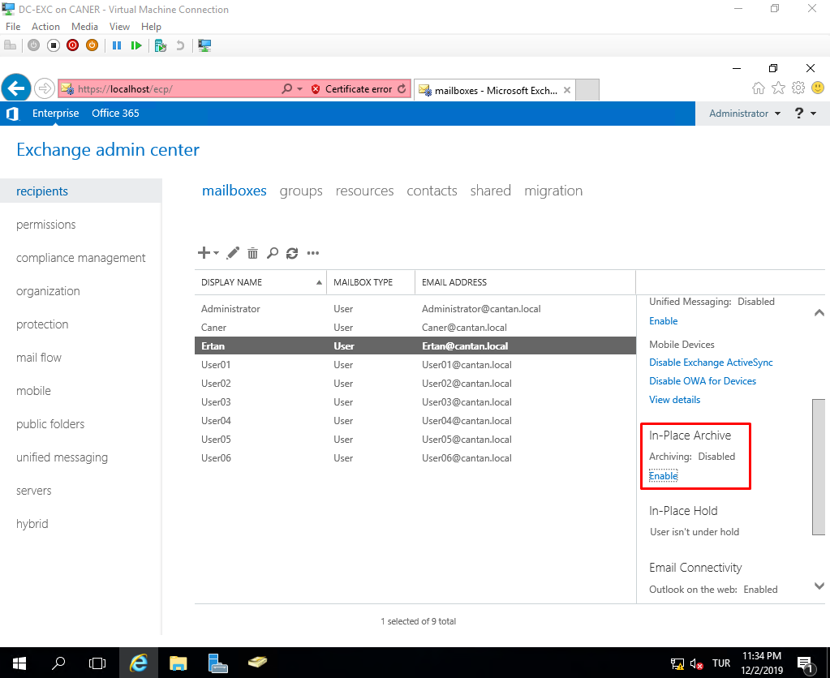

Once we enable archiving, the server requests a database to keep the archived e-mails. We selected the same database as the mailboxes but it’s possible to create a distinct database for archives. Use the browse button to select one of the databases.

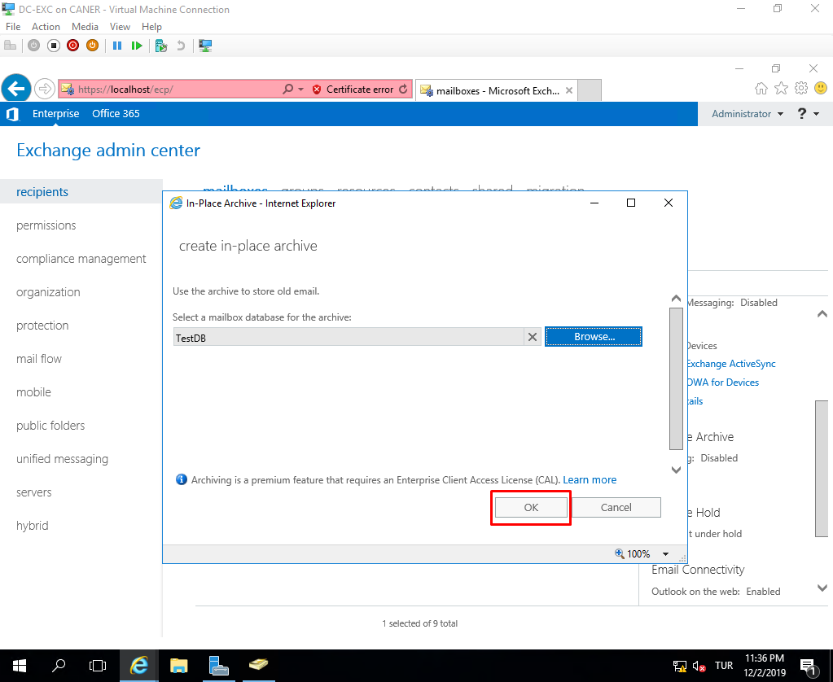

Another thing we can do as an Exchange Server admin is to limit how much space a user can utilize in the database. We select the database that we want to enforce quotas under servers, databases and click on the pencil sign indicating edit.

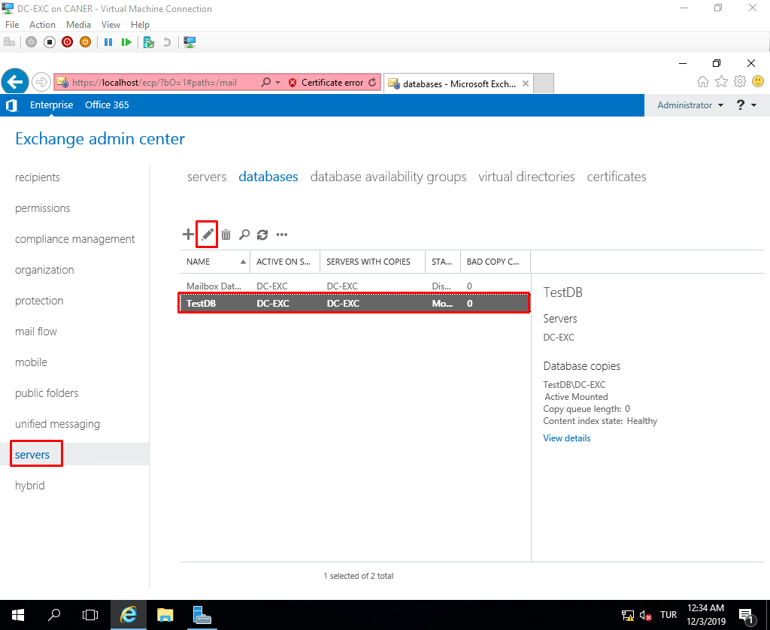

Under limits we designate the space limiting parameters.

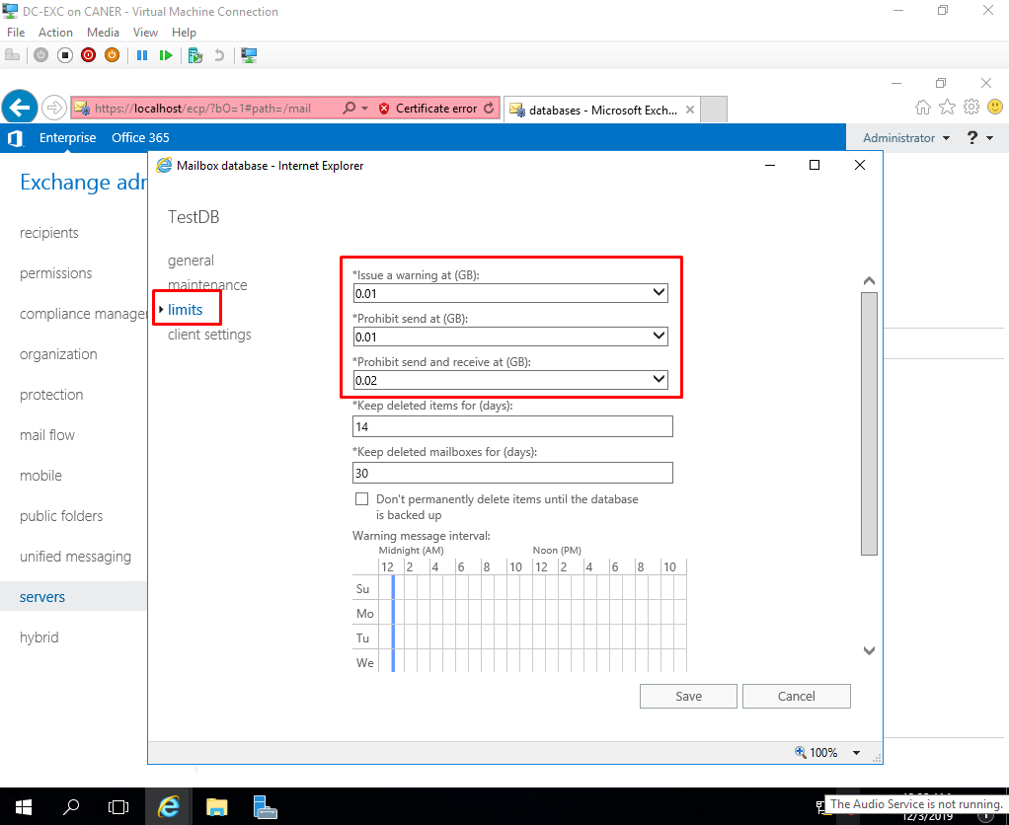

After we set up the rules for the quotas, we can see them enforced.

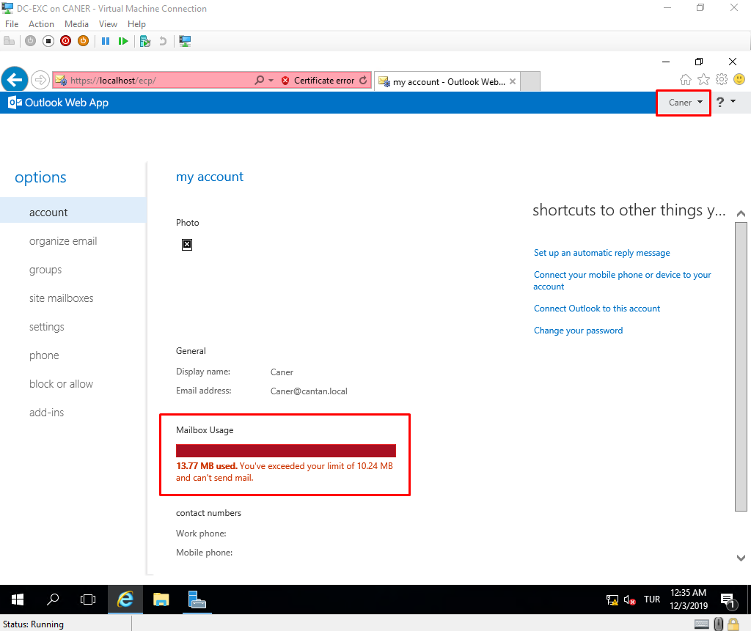

If a user reaches the quota that we determined, they cannot send or receive e-mails before deleting some e-mails.

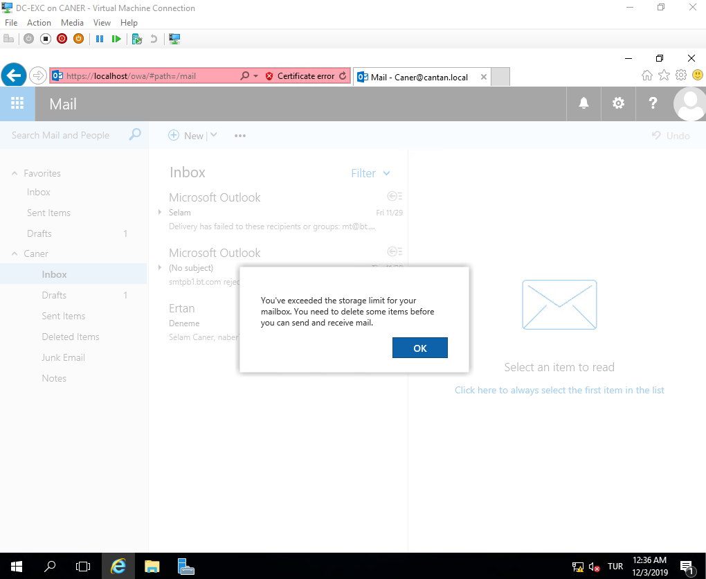

We can also set up public folders for further organizational structure. He first thing to set them up is to go under public folders and create a new mailbox for it.

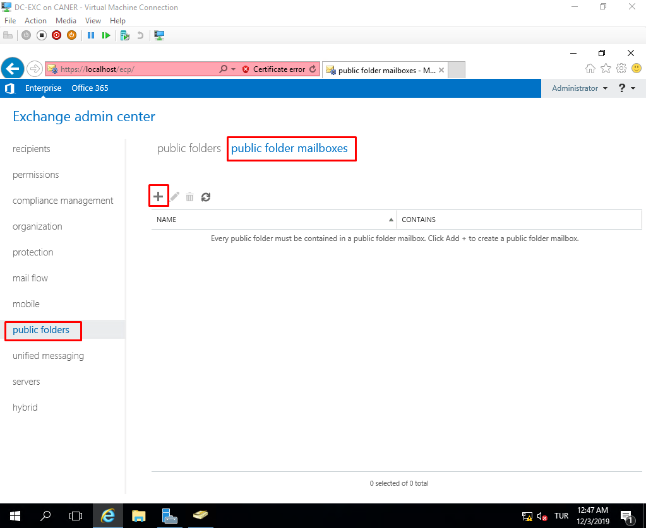

We name it and select which database we want to keep it at.

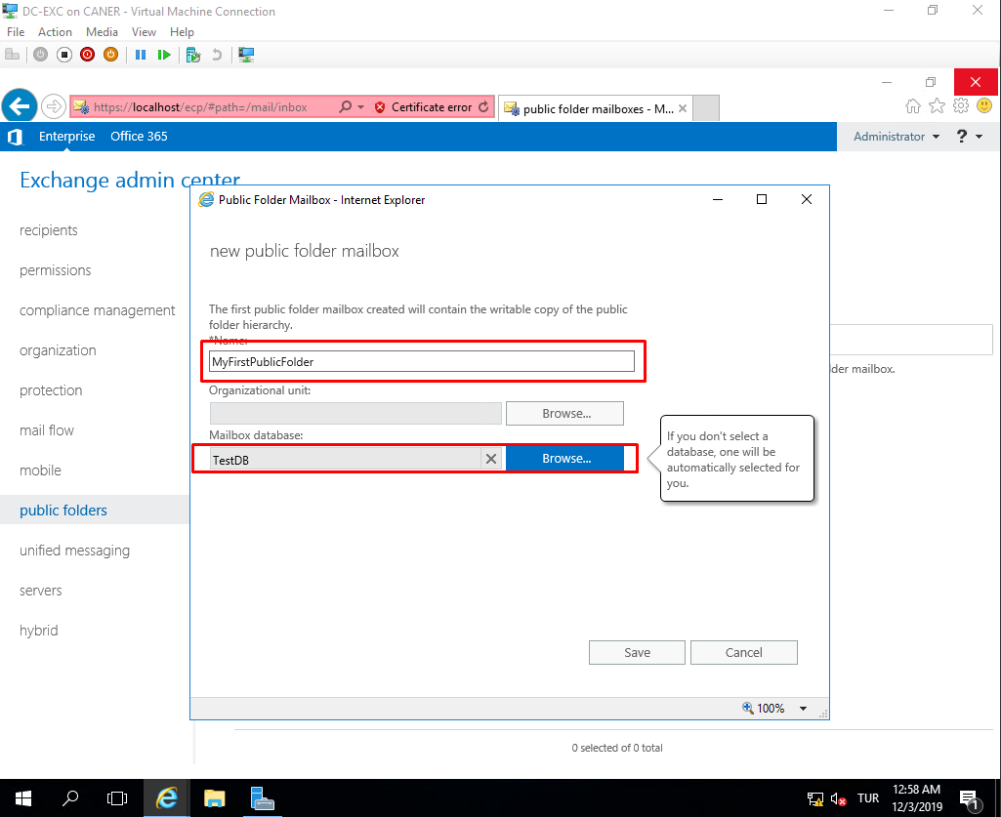

Then, under regular public folder tab we click on the plus sign to create a new one.

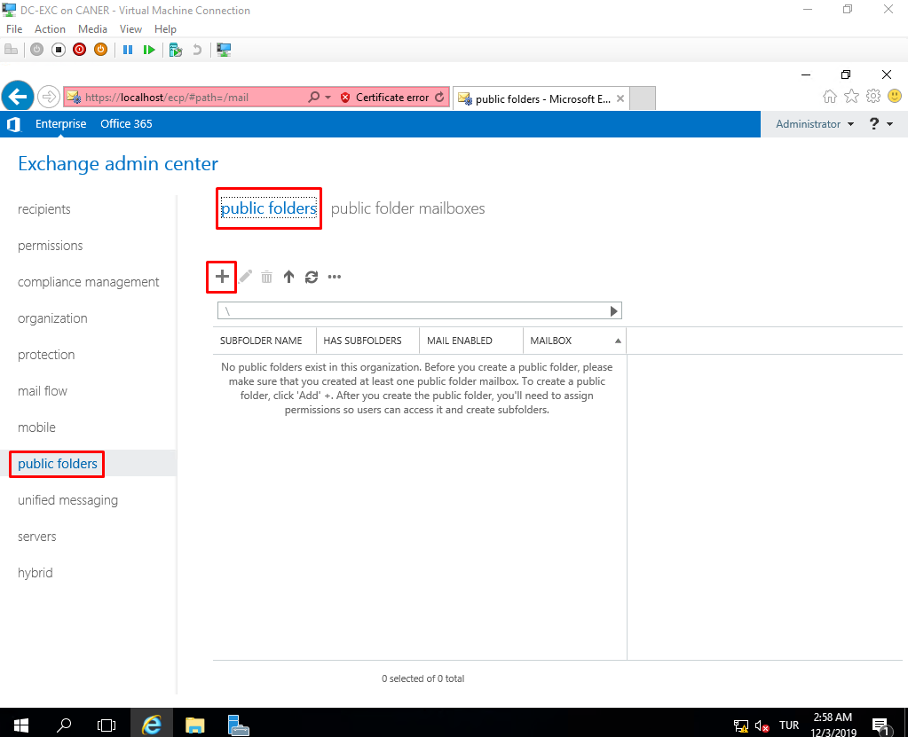

We name the folder as well.

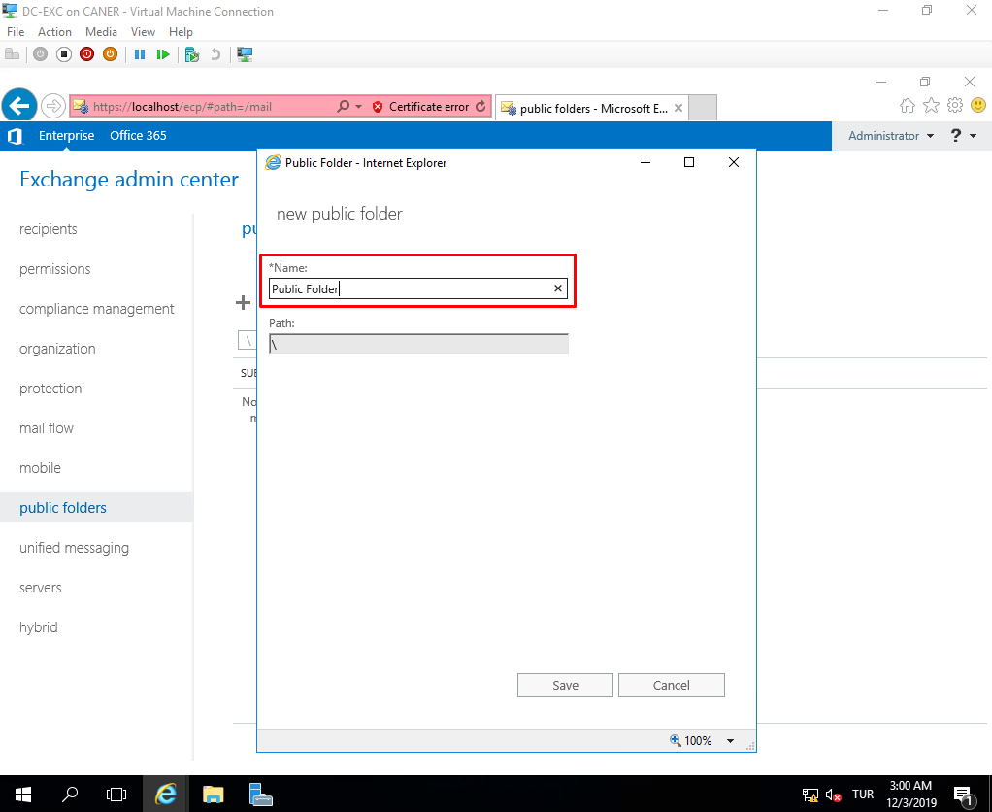

We need to select Root Permissions…

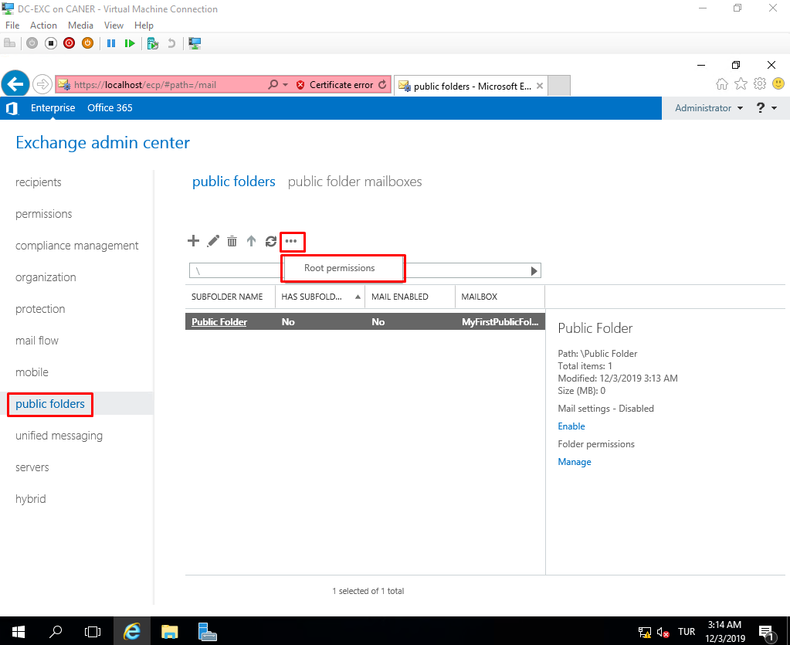

… to add new users for access to the folder.

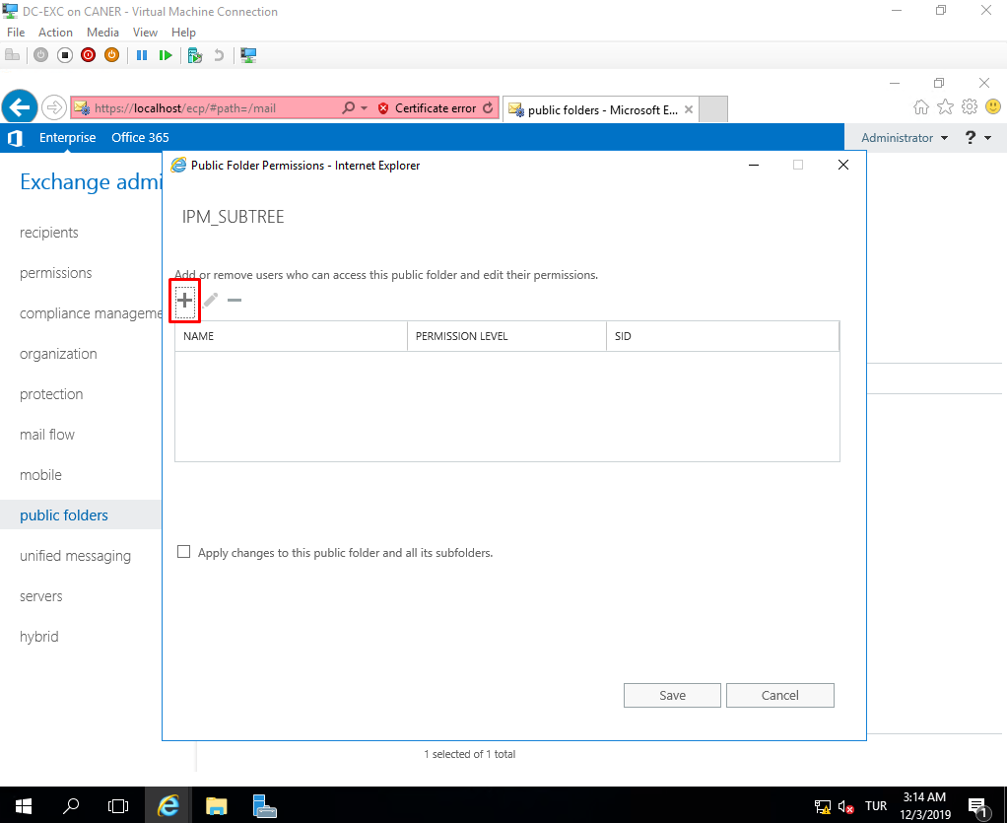

Access to the folder has distinct permission levels such as the owner which has full access:

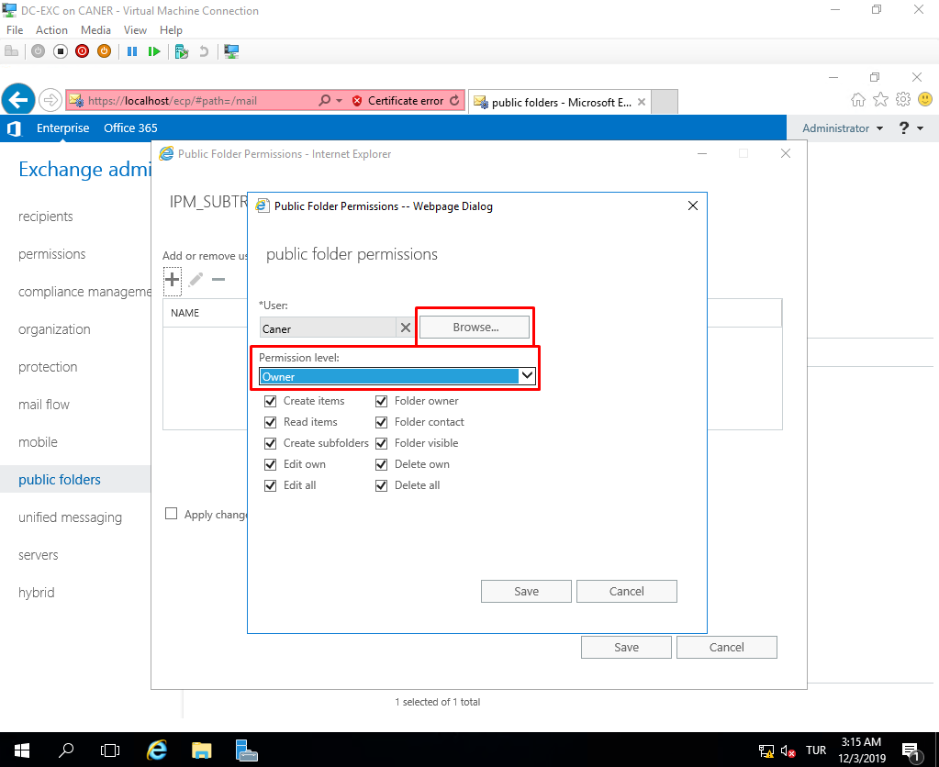

Or the custom user whose permissions we can designate.

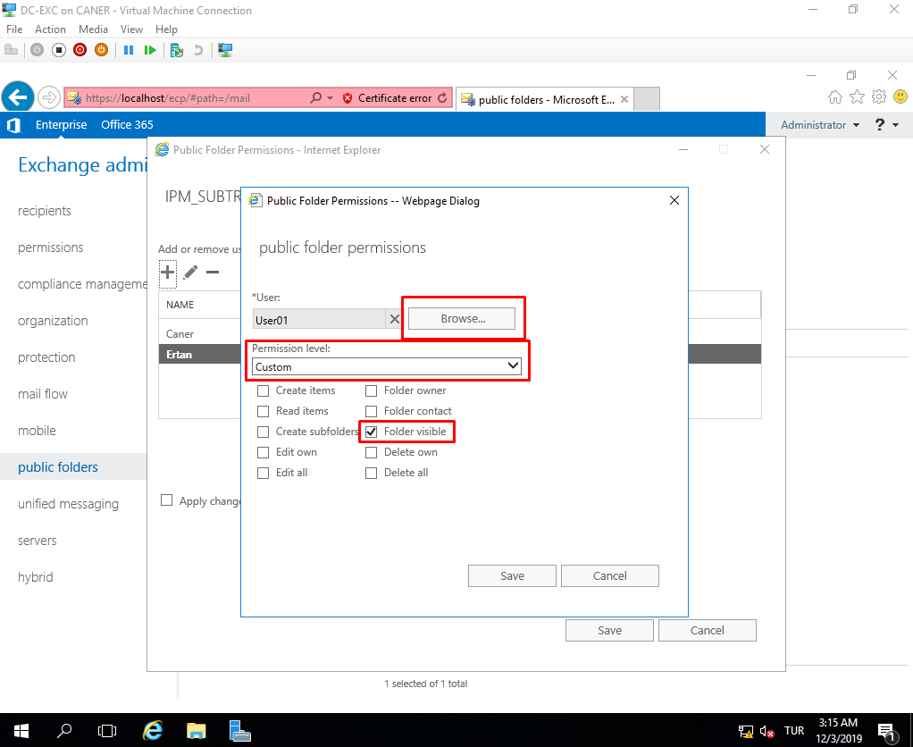

Then, we save these changes for the folder and all the subfolders.

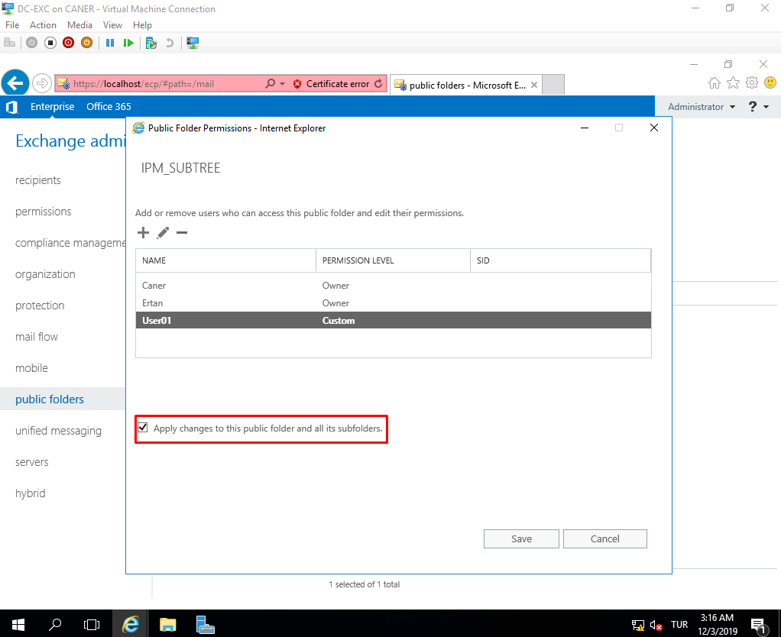

Note that Caner and Ertan are owners whereas User01 can only see the folder and nothing inside.

Then, we simply need to enable the folder.

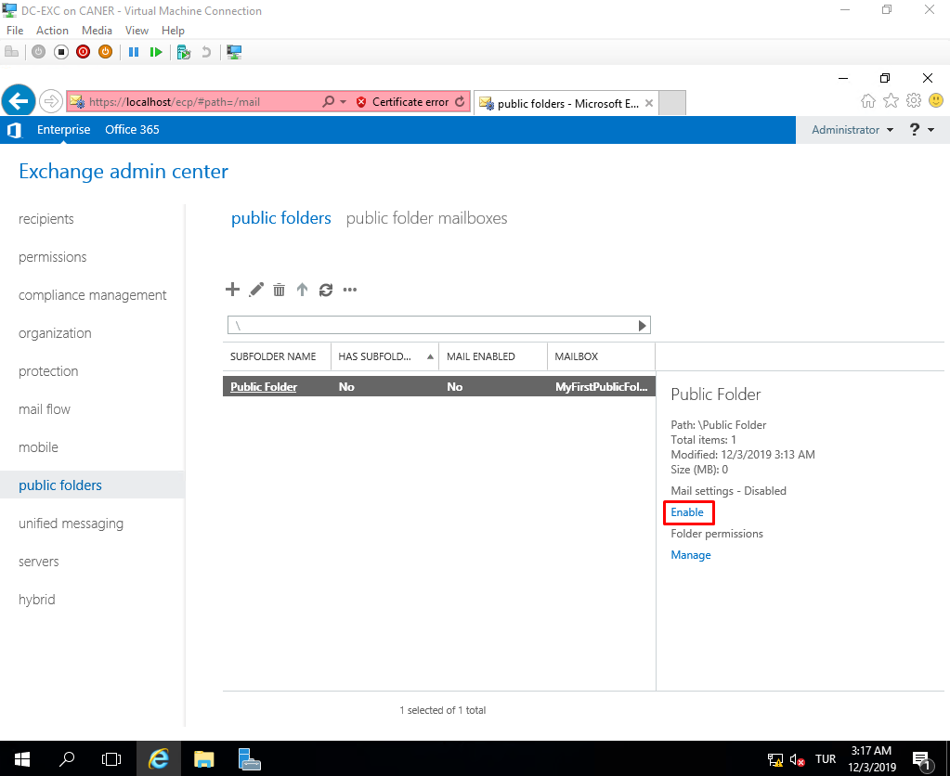

When we try to add a folder to favorites…

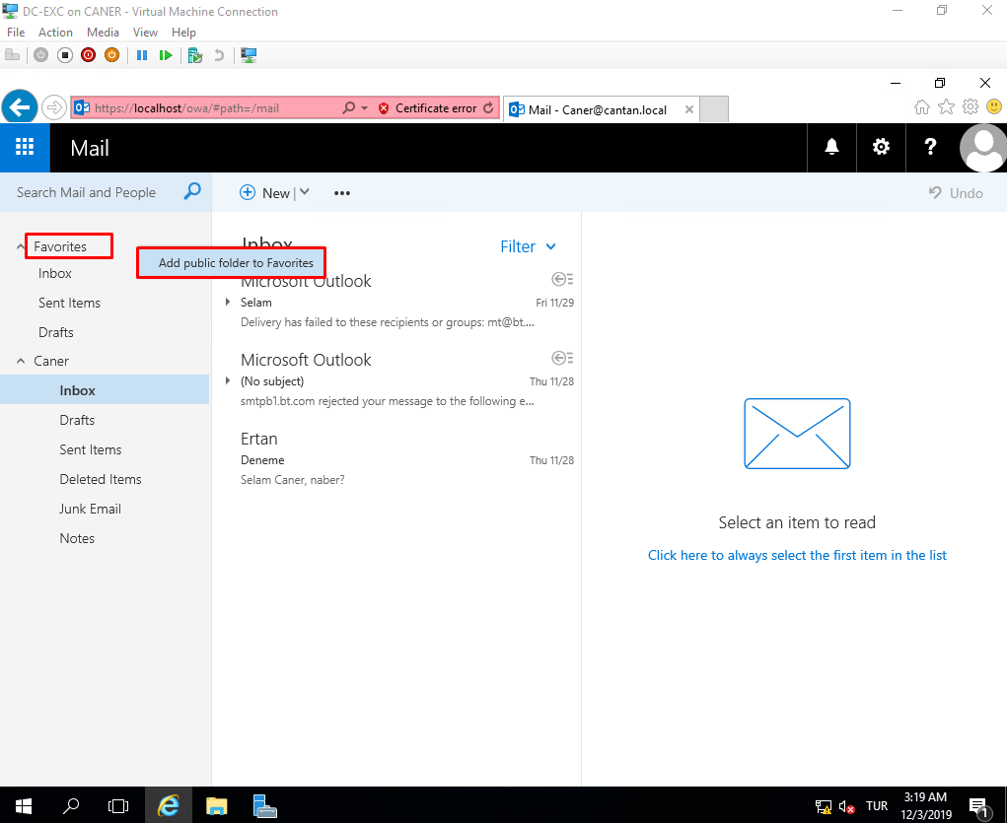

… the new public folder automatically appears for selection.

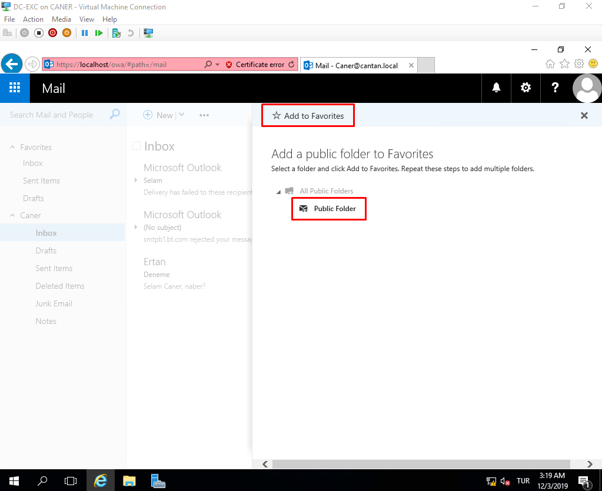

We can test the permissions by sending a public post.

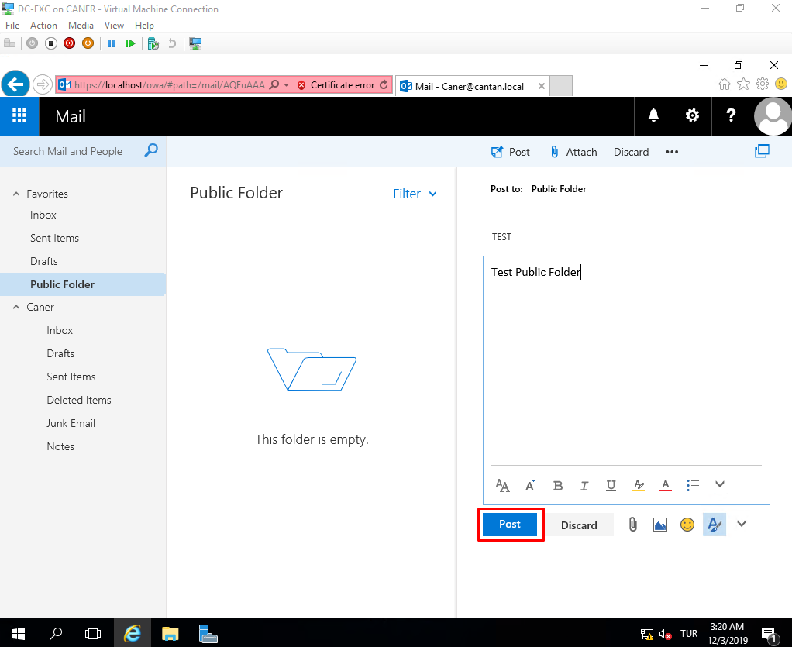

The owners have no issue seeing it.

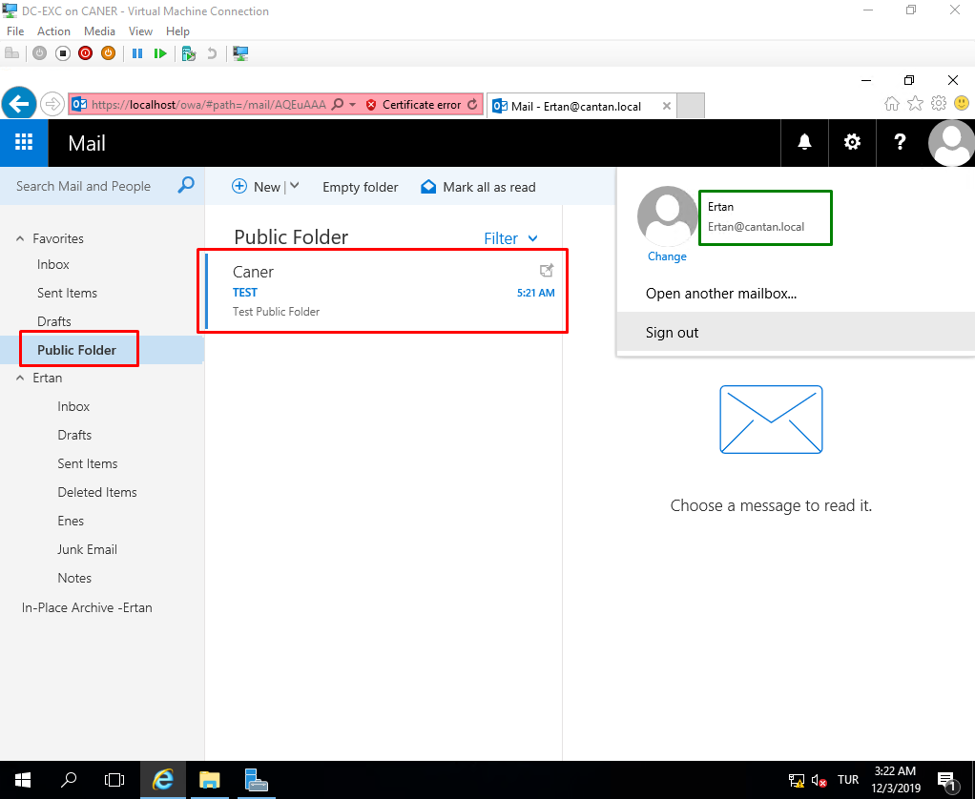

However, User01 cannot see the post.

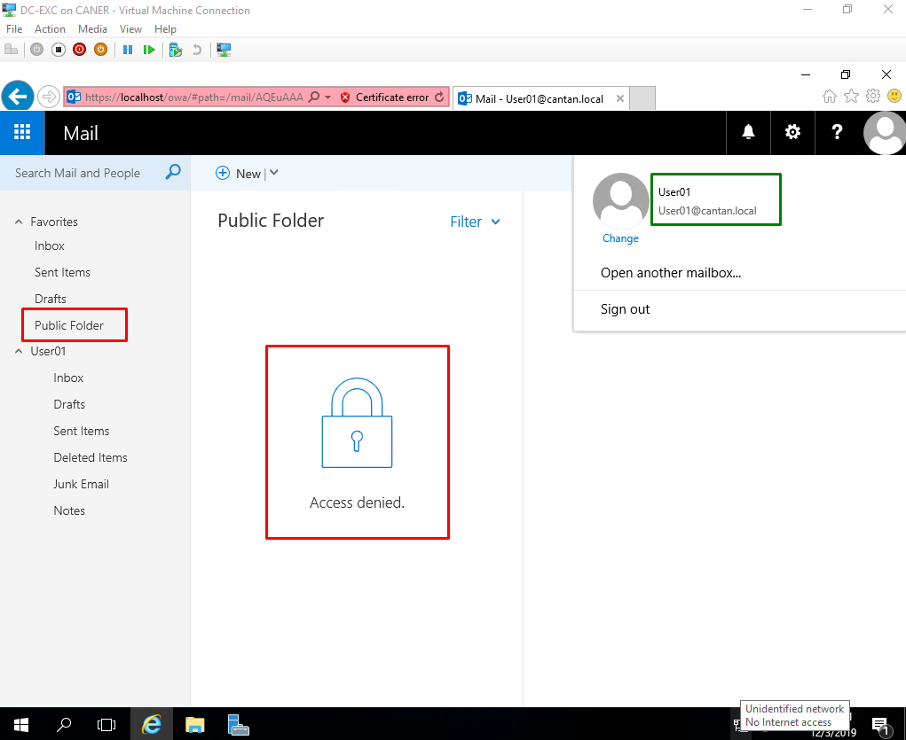

Now, let’s take a look at how Exchange 2010 works as well. First thing we need to do on our new virtual server for it is to download the necessary tools and applications before starting the setup process. We use the following commands on PowerShell:

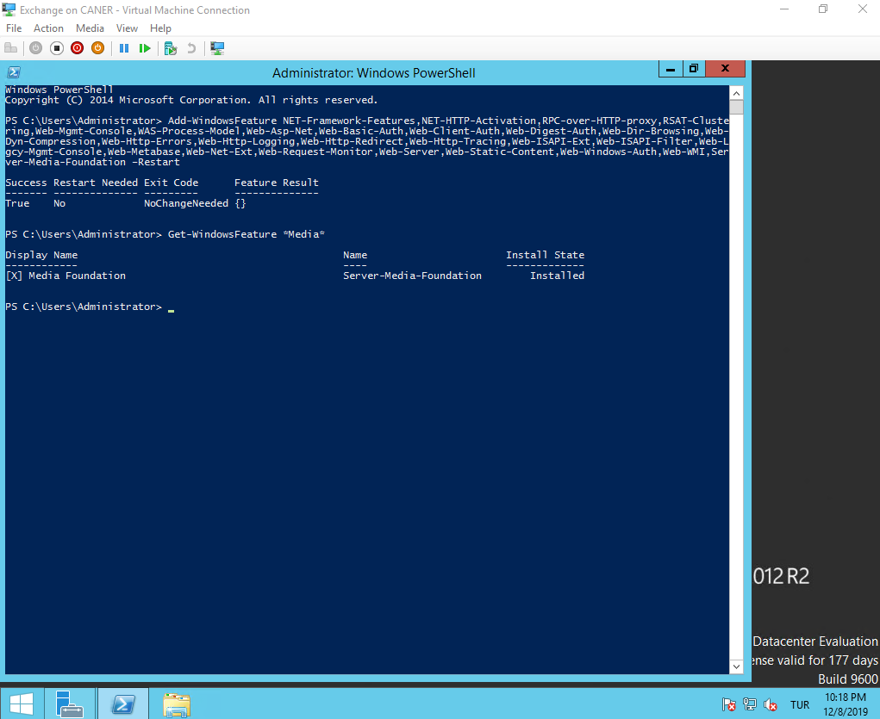

Note that we’re working on a Windows Server 2012 R2 machine now rather than Server 2016 as Exchange 2010 is not supported on it.

We start the setup process.

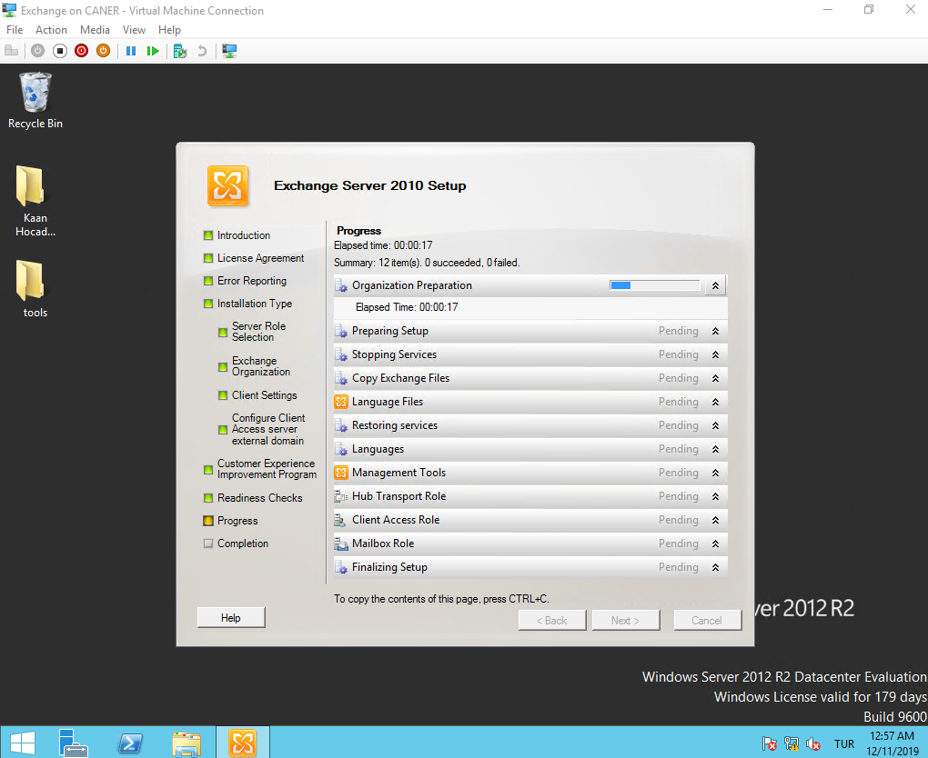

This is the Exchange Management Console of Exchange 2010, it looks quite different from 2016.

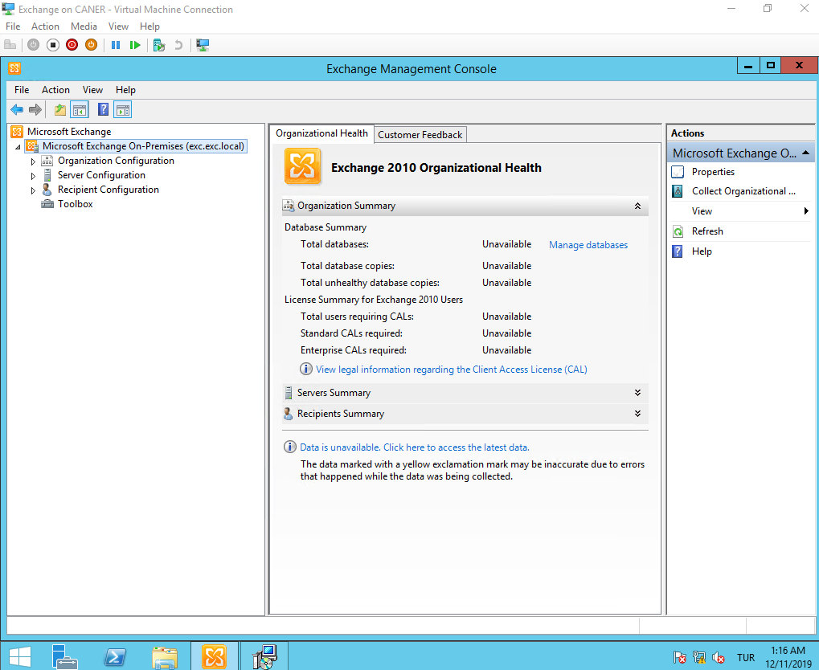

Now, let’s use Microsoft Outlook to connect to our Exchange Server 2010 to manage our e-mails. We want to select Add Account and then choose manual setup.

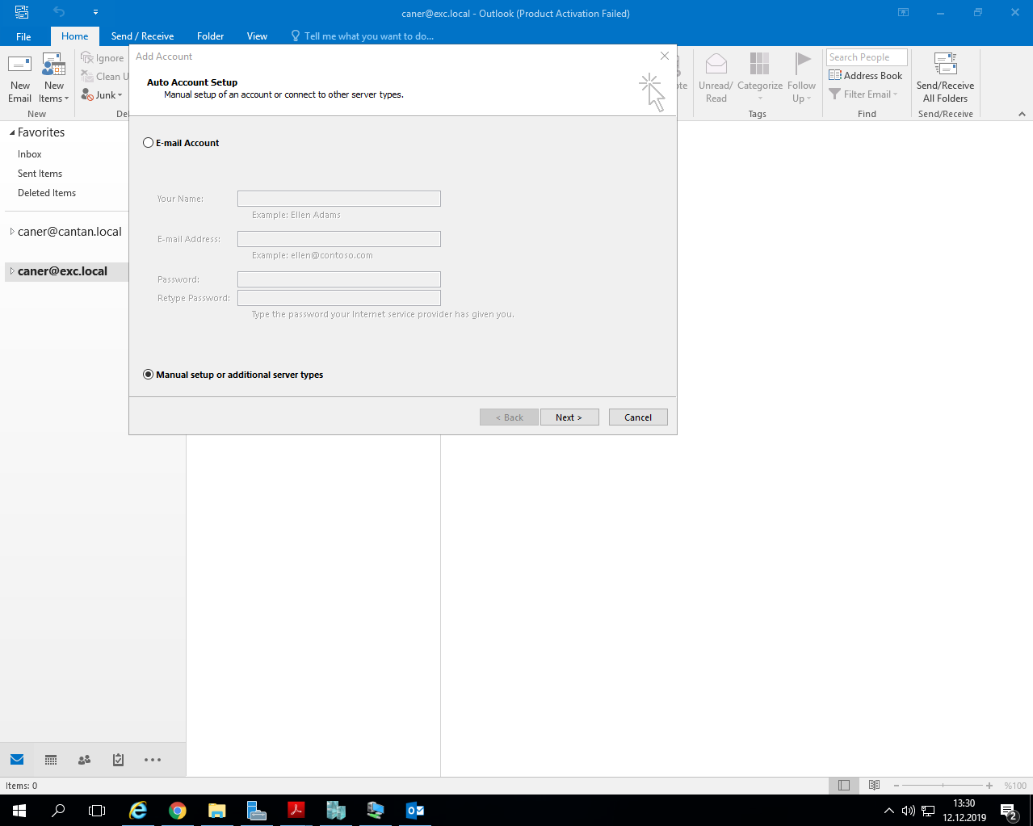

We, then, choose POP or IMAP.

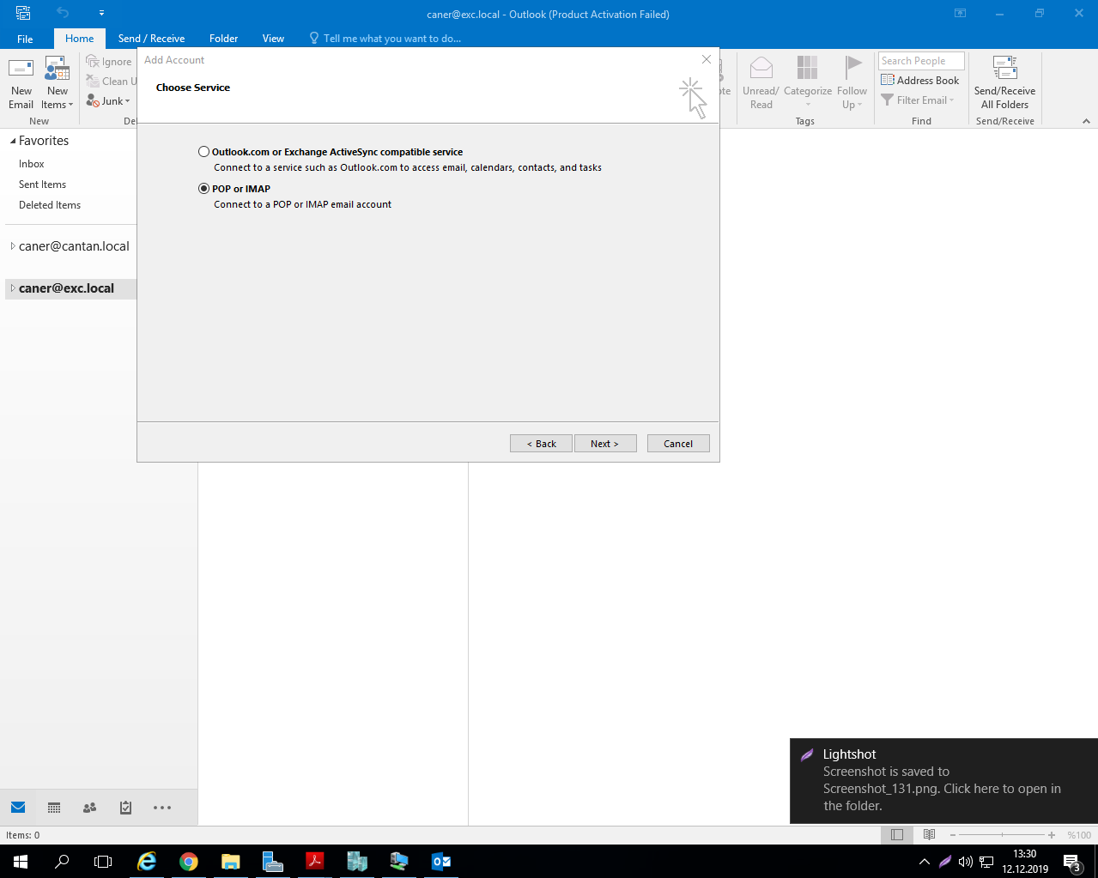

We enter our user information, the Exchange Server information and use the e-mail address and its password that we use to login to Exchange.

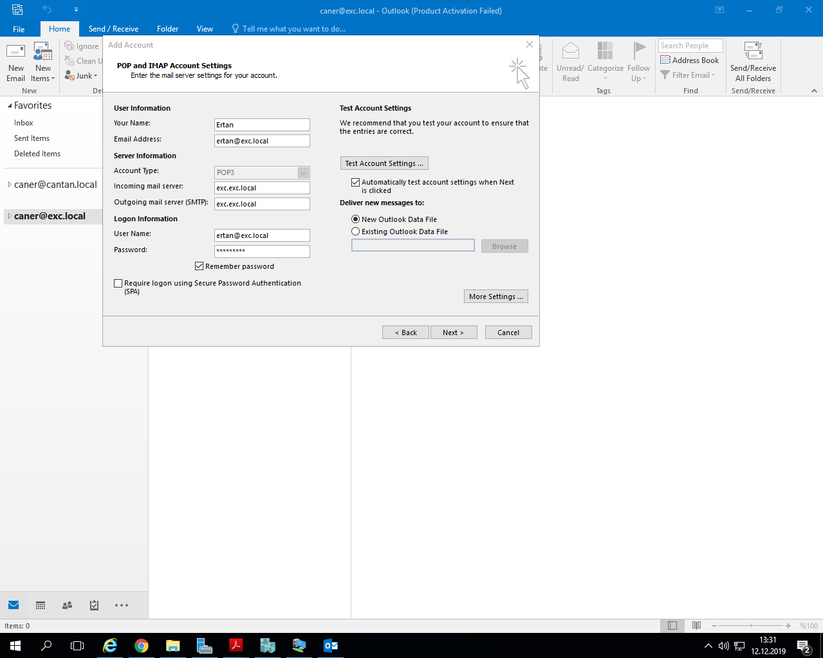

After doing a logon testing…

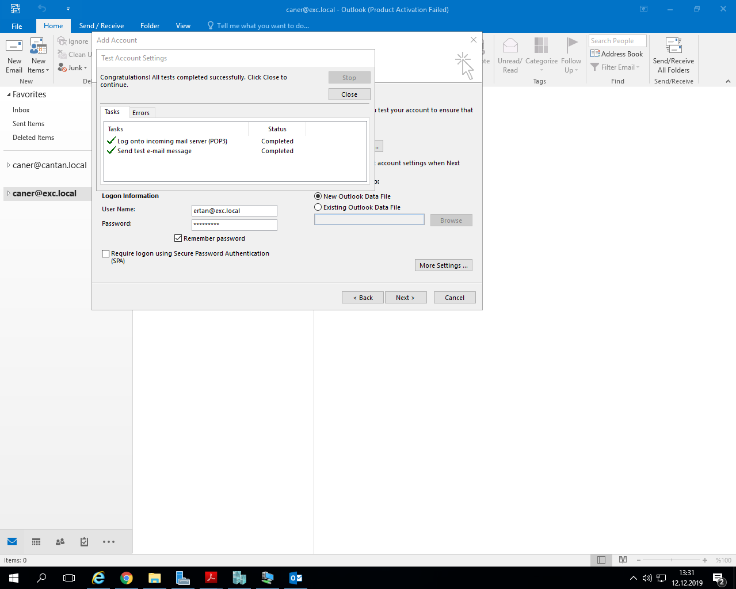

… it’s connected and we can send a test e-mail.

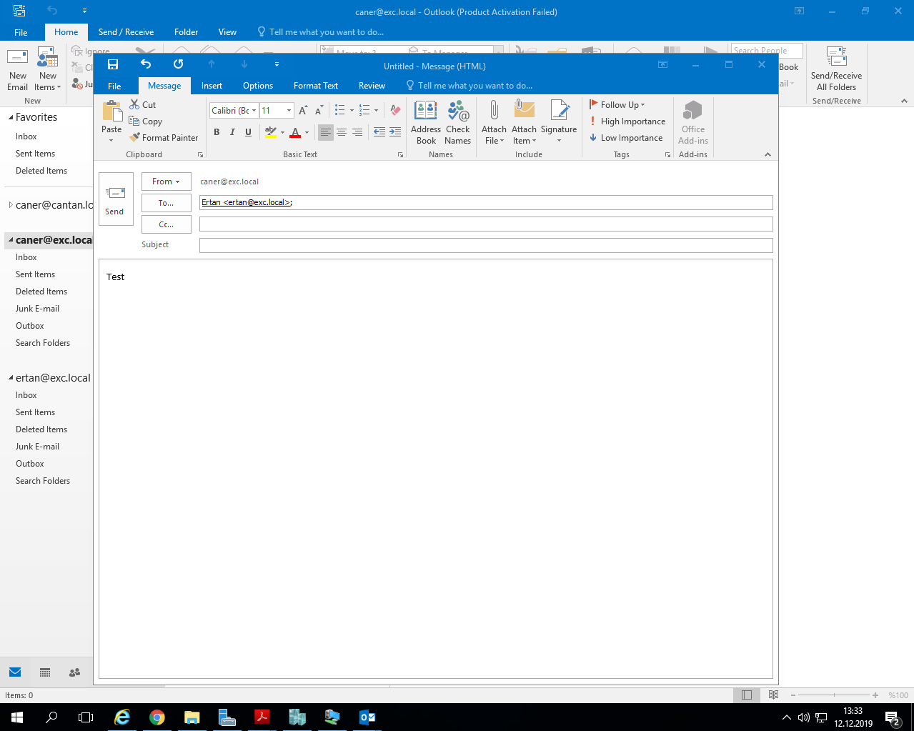

We can then easily see the test e-mail and all the previously sent and received e-mails still saved on the server.

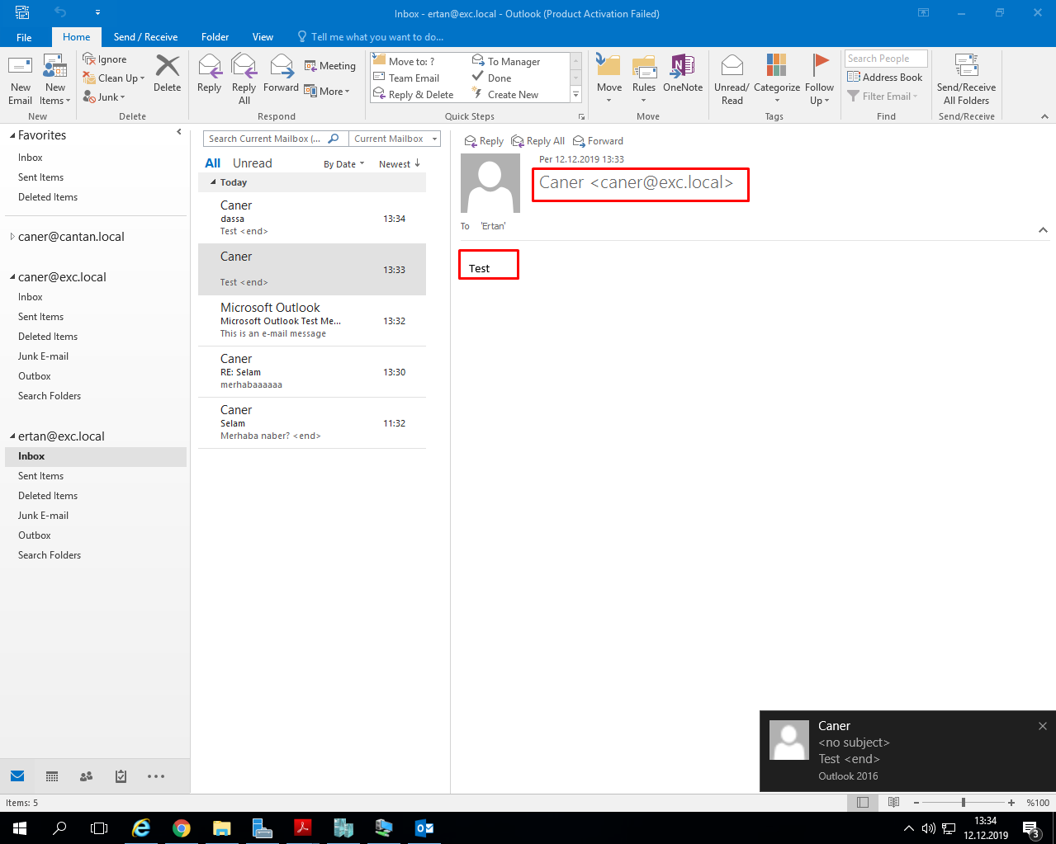

Now, let’s assume that for some reason we want to use Exchange 2013 but we already have been Exchange 2010 and don’t want to lose all the previous e-mails and data. Then, we need to perform a migration from Exchange 2010 to Exchange 2013. On another virtual machine in the domain we start to set up A Windows Server 2012 R2 to support Exchange 2013 installation. In addition to the previous codes to download necessary tools we enter the following code on PowerShell:

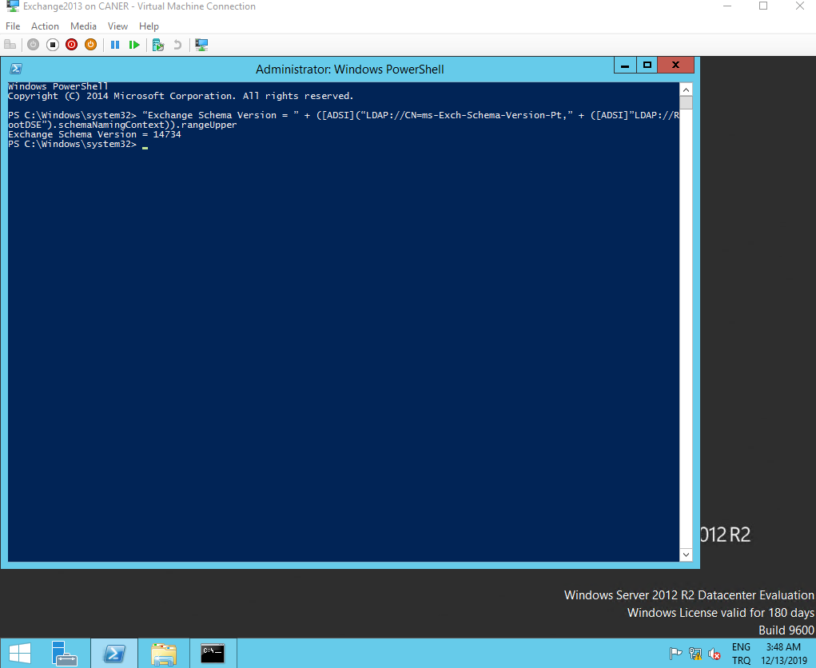

When we start the installation of Exchange 2013 it looks quite familiar to 2016’s process.

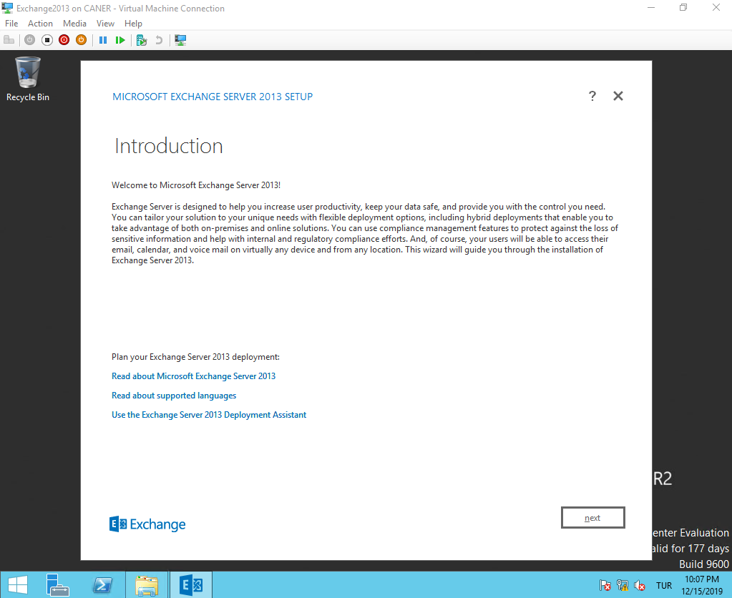

We do the set up with the exact options that we used for 2016 previously in this report.

When we start the Admin Center it looks very similar to Server 2016’s. Also, under databases, servers we don’t only see the new databases for this new server but also the databases of the Exchange 2010 machine since they are in the same domain and communication has been established.

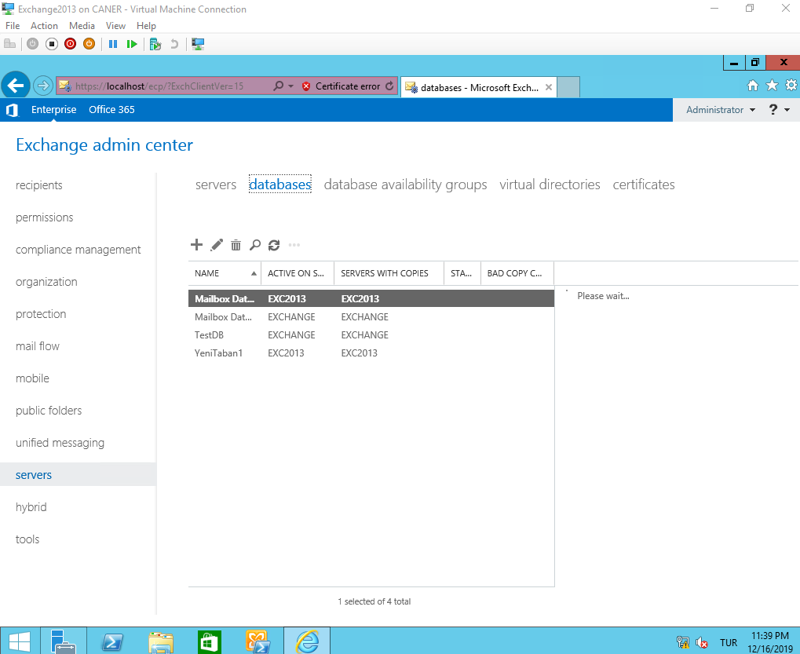

Furthermore, when we get to the Exchange Management Shell of 2013 and use the Get-ExchangeServer command it gets both servers’ data and displays the different versions clearly.

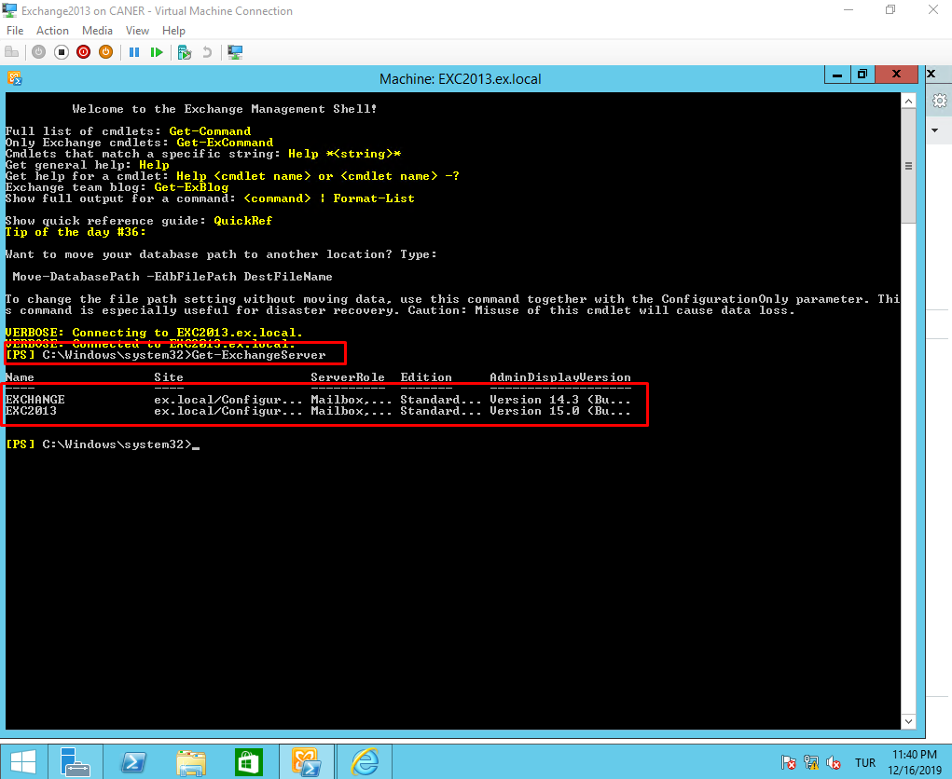

To start a migration this is exactly what we need.

We compare the server names and the databases and note them. In this exercise, EXCHANGE is the name of the 2010 server and EXC2013 is the name of the 2013 server. TestDB is the only mounted database on 2010 and YeniTaban1 is the database that we mounted on 2013. We want to perform the migration from TestDB database to YeniTaban1.

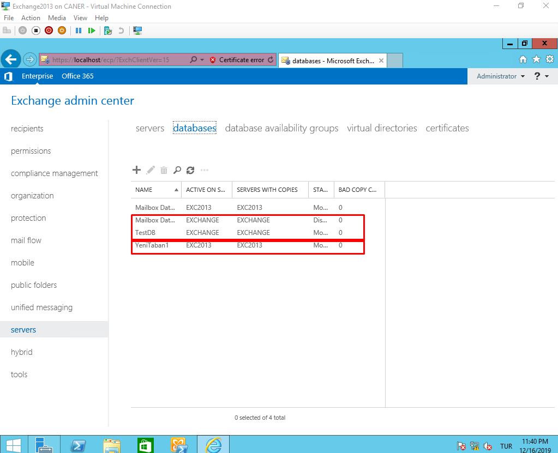

To start the process we go to Recipients, Migration.

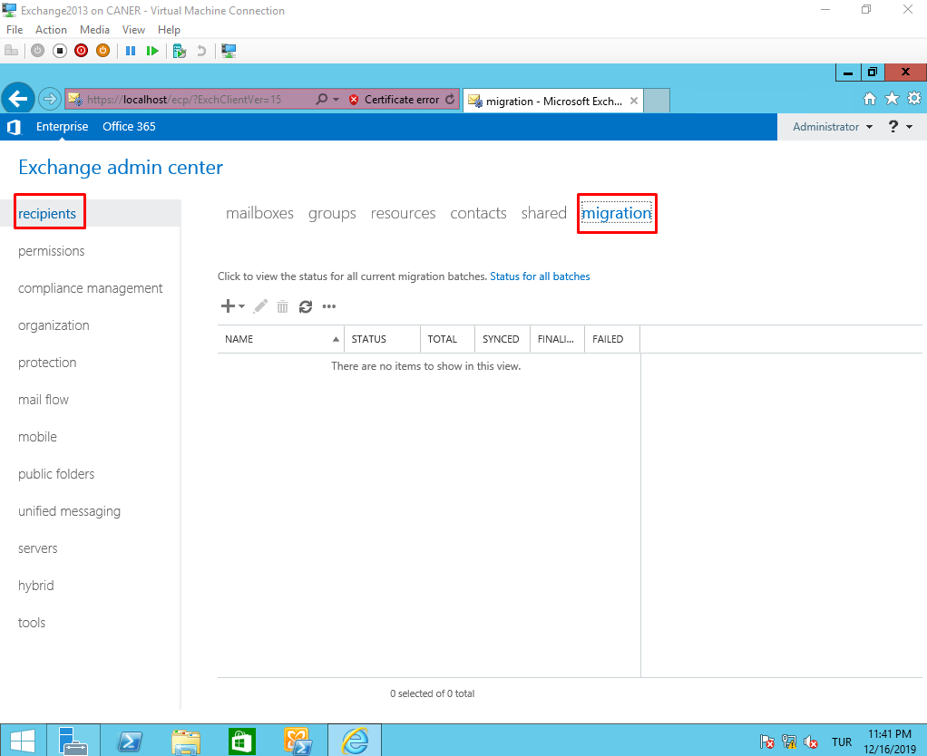

Under the plus sign we choose the option to move to a different database.

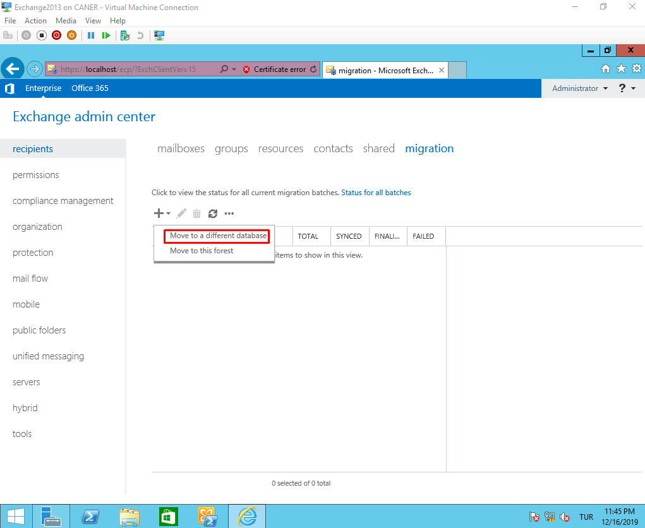

We then select which users we want to move. I’d recommend moving the administrator by itself and everything else as you see fit. I believe the administrator account is too crucial to be migrated along with other users.

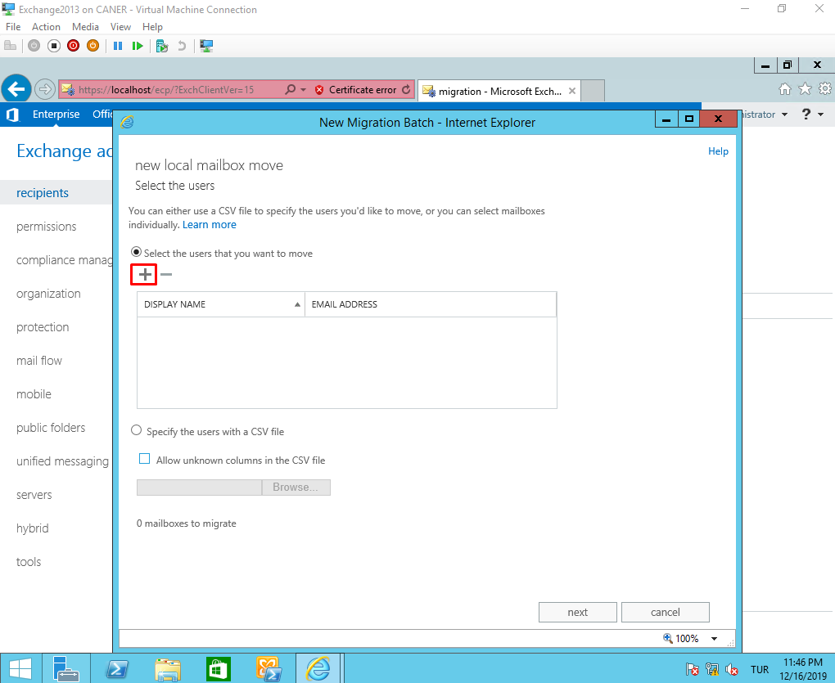

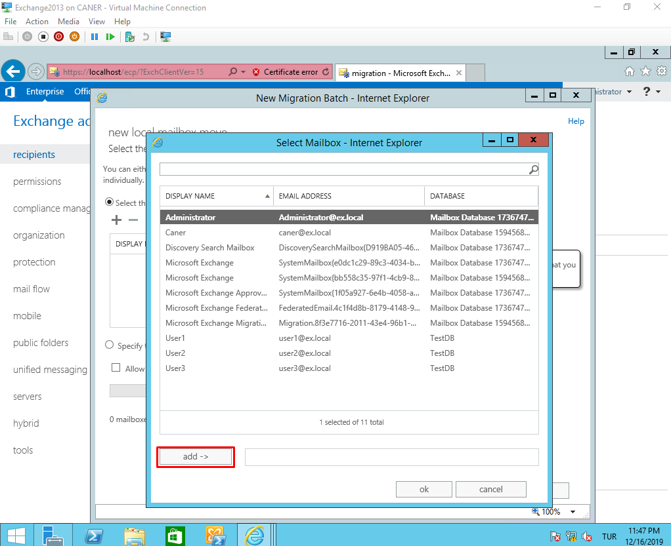

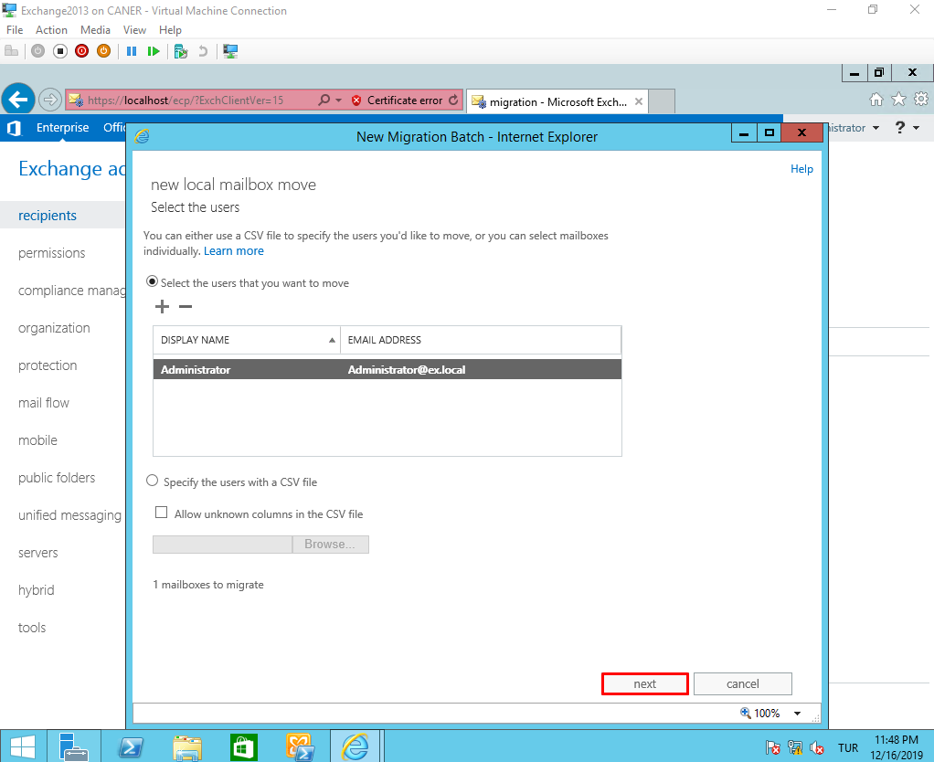

After choosing which users and groups to move, we select what to move; mailbox and or archive. In this case, we’re moving both. We select the target databases for each option.

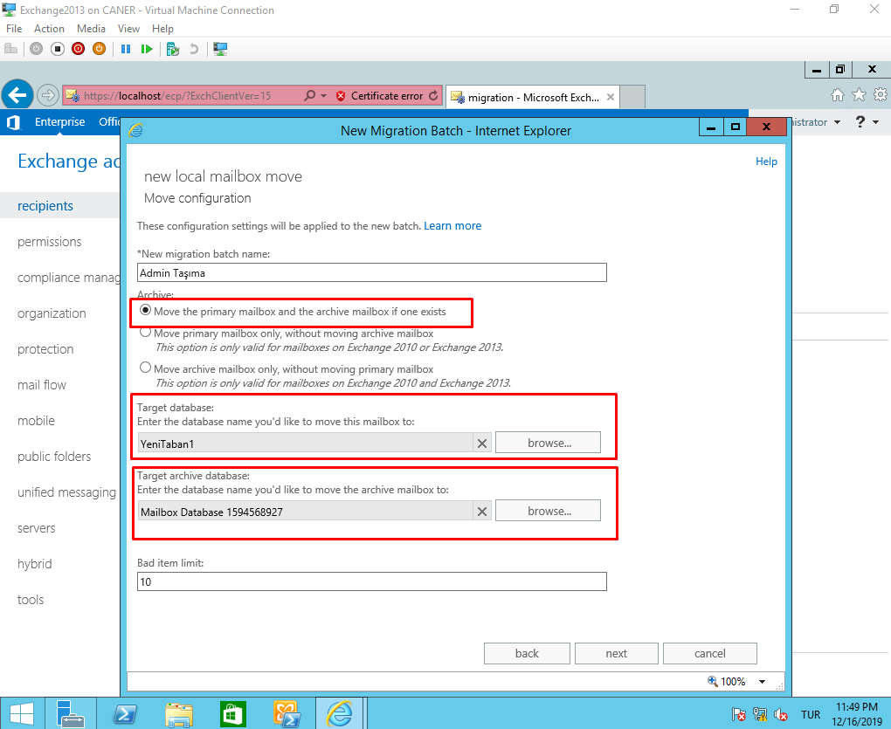

We select who gets notified once the process starts and completes and when it starts and completes.

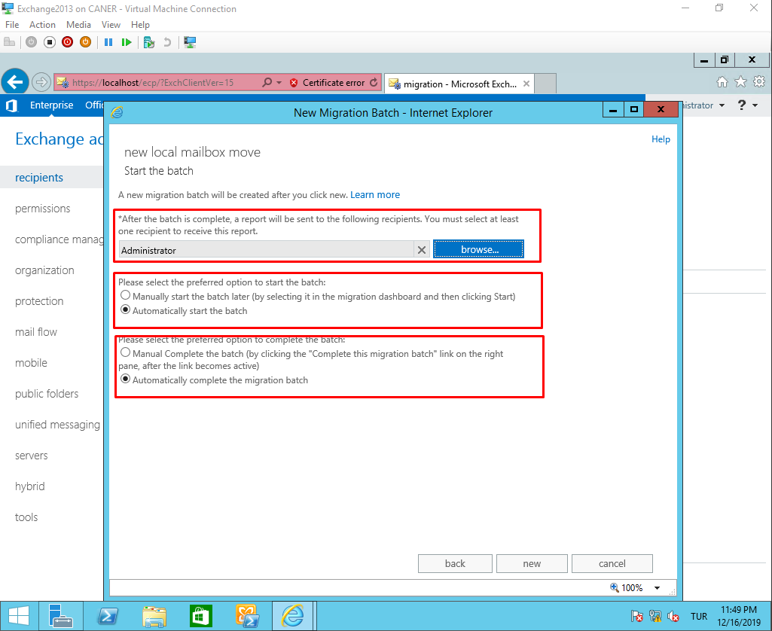

Then, the process starts and it says “Synching”.

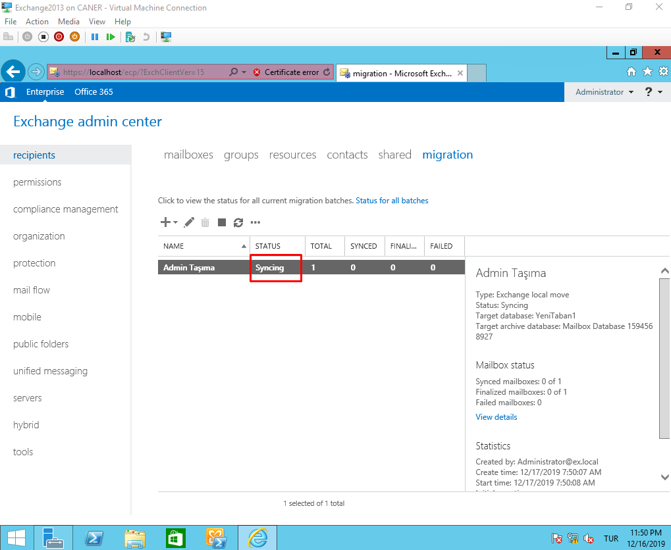

After a while it says it is completed.

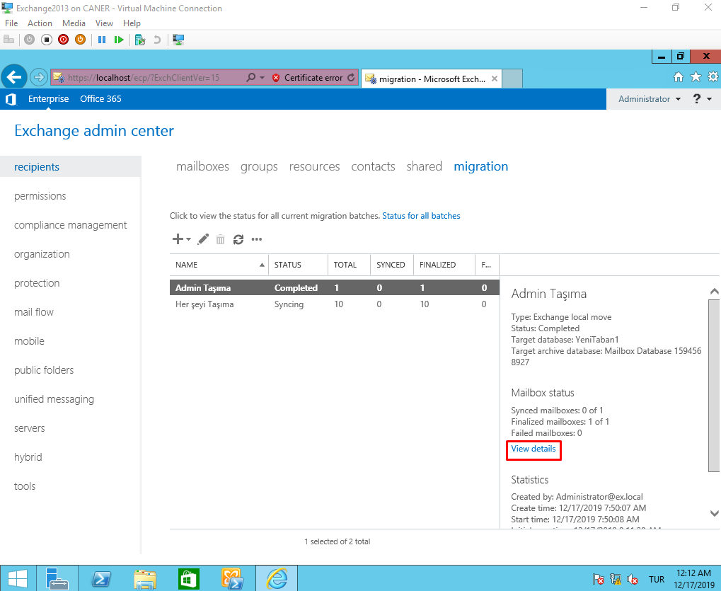

Note that we also started to move everything else meanwhile.

As you can see everything has moved to the new database in Exchange 2013.

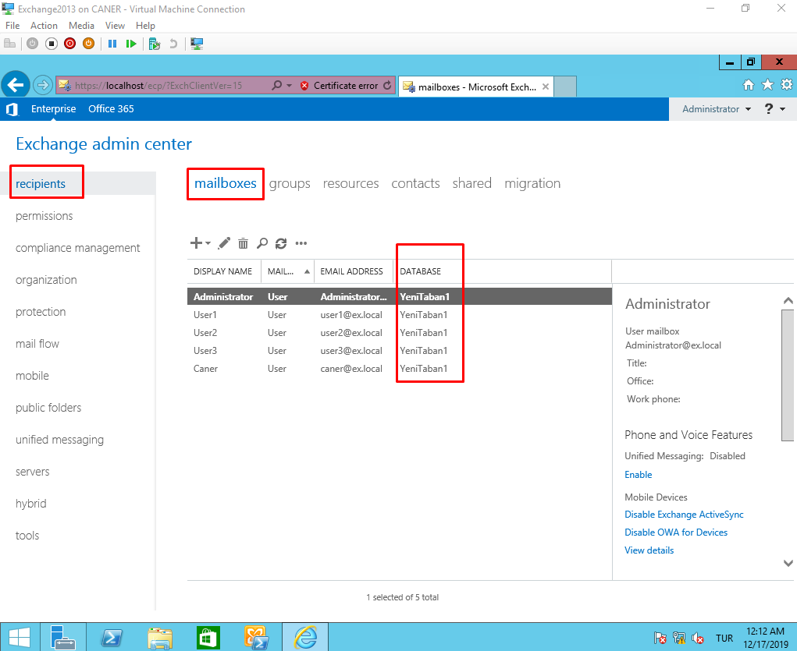

We can now dismount the unused databases…

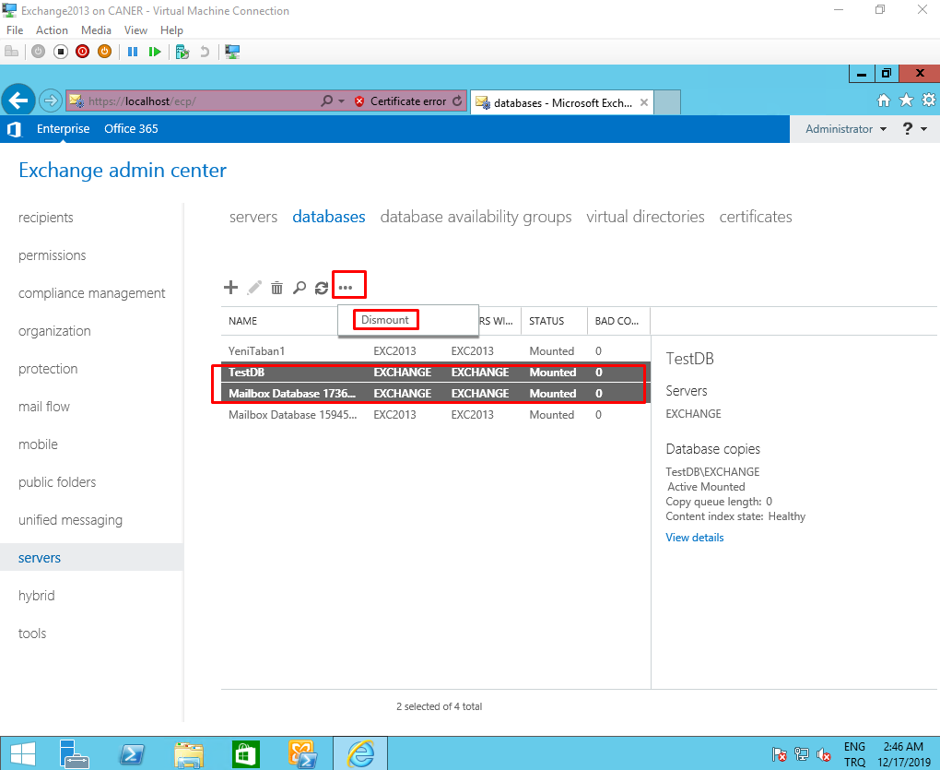

… and delete them.

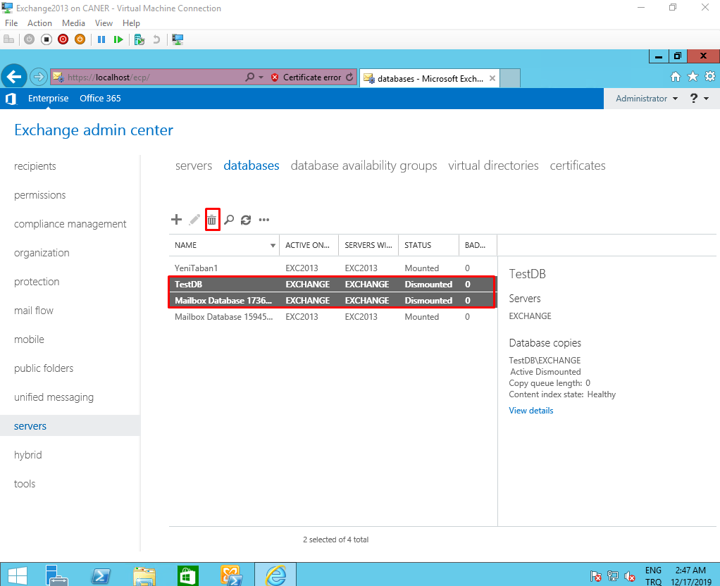

Migration is complete. We don’t need Exchange 2010 anymore.

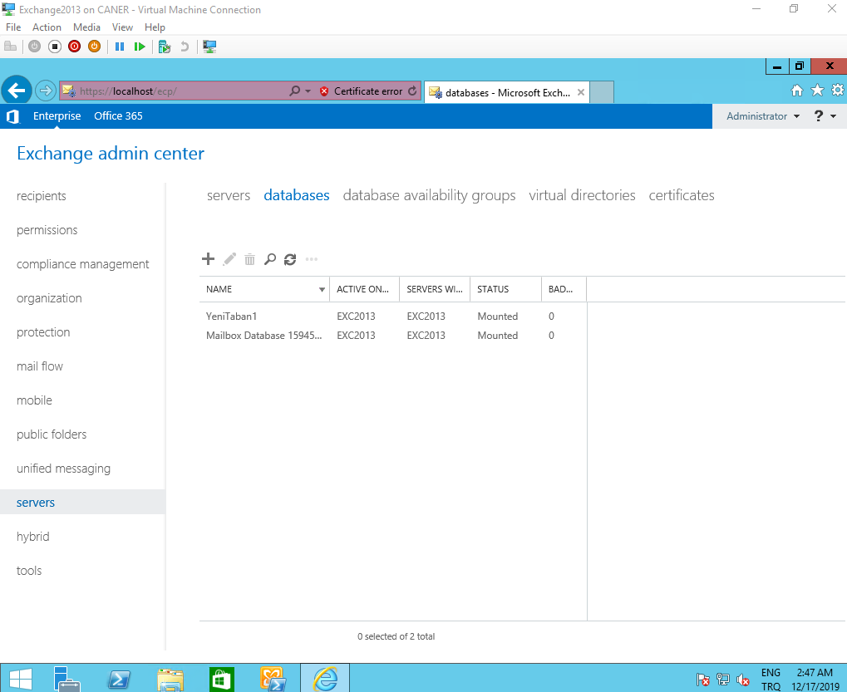

# **Conclusion**

Exchange Server is a very useful and necessary part of any enterprise that wants to use an on-premise setup for e-mails. Using a public domain is absolutely necessary for being able to e-mail out of domain addresses which is most often the case. Note that it’s taxing on physical hardware even with the bare minimum requirements; however, it’s is easy to manage as an admin if the company requires a complex set of rules and organization.

# **Evaluation**

Exchange 2016 Cumulative Update 13 has a bug about Distribution Groups, the requests to join one are never sent to the owners. Cumulative Updates 12 and 14 do not have this issue. Be careful about which version you use. Another problem with Cumulative Update 13 is that connecting to Outlook is troublesome. I’d recommend using Cumulative Update 14 for it; however, I have not tested Cumulative Update 12. In my understanding Exchange 2010 and 2013 are much more widely used than 2016 and these issues might be why. In case, you plan to use an on-premise Exchange Server and not Office 365 for e-mail management I’d recommend familiarizing yourself with all these versions enough to migrate if needed.